**BIRD HOUSE**

***Age category:* 6-12 years**

***Authors:* Chira Dorina Elena, Moraru Ovidia Monica**

***Competences:***

* **The students will know to explain how some recyclable materials can be used to make bird houses**
* **The students will know to make a bird house**
* **The students will know how to act properly in relation to the environment and to protect the animals (birds)**

***Competences according to European curriculum:***

[***http://eur-lex.europa.eu/legal-content/EN/TXT/?uri=LEGISSUM%3Ac11090***](http://eur-lex.europa.eu/legal-content/EN/TXT/?uri=LEGISSUM%3Ac11090)

***Formative assessment:***

* **Explain the steps for building a bird house using recyclable materials**
* **Define the word: bird house, recyclable materials,**
* **Identify the tools needed to build a bird house from recyclable materials**

***Summative Assessment:***

* **Build a bird house using recyclable materials**

***Specific vocabulary list/Keywords:***

* **Recycling, cartoon, plastic, bird house, recyclable materials**

***Short description of the educational context/scenario:***

* **The teacher and the children watch the video ”Birds’ House” without stop. The teacher will explain the new vocabulary and the concepts. The children will sign the new vocabulary. They will see the movie again without stop. One child can explain the steps for building a bird house using recyclable materials. The teacher will give the educational sheet to the children. The children will complete the educational sheet. The teacher will assist the students.**

***Materials needed/Technical requirements:***

* **images, scissors, glue, brushes, watercolor/acrylic colors, juice/milk boxes, plastic bottles**

***Focus on sign language:***

* **Sign the new vocabulary, sign the materials needed to build a bird house using recyclable materials, sign the steps**

1. **Circle the paper containers:**

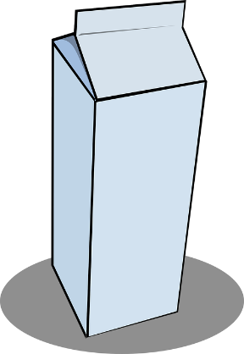

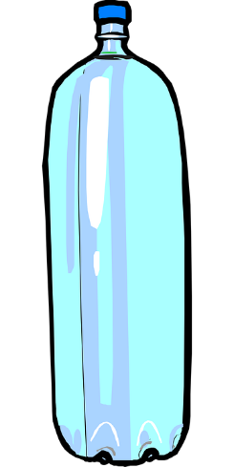

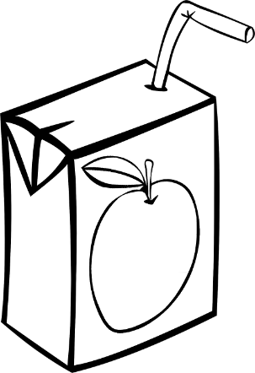

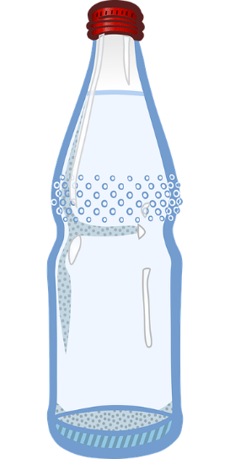

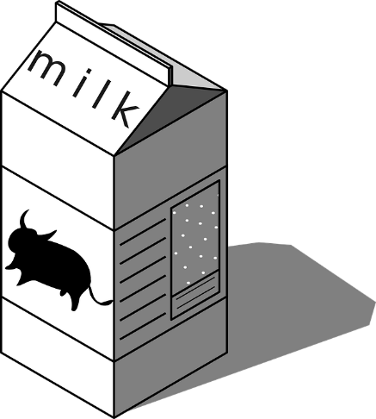

1. **What do you need to make a recyclable bird house? Match the images**

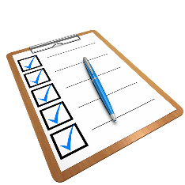

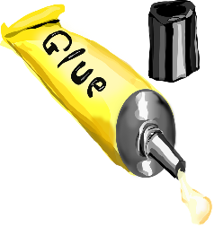

**

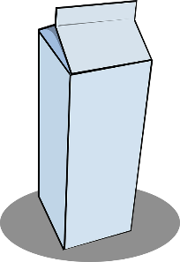

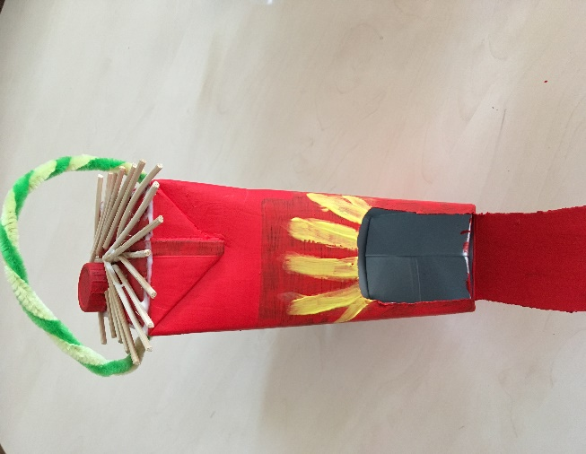

**

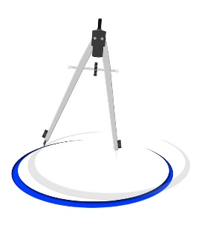

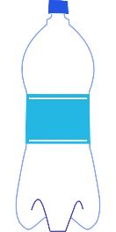

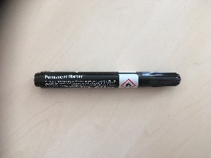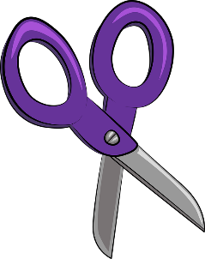

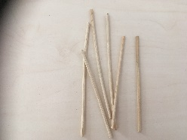

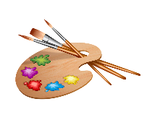

1. **Color/paint the bird house**

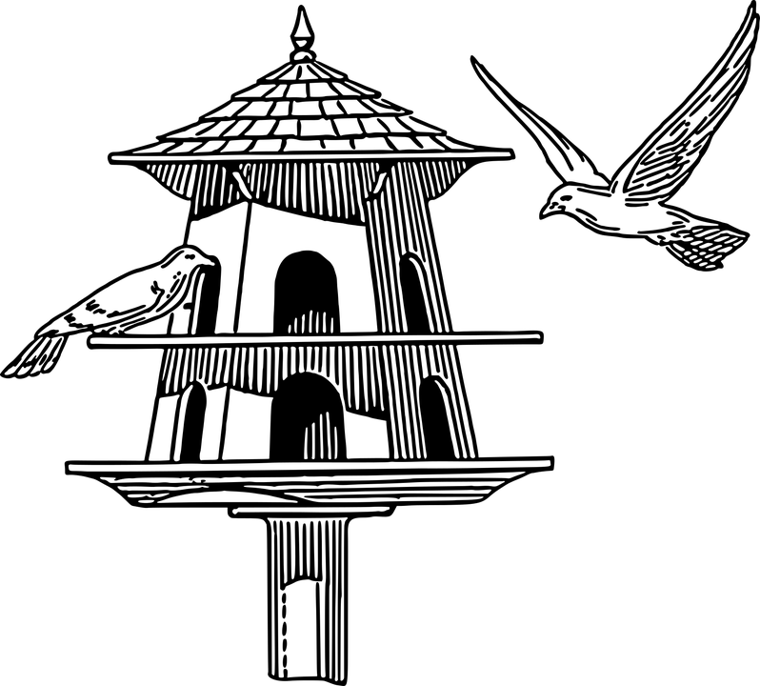

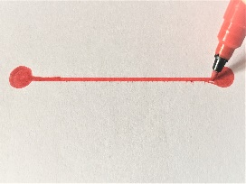

1. **Where can you place the bird house? Match the images**

|  |  |
| --- | --- |
|  |  |
|  |
|  |
|  |

1. **Match each image with the correct word.**

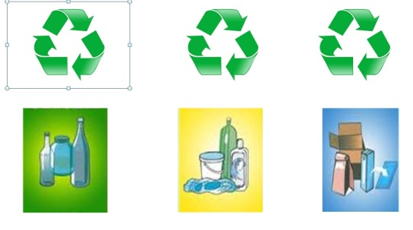

***Paper container***

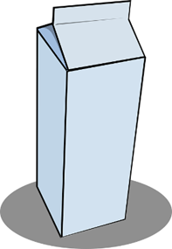

***Plastic container***



***Bird house***

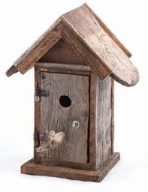

***Recycling symbols***

1. **Write the name of each image in the box below.**





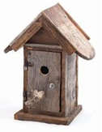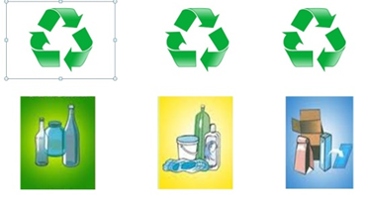



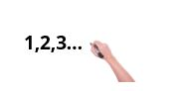

1. **Number the images in the correct order**

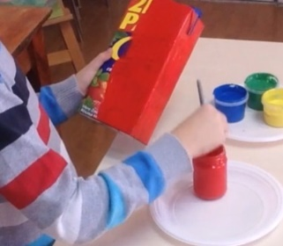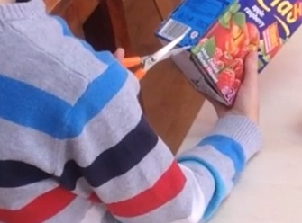

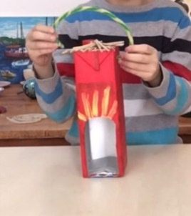

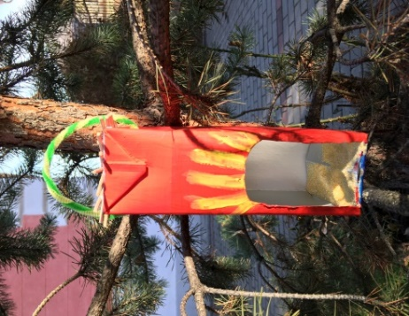

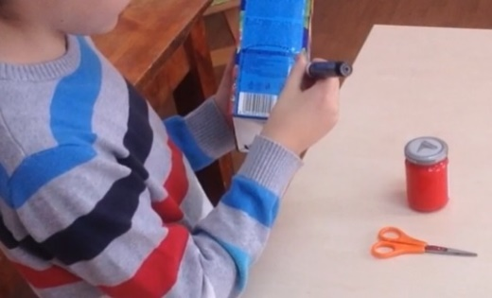

1

1. ***Extend / Enrichment / Prolongations Web links with others digital tools:***

***Bird House from Plastic Bottle- How to Build Bird House- Recycle Craft***

[***https://www.youtube.com/watch?v=GMB6ZaoB6Tc***](https://www.youtube.com/watch?v=GMB6ZaoB6Tc)

***How To Make A Bird Water Feeder | DIY Homemade Plastic Bottle Bird Water Feeder***

[***https://www.youtube.com/watch?v=q6EitavSRNg***](https://www.youtube.com/watch?v=q6EitavSRNg)

***DIY Cute Bird House. How to Make a Bird House from Recycled Materials.***

[***https://www.youtube.com/watch?v=Ov0ScGjmaiU***](https://www.youtube.com/watch?v=Ov0ScGjmaiU)

[**www.freepik.com**](http://www.freepik.com)

[**www.pixabay.com**](http://www.pixabay.com)

[**www.pdclipart.org**](http://www.pdclipart.org)