Title: CATHERINE WHEEL

Age category: 6 -12 years old

Authors: Istituto dei Sordi di Torino www.istitutosorditorino.org

Competences :
- The students will use mathematics and geometry of shapes.
- The students will know that they can bend shapes and obtain different ones.
- The students will know to use their manual dexterity and act properly in relation to the objects and different shapes in order to create something new.
- The students will learn to make simple geometrics calculations in order to obtain the correct materials needed for making the Catherine wheel.

Competences according to European curriculum:
http://eur-lex.europa.eu/legal-content/EN/TXT/?uri=LEGISSUM%3Ac11090

Formative assessment:
- Identify the tools
- Explain the actions to do on the materials: what to do first and the different phases
- Define new terms and what do they mean: Catherine wheel, square, rectangle…

Summative Assessment:
- Use geometry and logic on shapes in order to create new objects and games.

Specific vocabulary list/Keywords:
- Catherine wheel, square, creativity, precision, geometry, logic, measure, cut, wooden stick, pin.

Short description of the educational context/scenario:
The teacher will collect the materials needed in order to build a Catherine Wheel: coloured papers, wooden stick and a pin. The teacher will ask to the children if they think we can change the shape of papers in order to create a new object, and what they think they can create.
After discussion with them, the teacher will propose to make a Catherine Wheel, similar to those they can see in some stories (Don Quixote) and places (the Netherlands).
The teacher can help the children in both actions, the imaginative one about the mental imagination on how to give the paper the right shape and the practical one.
The teacher will assist the students.

Materials needed/Technical requirements:
- Scissors, colored papers, wooden stick and a pin.

Focus on sign language:
- Sign the new vocabulary, sign the materials needed to make the Catherine wheel, sign the steps to take.

- Circle the shapes that has same length sides.

- Each shape, its colour! Colour the man.

- Cut and re-build the square as in the image.

- What do you need to make a Catherine wheel?

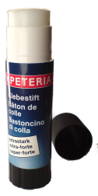
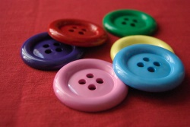
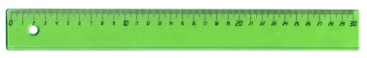
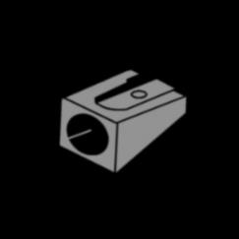
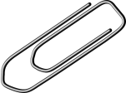
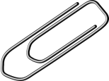
- Cut the images and make the puzzle.
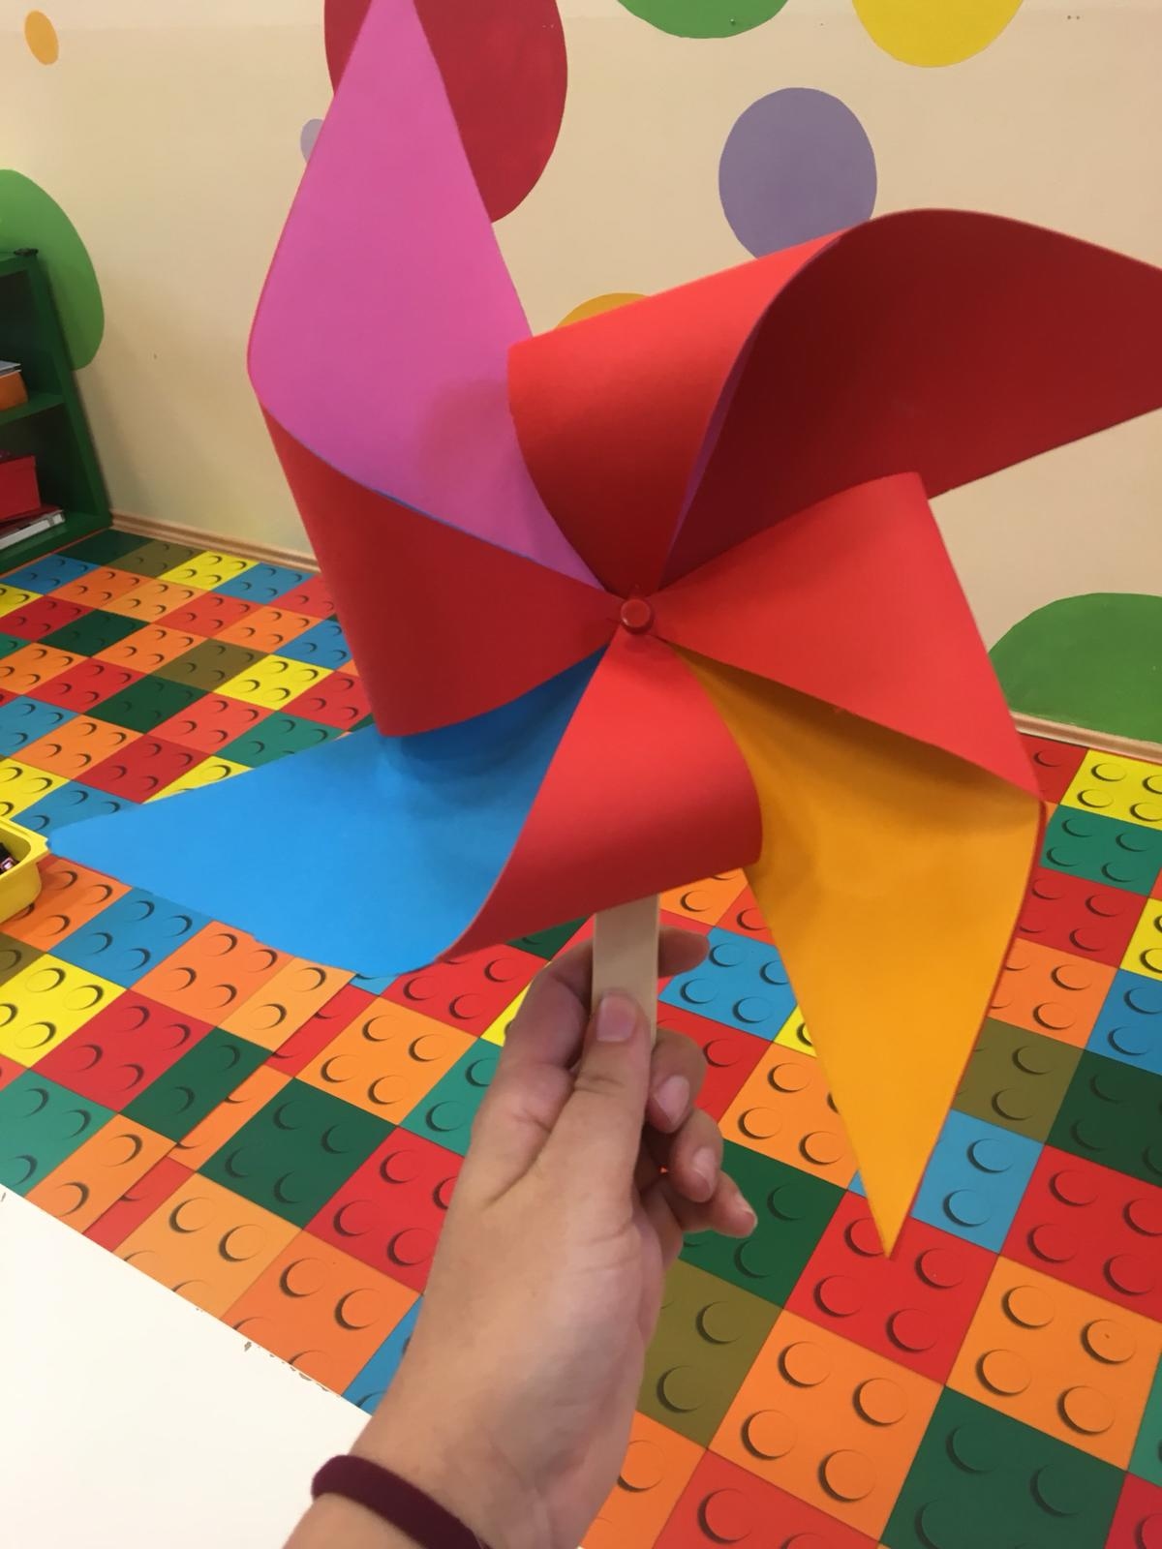
Extend / Enrichment / Prolongations Web links with others digital tools:

- https://www.youtube.com/watch?v=jhd5WcWBcBk
- https://www.youtube.com/watch?v=C-84mZwATbw
- https://www.youtube.com/watch?v=lBCIGY3dWXQ

