MAKING ANIMALS FROM PRINTS

Age category: 6- 12 years

Authors: Moraru Ovidia Monica

Competences:
- The students will know the necessary materials for making animals from prints
- The students will learn how to paint animals through prints
- The students will learn to appreciate art and they will develop their creativity and artistic imagination

Competences according to European curriculum:
http://eur-lex.europa.eu/legal-content/EN/TXT/?uri=LEGISSUM%3Ac11090

Formative assessment:
- Explaining the steps for making an animal from prints
- Indentifying instruments and materials needed to make animals from prints
- Enriching the students’ knowledge about animals

Summative Assessment:
- Making animals from prints with the help of instruments and materials which are easy for children to find

Specific vocabulary list/Keywords:
- Prints, painting, watercolors, pictures with animals

Short description of the educational context/scenario:
- The students and the teacher watch the video ”Fingerprint Animals”. The teacher and the students have a conversation about creating paintings with animals by using their fingerprints. Two of the students talk about how much they love animals and how they would like to create small animals through drawing and painting. The stundets explain in sign language the steps of making animals through prints and what materials and instruments are needed for this purpose. Then, the teacher will hand the educational sheets to the students so they can verify and enrich their knowledge about animals and arts in general. The teacher supervises and guides the students.

Materials needed/Technical requirements:
- Paper cards, watercolours/ fingerprint paint, trays for the paint, napkins, suggestive animals pictures, marker

Focus on sign language:
- Sign the vocabulary, sign the instruments and the materials needed to make animals from prints, sign the steps of making animals through prints

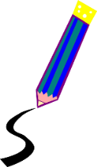
- Color only the animals presented in the video “Fingerprint Animals”

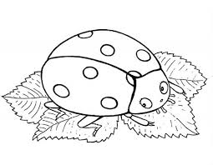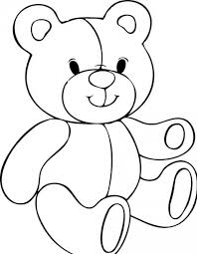

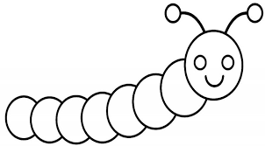

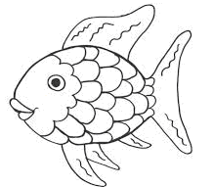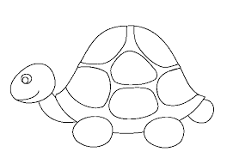

- Finish the drawing so you complete the animal.

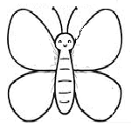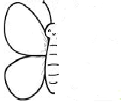

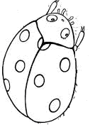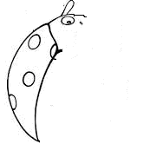

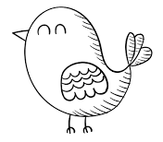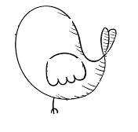
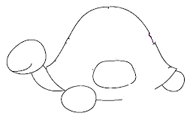

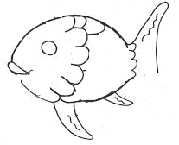

3. Count and write down the number of each animal. 1, 2, 3 ….

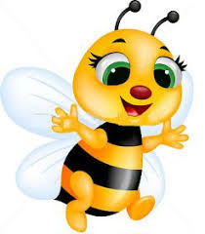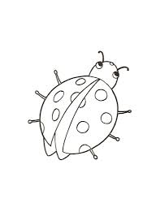

-----------------------------------------------------------------------------------------------------------------------------------

- Make the correspondence between the painting and the picture of each animal .

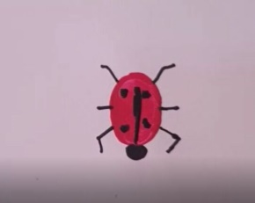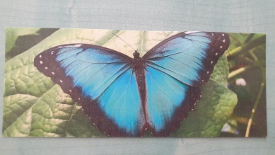

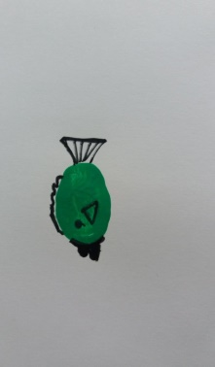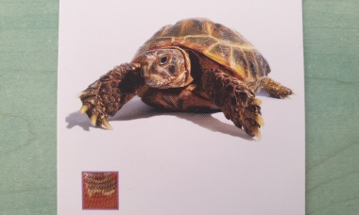

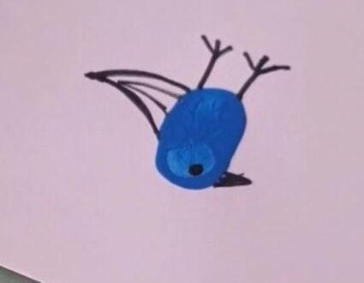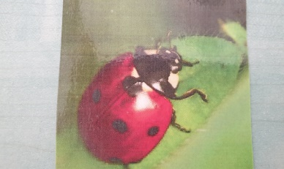

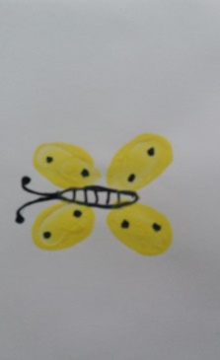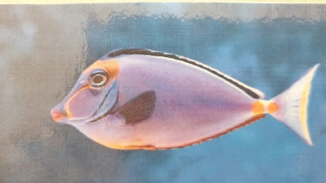

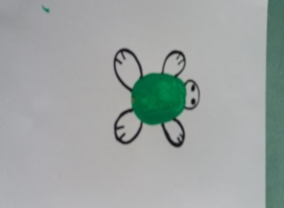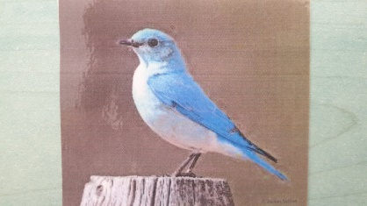

- Make the correspondence between the image and its written word.

Ladybug

Bird

Butterfly

Turtle

Fish

- Arrange the images in the right order of making a butterfly form prints

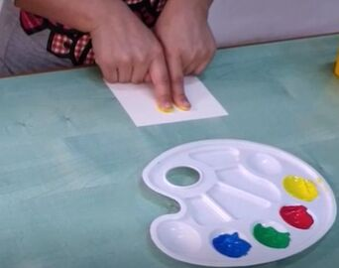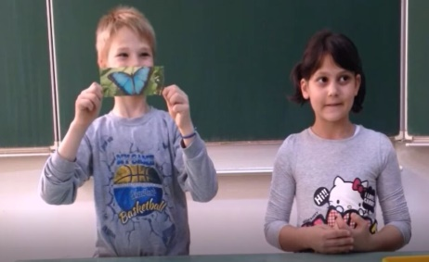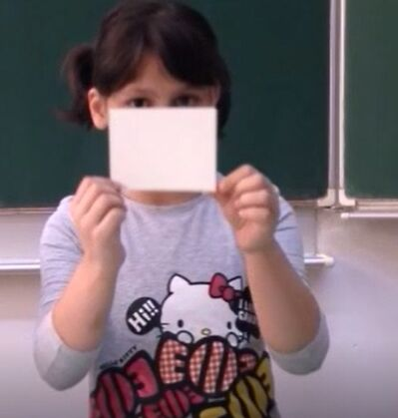

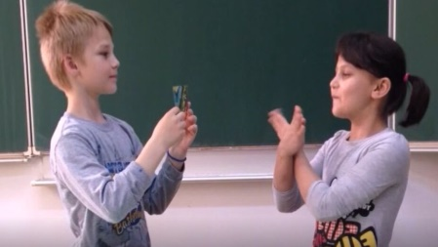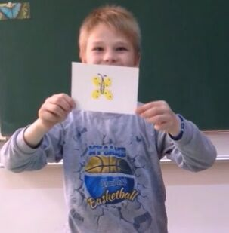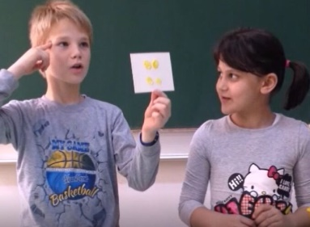

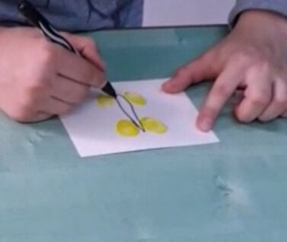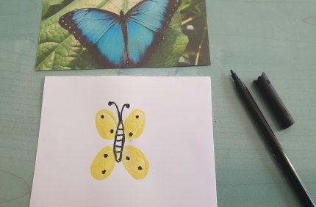

- Make the correspondence between the animal and its environment.

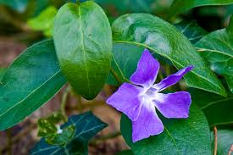

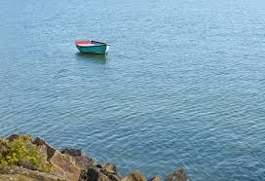

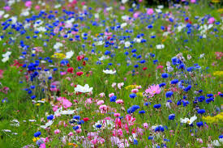

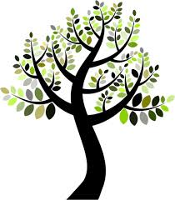

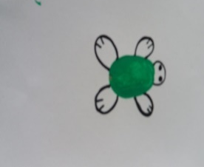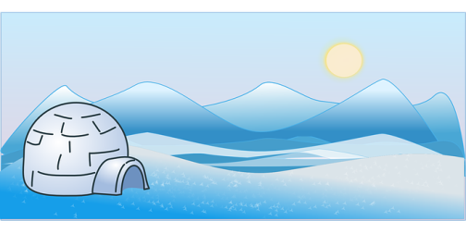
- Paint with your fingerprints.

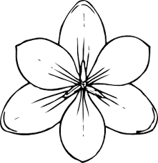

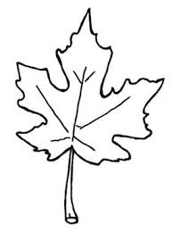

- Create other animals from fingerprints.

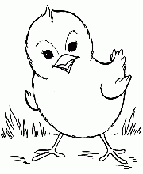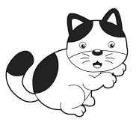

a caterpillar a chicken a kitty a Teddy bear

Extend/Enrichment /Prolongations Web links with others digital tools:

1. www.freepik.com
2. www.pixabay.com
3. www.pdclipart.org
4. How To Make Easy Fingerprint Art for Kids
https://www.youtube.com/watch?v=yEeaeDnI_Sc

