**FLOWER POT**

***Age category :* 6-12 years**

***Authors:* Chira Dorina Elena, Radu Ofelia**

***Competences:***

* **The students will know to explain how some recycling materials can be used to make a flower pot**
* **The students will know to make a flower pot**
* **The students will know to act properly in relation to the environment and use some recycling materials, instead of throwing them away**

***Competences according to European curriculum:***

[***http://eur-lex.europa.eu/legal-content/EN/TXT/?uri=LEGISSUM%3Ac11090***](http://eur-lex.europa.eu/legal-content/EN/TXT/?uri=LEGISSUM%3Ac11090)

***Formative assessment:***

* **Explain the steps for making a flower pot using recyclable materials**
* **Define the words: flower, pot, paint, brush, hammer, nail, flower soil**
* **Identify the tools needed to make a flower pot from recycling materials**

***Summative Assessment:***

* **Make a flower pot using recyclable materials**

***Specific vocabulary list/Keywords:***

* **Recycling, flower, pot, paint, brush, hammer, nail, recyclable materials**

***Short description of the educational context/scenario:***

**The teacher and the children will see the movie “Flower pot” from the beginning till the end. The teacher will explain the new vocabulary and the concepts. The children will sign the new vocabulary. They will see the movie again. One child can explain the steps for making a flower pot using recycled materials. The teacher will give the educational sheet to the children. The children will complete the educational sheet. The teacher will assist the students.**

***Materials needed/Technical requirements:***

* **Flower, can, hammer, nail, paint, brush, flower soil**

***Focus on sign language:***

* **Sign the new vocabulary, sign the materials needed to make a flower pot using recycling materials, sign the steps**

**1. Circle the objects you need to make a flower pot from a can: **

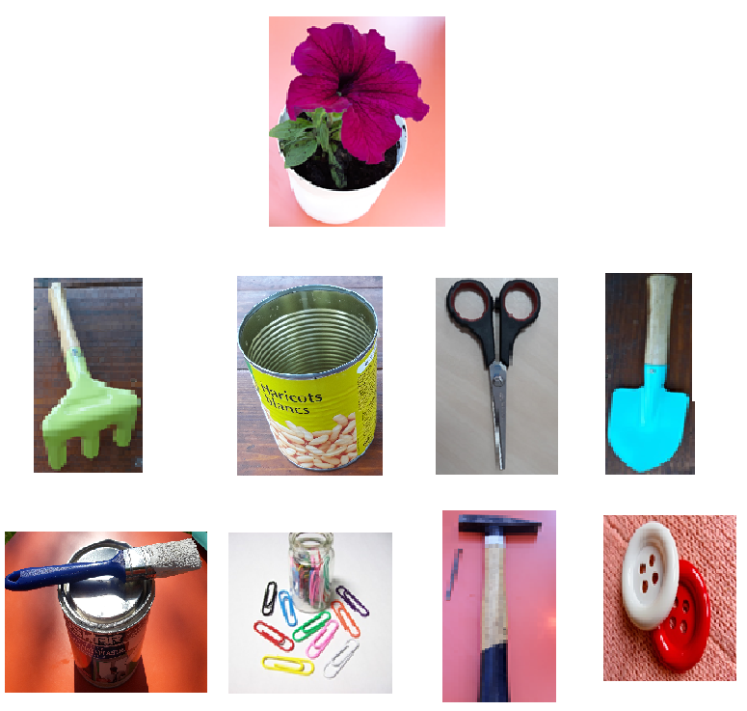

**2. Look at the images! Sign the images, then select the objects you need to make a flower pot from a can.**



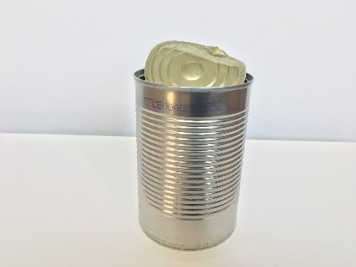 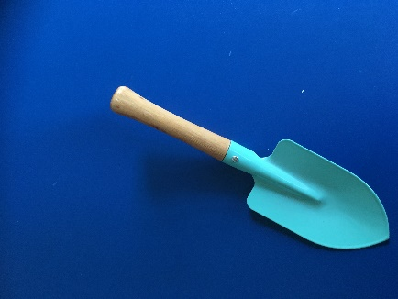 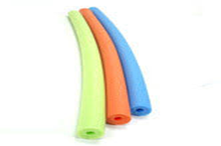

** **

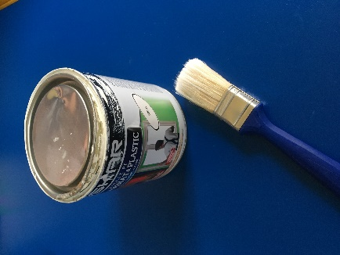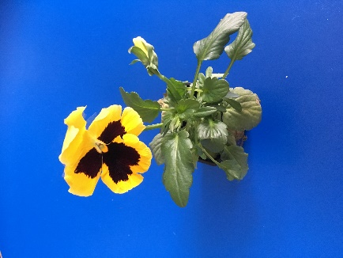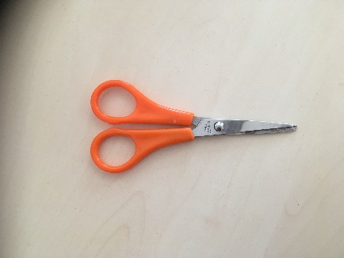

**  **

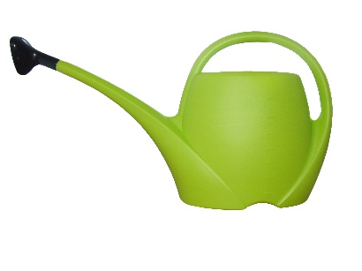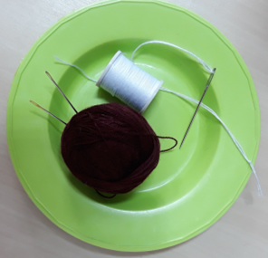 



**3. Look at the images! Explain the steps of making a flower pot.**

****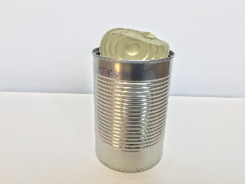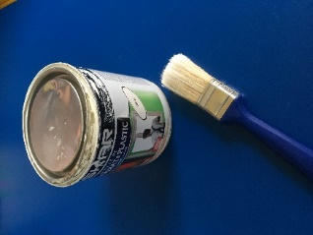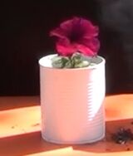

 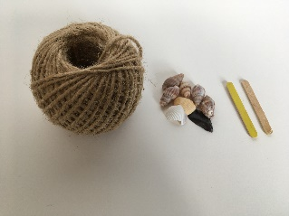 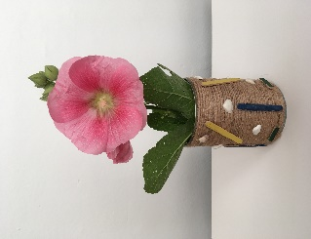

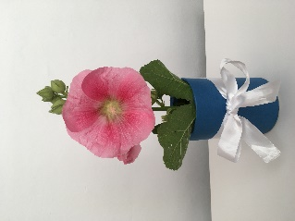

**4. Color in each column as many objects as indicate the number.**

|  |  |  |  |  |
| --- | --- | --- | --- | --- |
| **2** | **3** | **6** | **5** | **4** |
|  |  | Imagine similarÄ  Imagine similarÄ  Imagine similarÄ  Imagine similarÄ  Imagine similarÄ  Imagine similarÄ  Imagine similarÄ  Imagine similarÄ  Imagine similarÄ  Imagine similarÄ |  |  |

**5. Help the girl choose the right way to the flower.**



**3**

**2**

**1**

  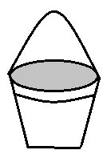

**6. Order the images to make a flower pot from recycled materials**

1. 

|  |
| --- |
|  |

B.

|  |
| --- |
|  |

**7. Circle the images of the recyclable packaging you can use to make a flower pot**

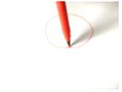

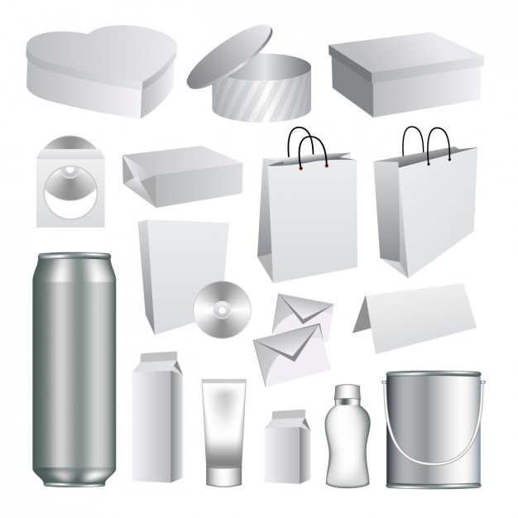

**8. Draw a flower in a pot and color your drawing.**



**9. Color and decorate the can in order to transform it in a flower pot.**

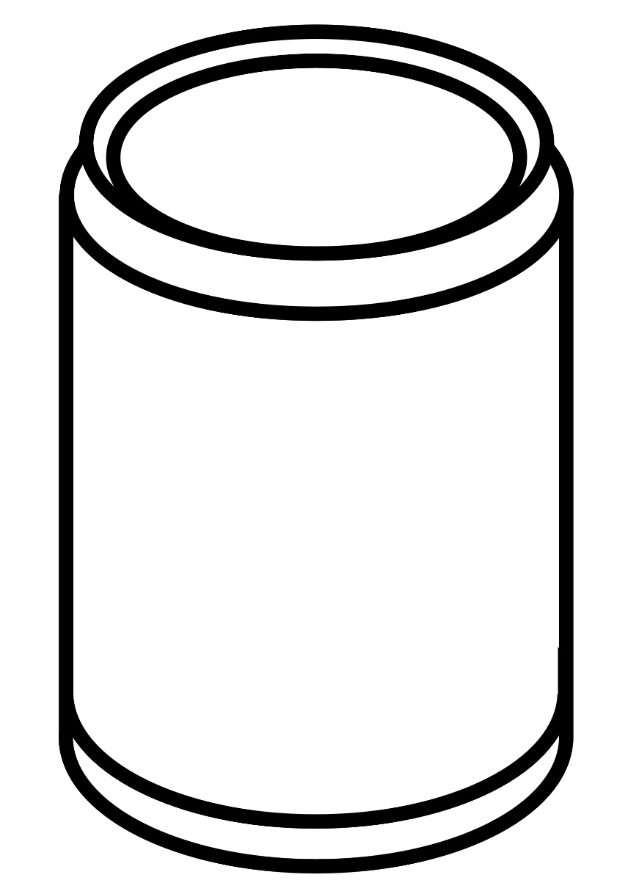

**10. Watch the video again and make your own flower pot from a can.**

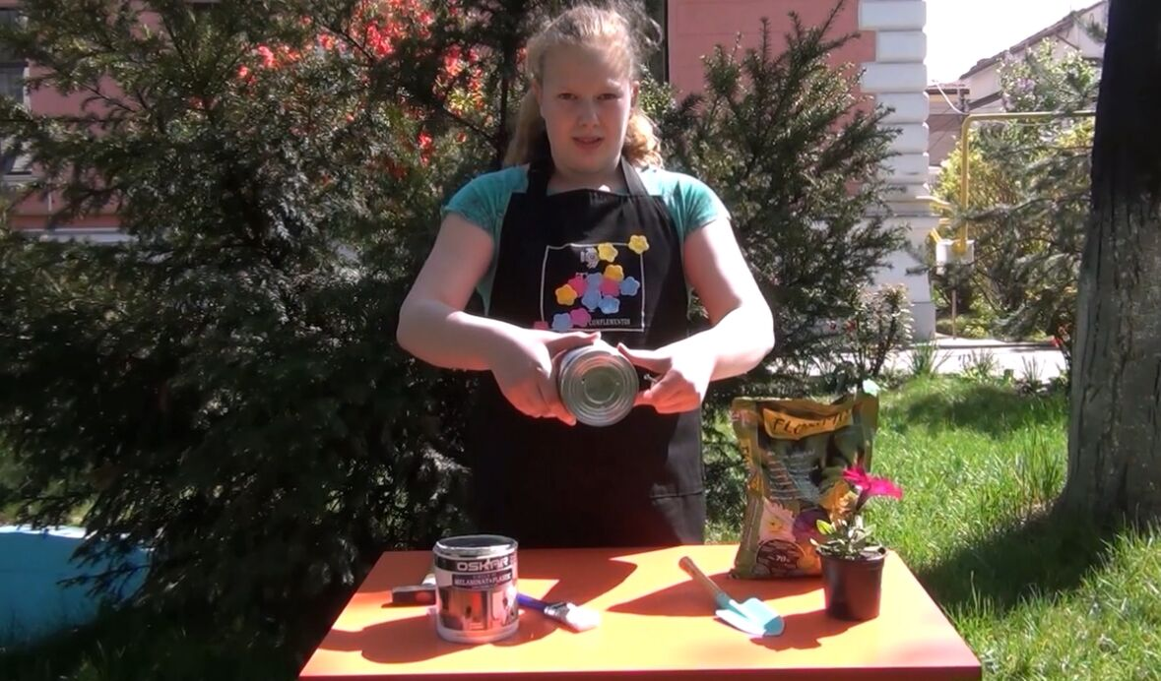

**Extend / Enrichment / Prolongations Web links with others digital tools:**

**1**. [www.freepik.com](http://www.freepik.com)

**2.** [www.pixabay.com](http://www.pixabay.com)

**3.** [www.pdclipart.org](http://www.pdclipart.org)

***4. How to make a tin can plant pot***

<https://www.youtube.com/watch?v=qp05JtoQA2>

***5. DIY : pot plastic bottle***

<https://www.youtube.com/watch?v=fno1mofz60c>