HOW TO SEW A BUTTON

Age category: 6-12 years

Authors: Chira Dorina Elena, Radu Ofelia

Competences:
- The students will know to explain how to sew a button
- The students will know how to sew a button
- The students will know to create useful products in everyday life using the techniques learned

Competences according to European curriculum:
http://eur-lex.europa.eu/legal-content/EN/TXT/?uri=LEGISSUM%3Ac11090

Formative assessment:
- Explain the steps for sewing a button
- Define the words: button, thread, node, sew, sewing kit
- Identify the tools needed to sew a button

Summative Assessment:
- Sew a button for personal clothes

Specific vocabulary list/Keywords:
- Sewing, button, thread, needle, sewing kit

Short description of the educational context/scenario:
The teacher and the children will see the movie ”Button sewing” from the beginning till the end. The teacher will explain the new vocabulary and the concepts. The children will sign the new vocabulary. They will see the movie again. One child can explain the steps for sewing a button. The teacher will give the educational sheet to the children. The children will complete the educational sheet. The teacher will assist the students.

Materials needed/Technical requirements:
- Textile or clothes, different types of buttons, scissors, thread

Focus on sign language:
- Sign the new vocabulary, sign the materials needed to sew a button, sign the steps for sewing a button

1. Circle the buttons: 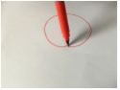

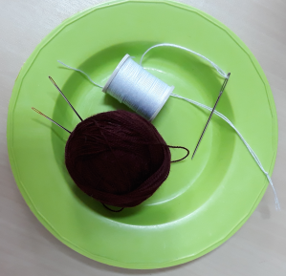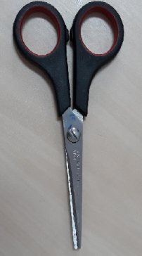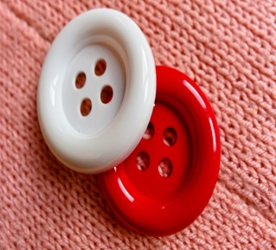

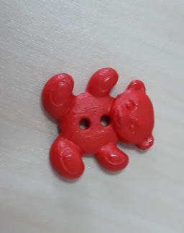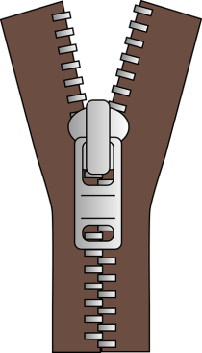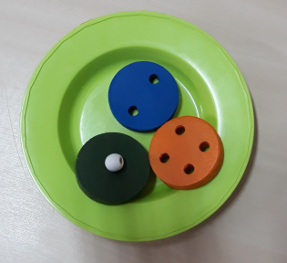

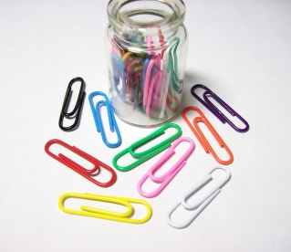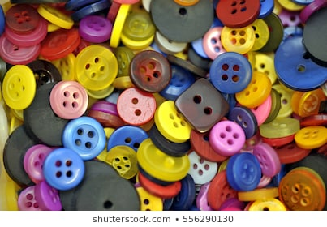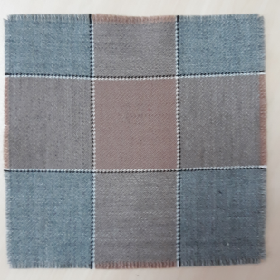

2. Match the buttons with the same numbers of holes.

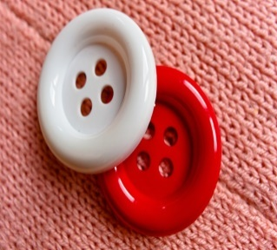
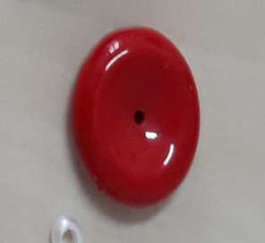

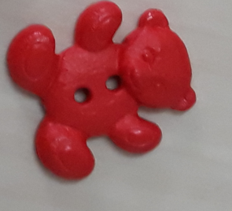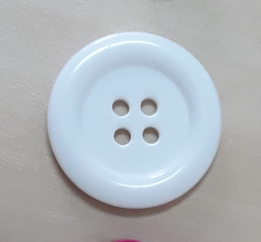

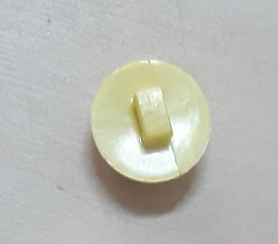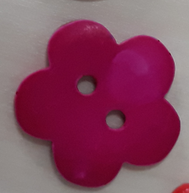

3. What do you need to sew a button? Match the images.

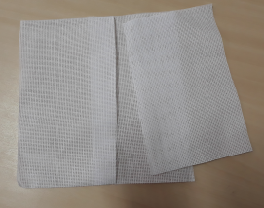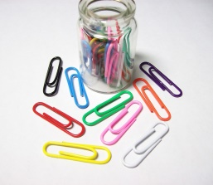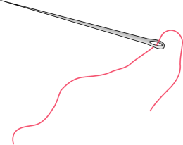

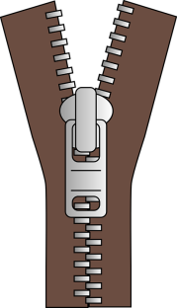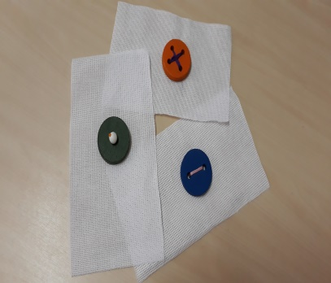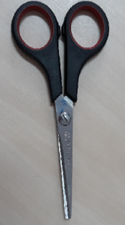

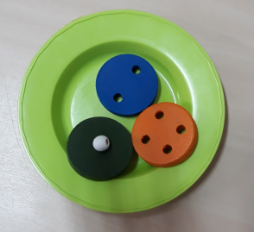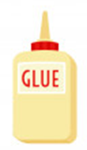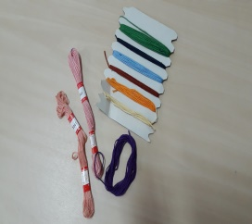

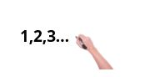
4. Number the images in the correct order.

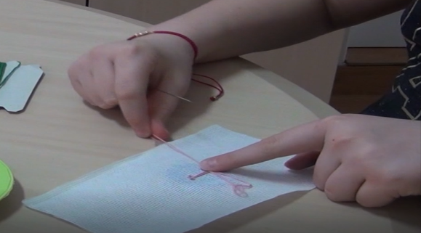

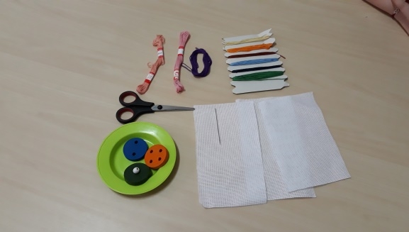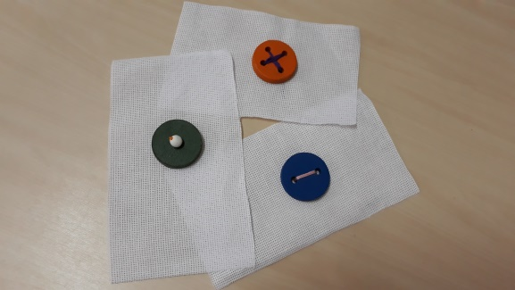

1

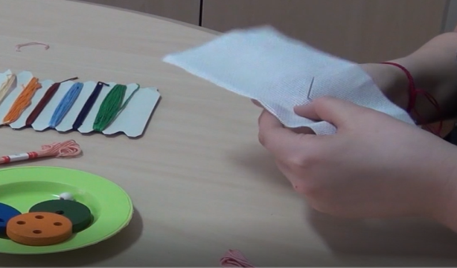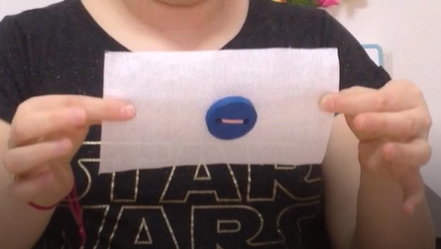

5. Cut the images and make the puzzle.

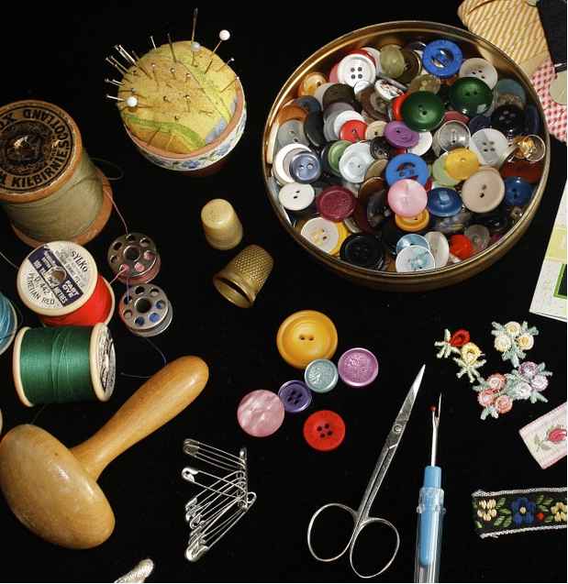

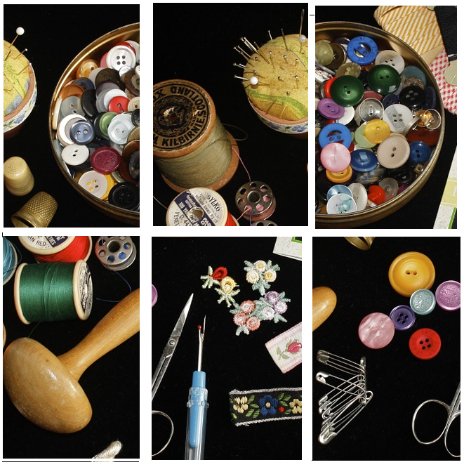

6. The boy is missing a button. Help him get to the sewing kit.

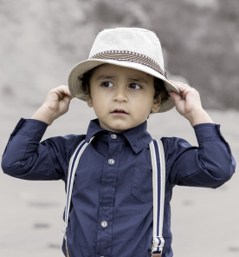
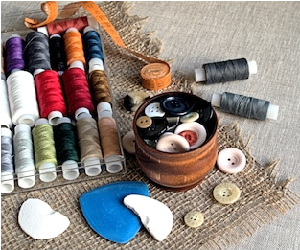
7. Match the imagine with the correct word.

Button
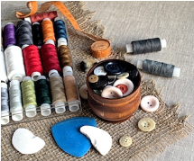

Thread
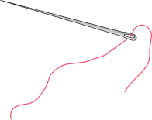

Needle
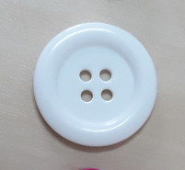

Scissor
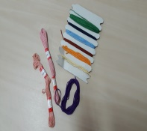

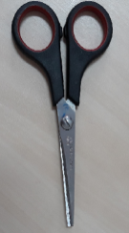

Sewing kit

8. Draw your favorite clothing object with buttons.

Extend / Enrichment / Prolongations Web links with others digital tools:

How To Sew A Button Like A Pro
https://www.youtube.com/watch?v=CPImtFR4hqw

How To Sew On A Button | Quick & Easy Sewing By Hand - https://www.youtube.com/watch?v=xNy9hLCl0NM

Hand sewing 2 Sewing on a button
https://www.youtube.com/watch?v=MjmUaWkzF-I

How to Sew on a Button By Hand - Quick & Easy Beginners Guide for Shirts, Coats & Jackets - https://www.youtube.com/watch?v=act1vCEchLY

Sewing a Button by Hand | Beginner sewing tutorial with Angela Wolf - https://www.youtube.com/watch?v=otF9K8IOQEY

www.pixabay.com
www.freepik.com

