LEMONADE

Age category: 6-12 years

Authors: Ramona Tranca; Ioana-Letitia Serban

Competences:
- The students will identify the name and the components of a soda drink.
- The students will be able to select fresh products to make a lemonade
- The students will be able to explain the difference between an artificial or a chemical product and a natural one.

Competences according to European curriculum:
http://eur-lex.europa.eu/legal-content/EN/TXT/?uri=LEGISSUM%3Ac11090

Formative assessment:
- Presenting the sodas, the fruit, the sugar and the honey and all the objects needed for the lemonade
- Dividing the artificial and the natural ingredients into two distinct categories
- Explaining the difference between a soda and a natural juice

Summative Assessment:
Using all the ingredients and kitchen tools to make the lemonade

Specific vocabulary list/Keywords:
Lemons, lemonade, soda, sugar, orange, blueberries, straw

Short description of the educational context/scenario:
The teacher and the students watch the video together. The teacher starts a debate in Sign Language encouraging the children to find arguments for either the benefits of natural juices or of the soda drinks. Together with the children the teacher summarizes the ideas and underlines the importance of healthy food and drinks. The children will be familiarized with the exercises in the educational sheet and at the end of the activity they will have to prepare themselves a lemonade following the steps shown in the video.

Materials needed/Technical requirements:
Lemons, water, honey, wooden spoon, oranges, blueberries, jar, bottles, laptop, internet.

Focus on sign language:
Signing the new vocabulary, signing words, debating/explaining in Sign Language

- Match the colour and then paint accordingly.

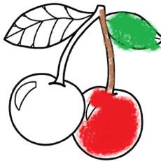

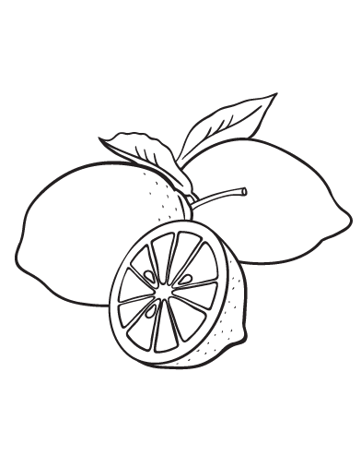

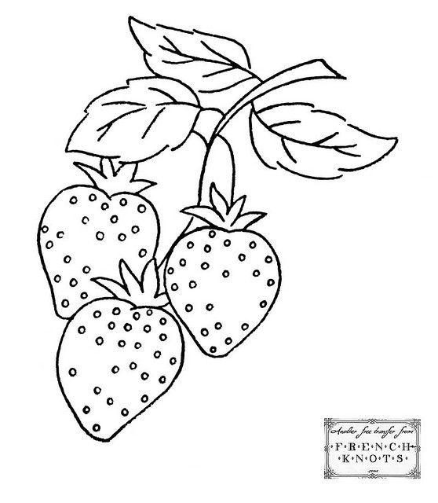

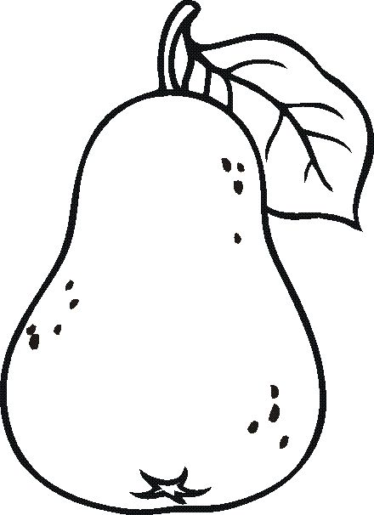

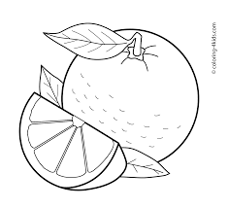

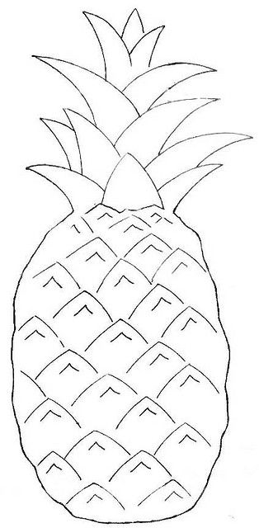

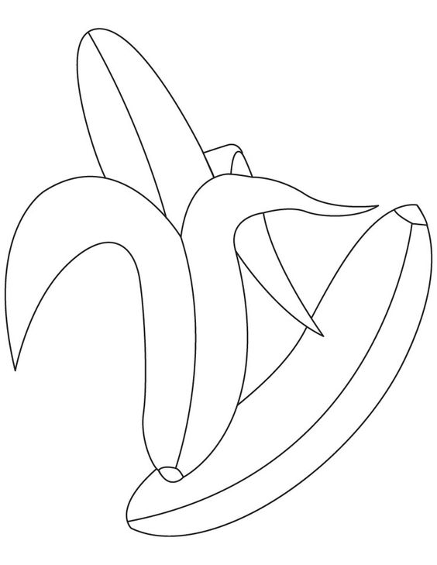
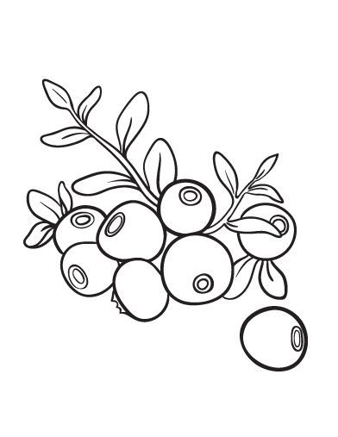

- Put the right mark in each box below the pictures.

HEALTY FOOD
UNHEALTY FOOD

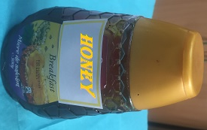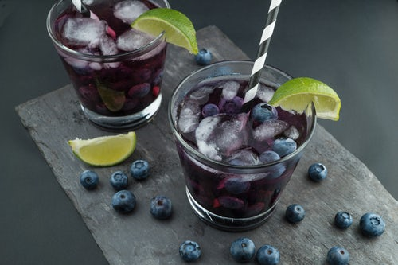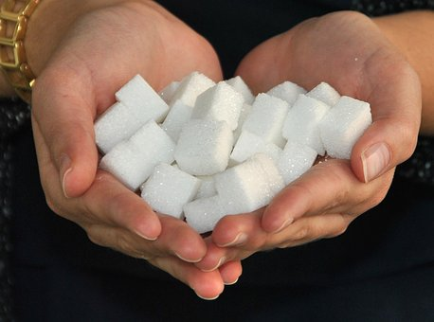

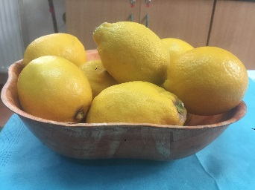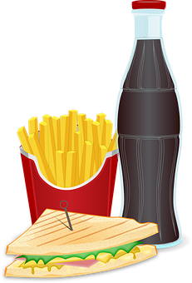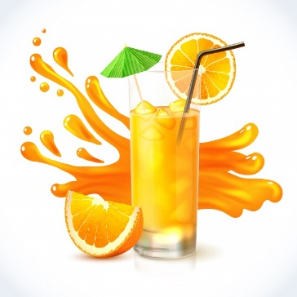

- Draw the next objects in the raw.

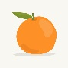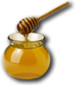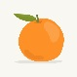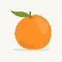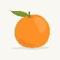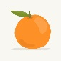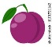

…………………...................

…………………................

……………….................

- Match the pictures below with either the soda or the natural juice.

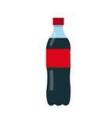
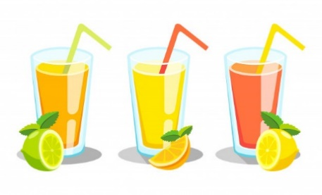

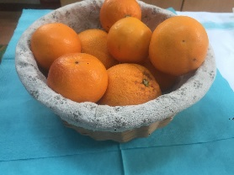
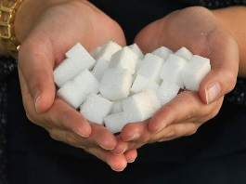

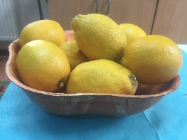

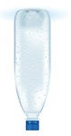
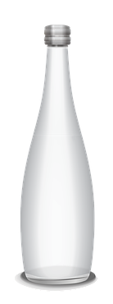

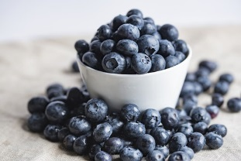

- Select the things you need to prepare and to drink lemonade:

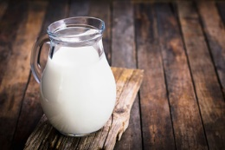
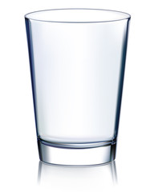

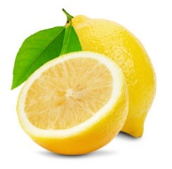
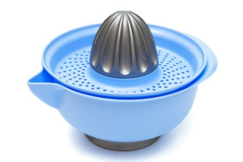
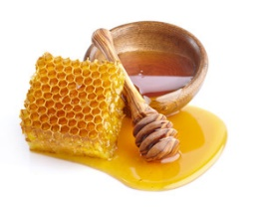
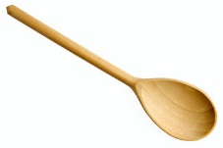
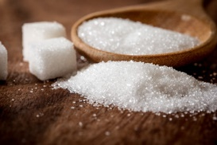
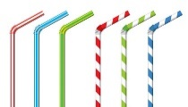
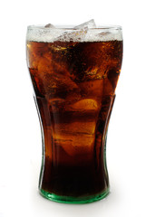
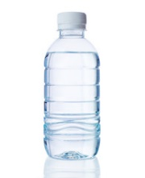
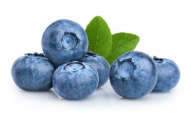
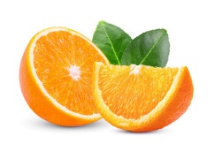
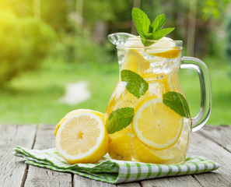

- Sign the following images:

- Sign the following sentences:

- I like fresh fruits.
- Lemons are sour.
- Sugar is bad for your health.
- Blueberries taste excellent.
- I know how to squeeze an orange.
- Soda drinks are not healthy.
- Sugar can be replaced with honey.
- We drink lemonade with a straw.
- I use the knife only with an adult present.
- You drink lemonade with your friends.

- Watch the video again and prepare your own homemade lemonade.

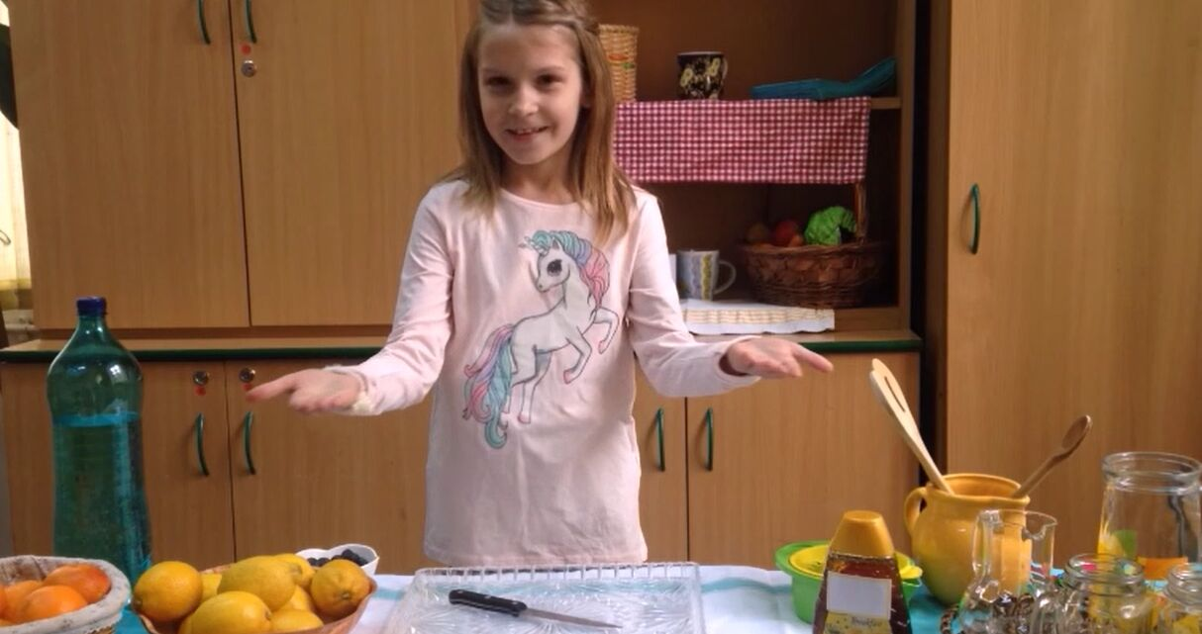

Extend / Enrichment / Prolongations Web links with others digital tools:

1. www.freepik.com
2. www.pixabay.com
3. www.pdclipart.org
4. How to make Honey Lemon | Best Honey Lemon Recipe
https://www.youtube.com/watch?v=GX7esNoKYuc

