You can create your own resources, videos and games at:

http://www.opensign.eu

GAME: The Egyptian Era

Age: 8 to 12 years
Creator: Média’Pi

Competences :
- Link an iconic/visual video description with objects used in Ancient Egypt

- Remember hidden memory cards and strategically choose your cards

- Be patient and perseverant

European Competences
https://eur-lex.europa.eu/legal-content/EN/TXT/?uri=uriserv%3AOJ.C_.2018.189.01.0001.01.ENG&toc=OJ%3AC%3A2018%3A189%3ATOC

Specific vocabulary / keywords :
Pharaoh, a block of stone, cutting stone, pyramids

Lesson outline:
View the thematic video on Ancient Egypt here:
http://www.opensign.eu/thematic_topics/57

After having seen the thematic video on «Ancient Egypt», the student can put the elements of the video in context and be able to learn the vocabulary to explain the different stages of constructing the pyramid blocks.

Resources:
A computer and an internet connection.

Focus on sign language:
Some images describe a fixed object and others describe a moving object or objects. Find other examples of characters or objects that require movement to be described.

Ce projet n ° 2017-1-FR01-KA201-037433 a été financé avec le soutien de la Commission européenne. Cette publication n'engage que son auteur et la Commission ne peut être tenue responsable de l'usage qui pourrait être fait des informations qui y figurent.

- Play the Game: The Egyptian Era: http://opensign.eu/memory_game/55
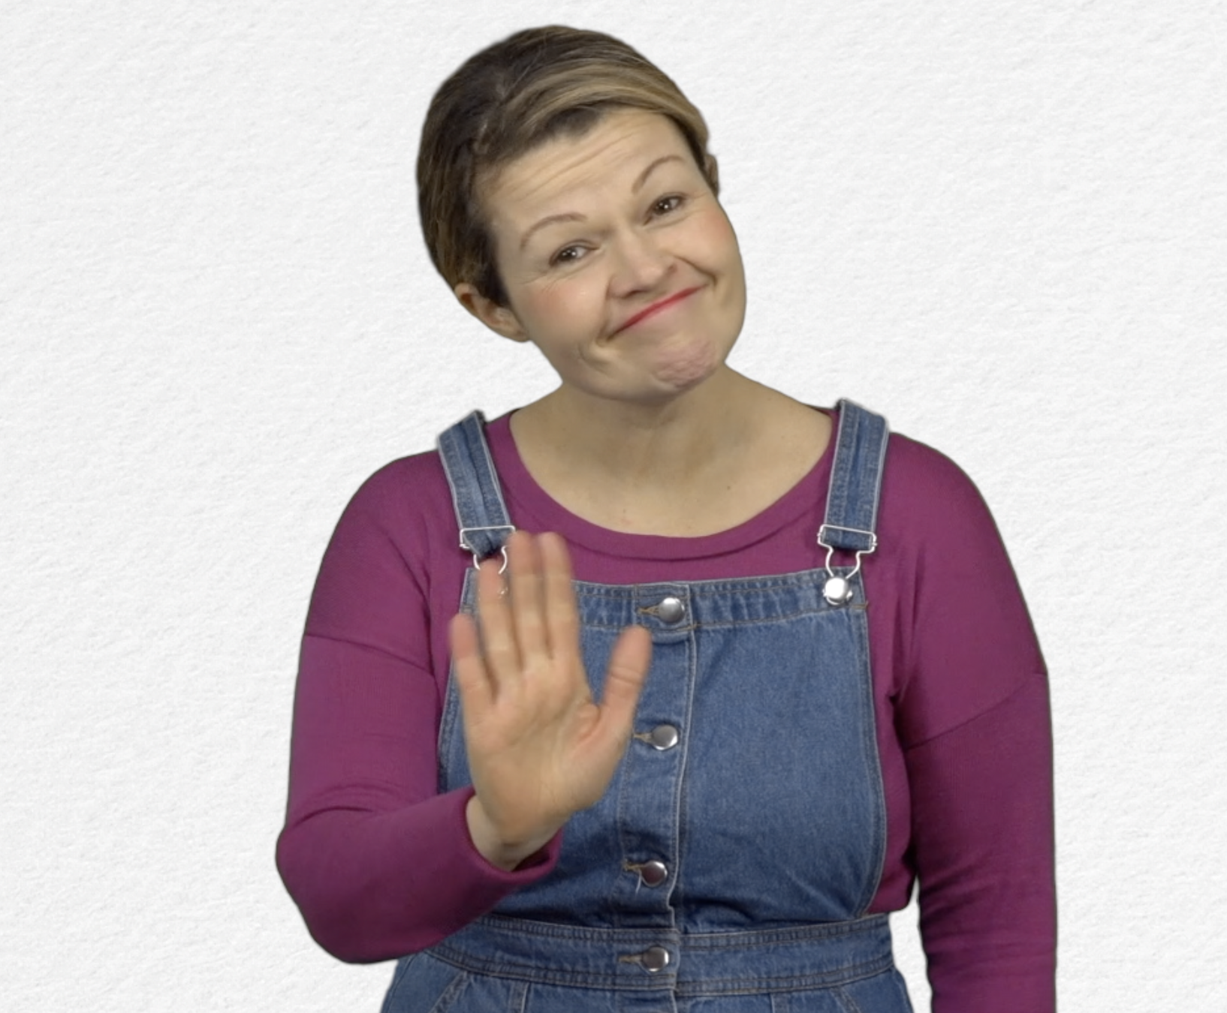
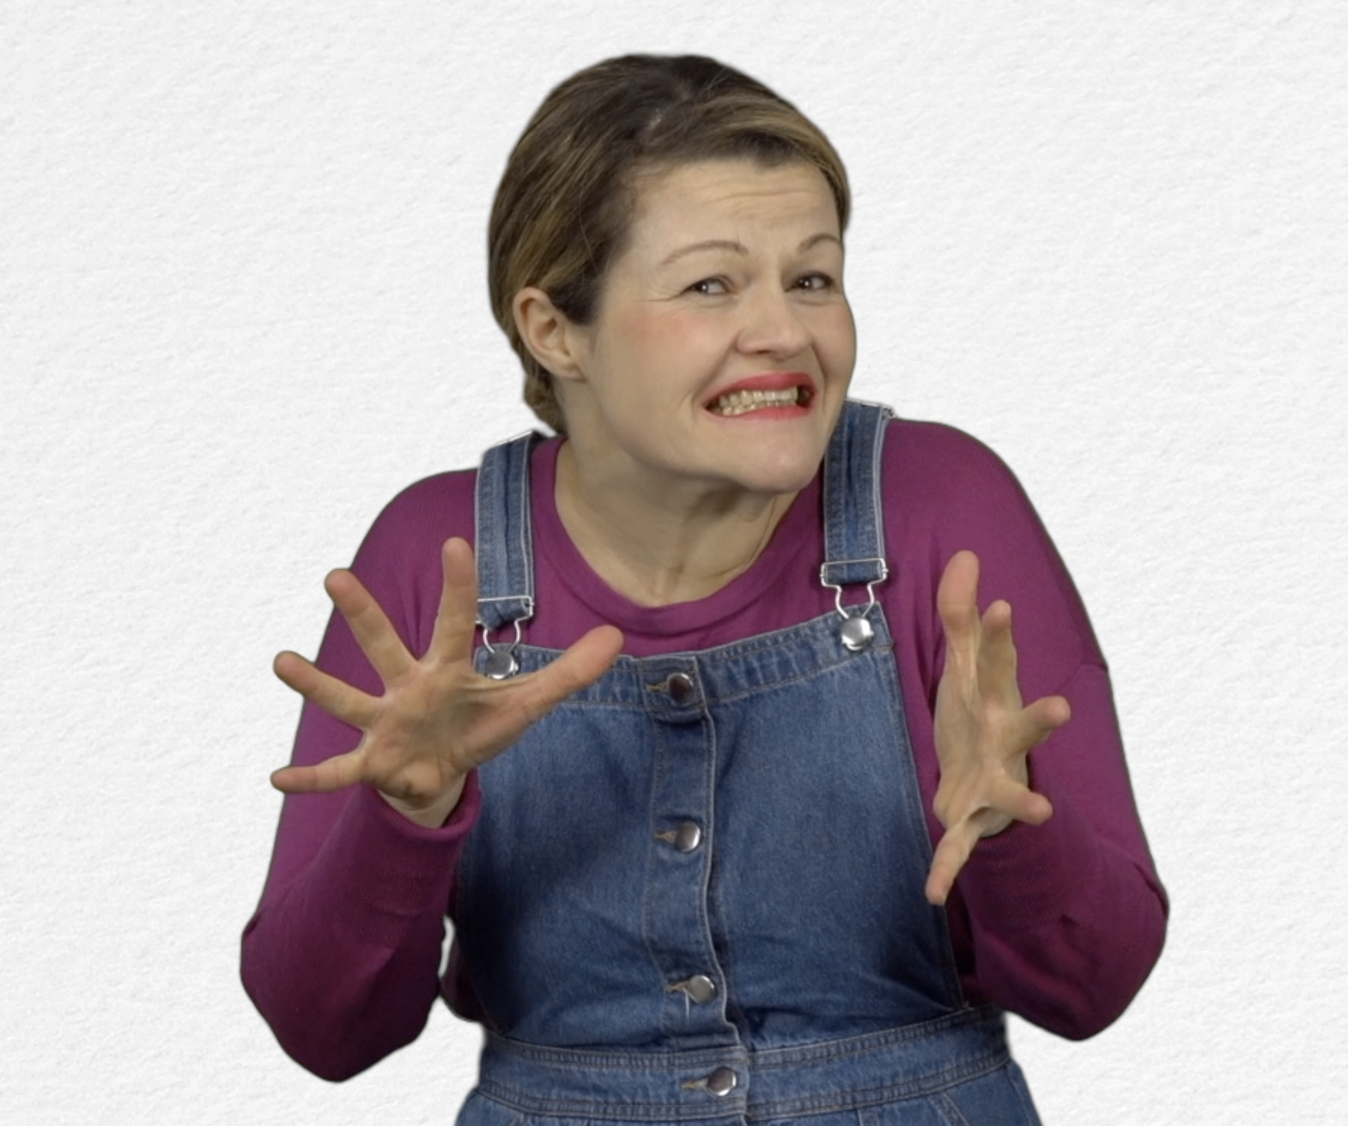
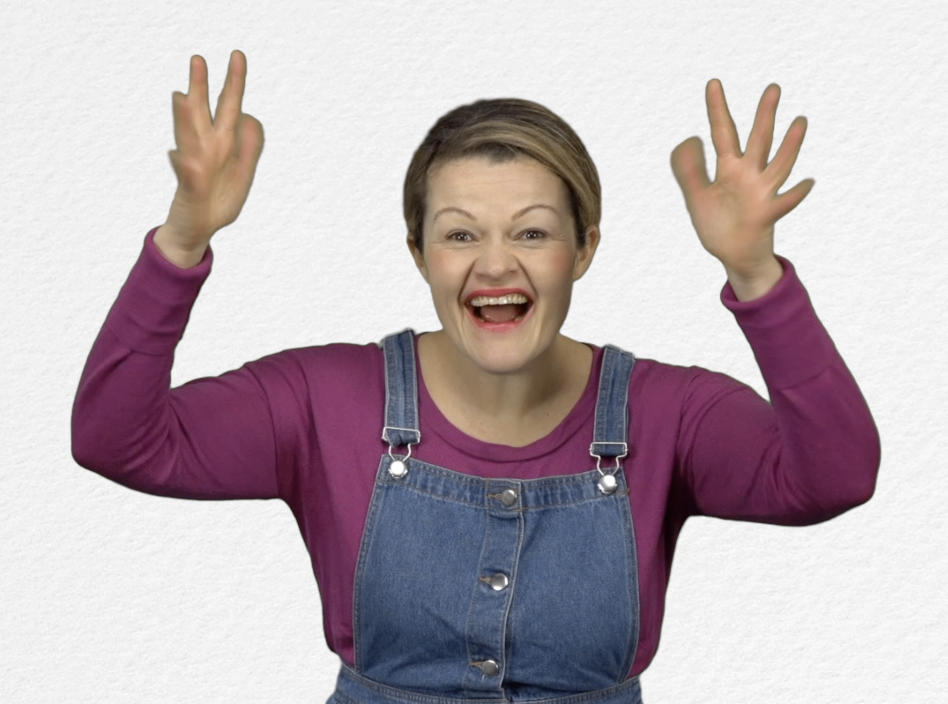
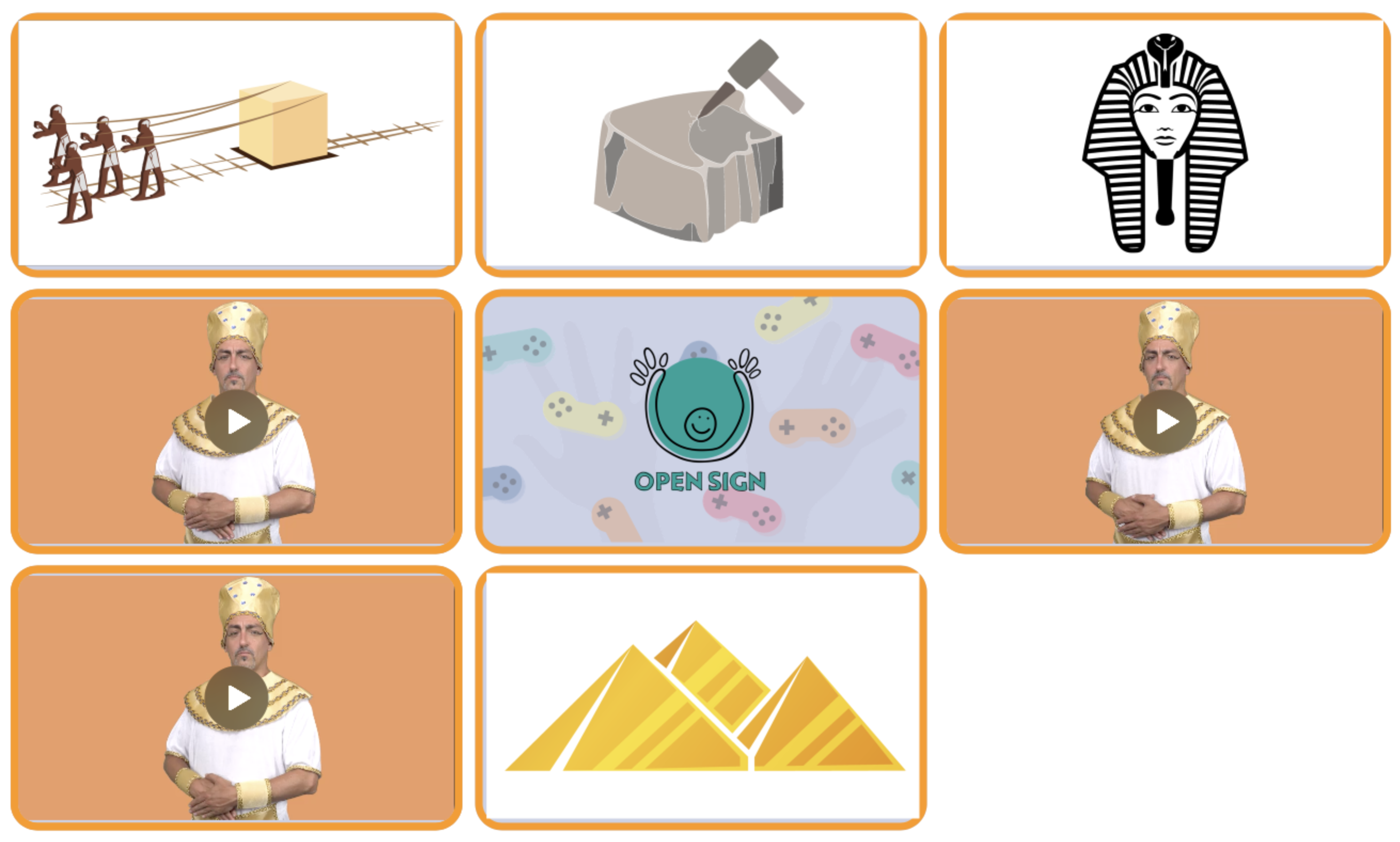
Tick the box if you have succeeded on the first try or note the number of tries.

- Extend / Enrichment / Prolongation Web links with others digital tools :
- Ancient Egypt: http://www.opensign.eu/thematic_topics/57
- The Egyptian Era : http://opensign.eu/memory_game/55
- Wheels in Egypt : http://opensign.eu/multiplechoice/60
- The Pyramid Blocks: http://www.opensign.eu/sequence/61
- DIY Open Sign: http://www.opensign.eu/manual_activities_videos

