You can create your own resources, videos and games at:

http://www.opensign.eu

Thematic Video : Recycling 1: What is Waste?
Age: 8-12 years
Creators: Media’Pi France
Watch our Thematic Topics at:
http://opensign.eu/thematic_topics/89 and http://opensign.eu/thematic_topics/88

Competences :
- Understand the concept of waste and the impact of waste on the environment and health.
- Give examples of pollution

- Adopt a critical attitude towards consumption
European Key Competences :
https://eur-lex.europa.eu/legal-content/EN/TXT/?uri=uriserv%3AOJ.C_.2018.189.01.0001.01.ENG&toc=OJ%3AC%3A2018%3A189%3ATOC

Formative evaluation:
- Explain what is waste
- Tell the difference between objects and waste
- Explain the consequences of discharging waste into nature
- Give examples of how waste is accumulated and it’s consequences
- Explain the harmful nature of waste and its link between nature, food and health.

Summative evaluation:
- Define the concept of waste and how to analyse one’s own waste

Specific vocabulary and keywords:
Waste, rubbish, bottles, per day, per year, per person, nature, toxic, dangerous

Lesson outline:
First, watch the video with pauses, ask questions about the sign language that is being used and pause to ask questions about vocabulary and concepts. Go back to the beginning of the video. Then, watch the video a second time without stopping.

Resources required : computer, video projector, examples of waste and packaging

Focus on sign language: Be careful to be precise about the names of materials and objects.

- Exercises, games and evaluation

1. Circle in red what can be put in the rubbish bin
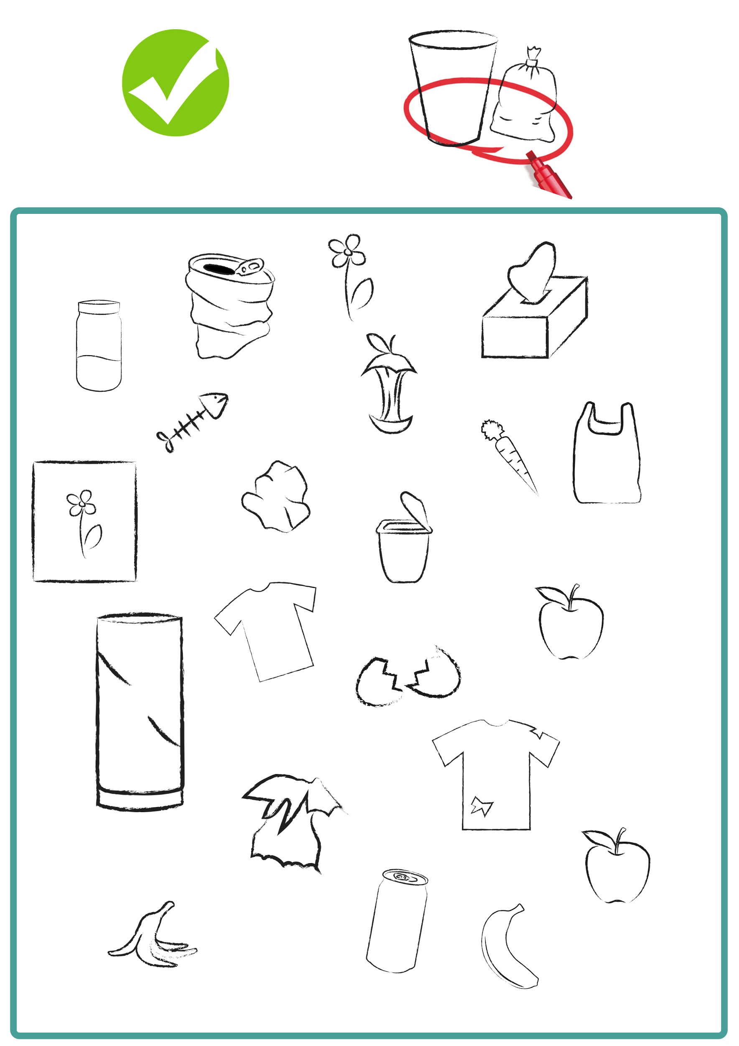

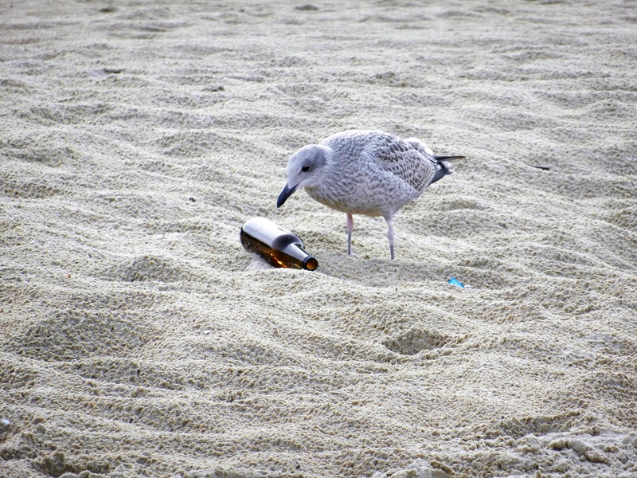
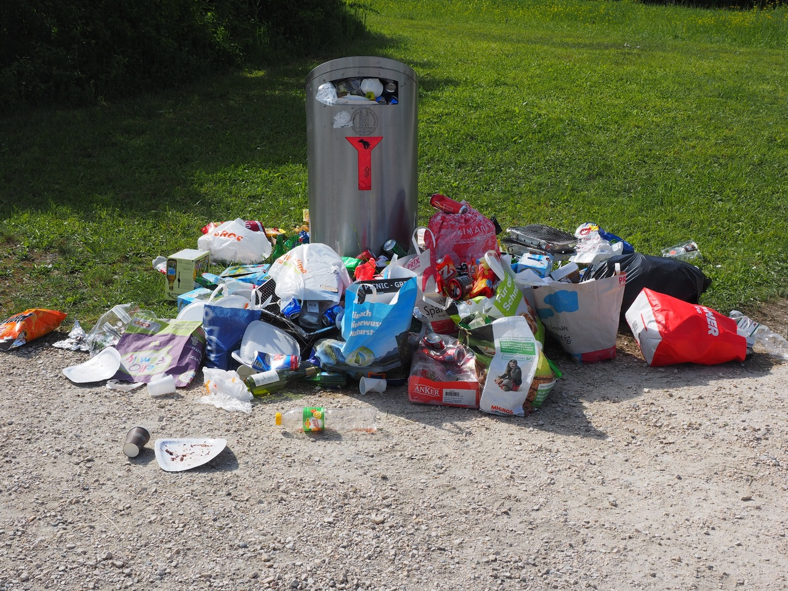
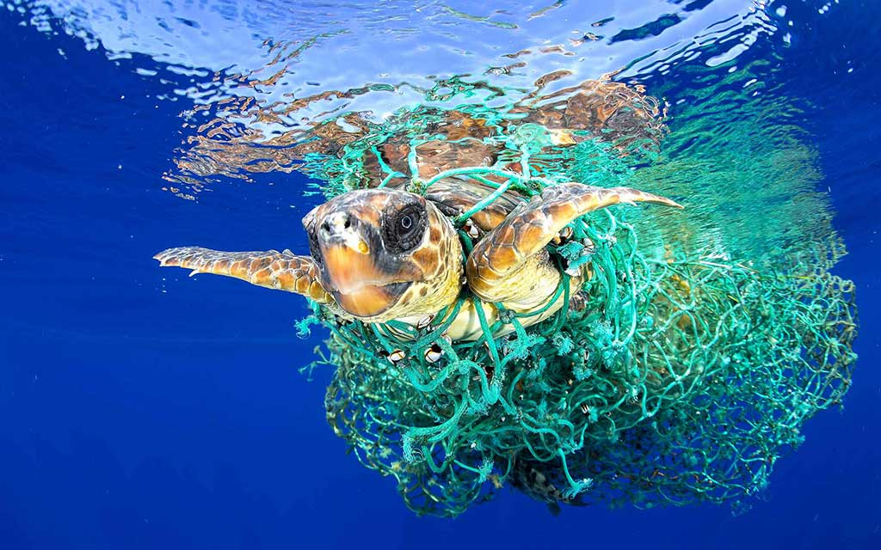
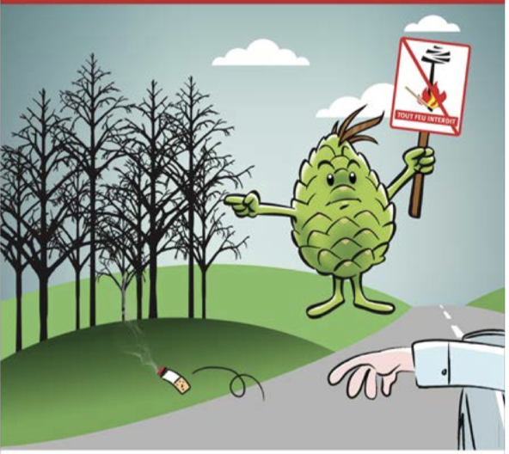
2. Why does this boy look worried?

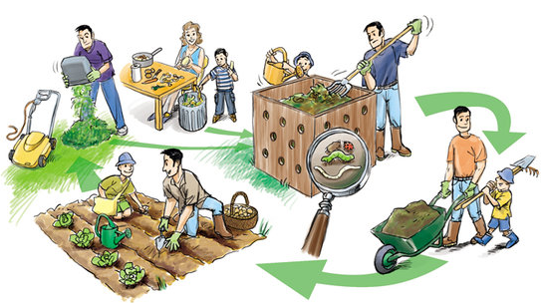
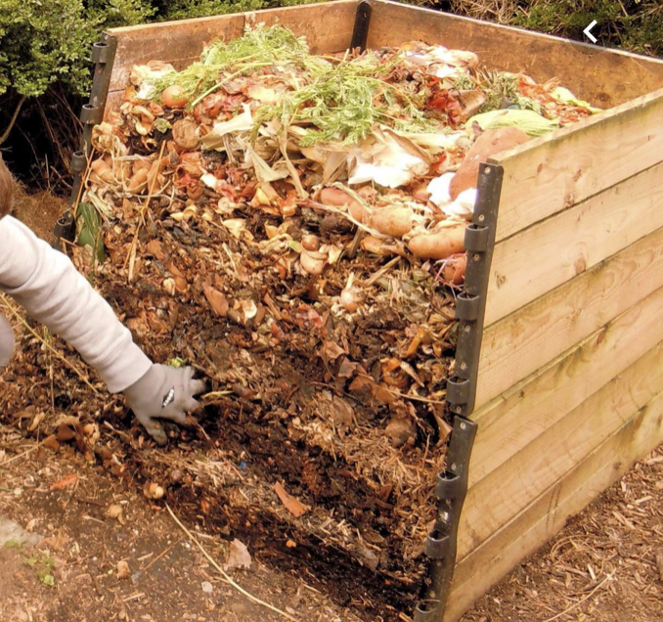
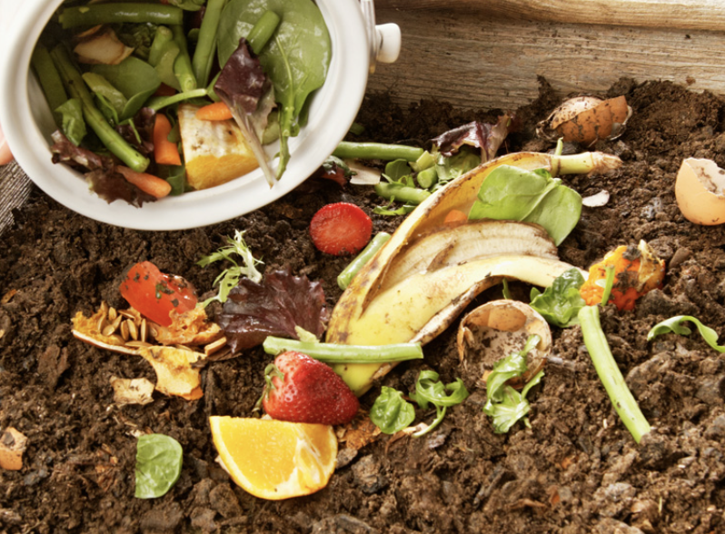
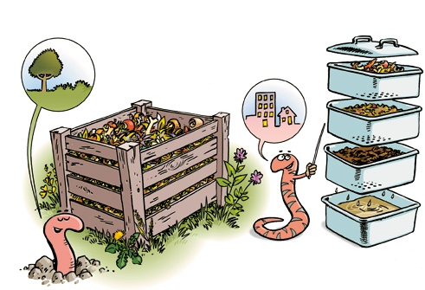
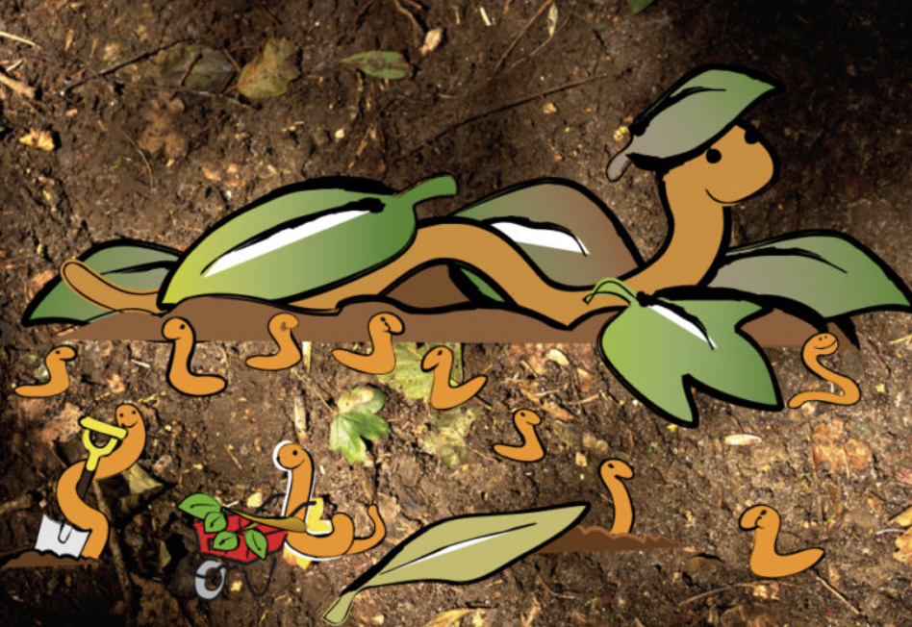
3. What is composting?

- Extend / Enrichment / Prolongation Web links with others digital tools:
1. How to keep plastics out of our ocean? / National Geographic
https://www.youtube.com/watch?v=HQTUWK7CM-Y

Ce projet n ° 2017-1-FR01-KA201-037433 a été financé avec le soutien de la Commission européenne. Cette publication n'engage que son auteur et la Commission ne peut être tenue responsable de l'usage qui pourrait être fait des informations qui y figurent.

