***PLANTING A TREE***

***Age category:***  ***6 – 12 years***

***Authors: IOANA-LETITIA SERBAN***

***Competences***

* ***The students will make the difference between types of trees***
* ***The students will learn the steps of planting a tree***
* ***The students will learn to appreciate nature, the ecological spirit and outdoor activities***

***Competences according to European curriculum:***

[***http://eur-lex.europa.eu/legal-content/EN/TXT/?uri=LEGISSUM%3Ac11090***](http://eur-lex.europa.eu/legal-content/EN/TXT/?uri=LEGISSUM%3Ac11090)

***Formative assessment:***

* ***Explaining the steps of planting a tree.***
* ***Identifying materials and instruments necessary for plantation.***
* ***Enriching the knowledge concerning ecological activities and nature preservation.***

***Summative Assessment:***

* ***Planting a baby tree with handy instruments and materials.***

***Specific vocabulary list/Keywords:***

* ***Tree, nature, growing, planting, soil.***

***Short description of the educational context/scenario:***

* ***The teacher and the students talk about the need to plant trees and their role in the production of oxygen. The baby tree is presented in comparison with a full-grown tree in the school garden. The next step shows the instruments necessary for the plantation of the baby tree. The video then continues with the use of each instrument for the plantation of the baby tree. The teacher will give the educational sheet to the students after they have watched the video. The teacher supervises and guides the students.***

***Materials needed/Technical requirements:***

* ***Baby tree, water, gardening tools.***

***Focus on sign language:***

* ***Sign the new vocabulary, sign the instruments needed to plant the baby tree, sign the steps of the activities.***

1. **Circle only the pine trees:**

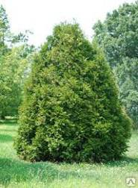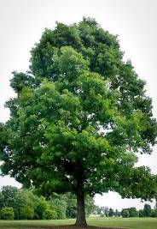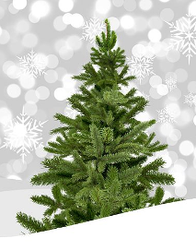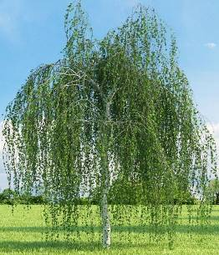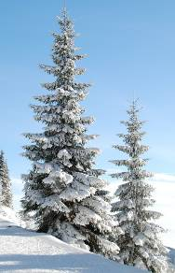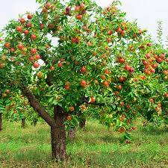

1. **Draw your favourite tree in the frame below.**

|  |
| --- |
|  |

1. **Colour only the leaves of the tree below:**

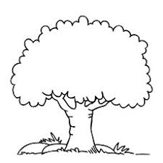

1. **Colour only the tree which has roots from the pictures below.**

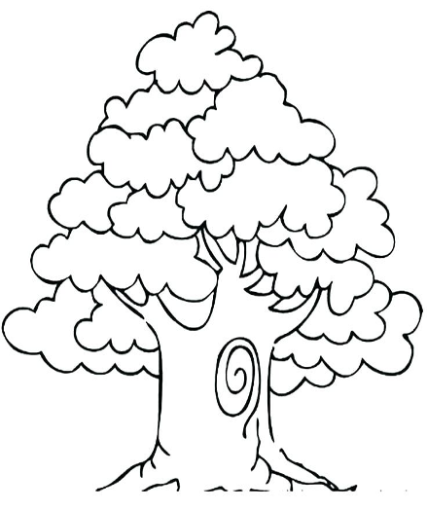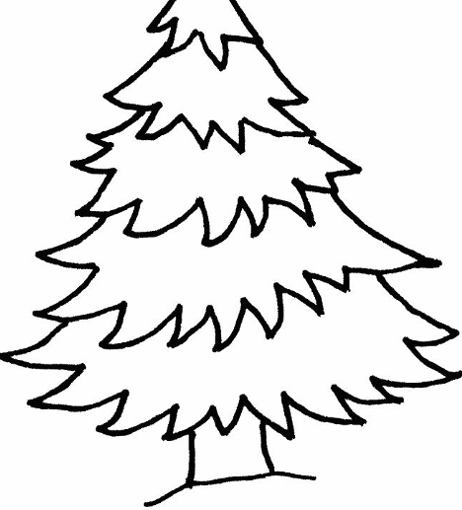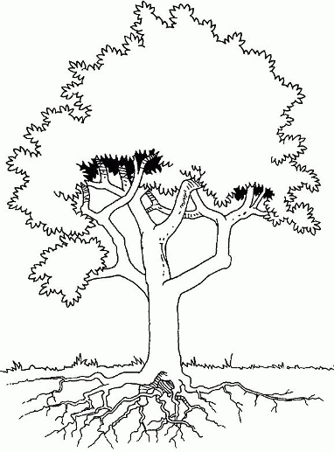

1. **Select only the gardening instruments.**

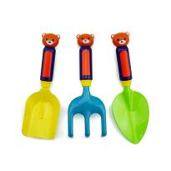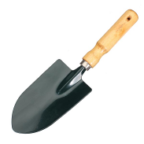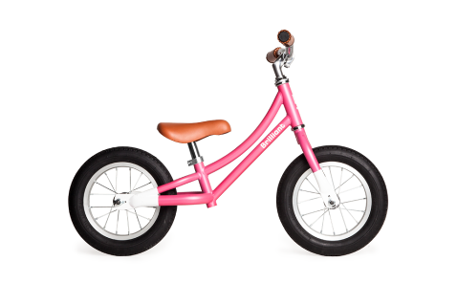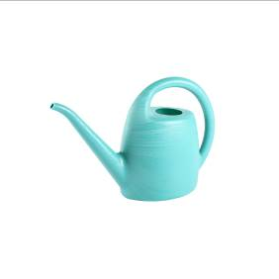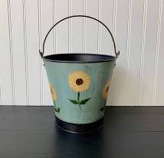

1. **Watch the video and then put the images in the right order:**



**1, 2, 3 ….**

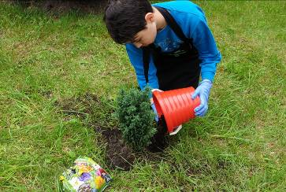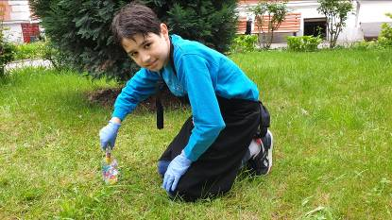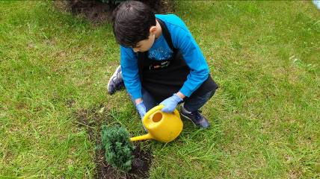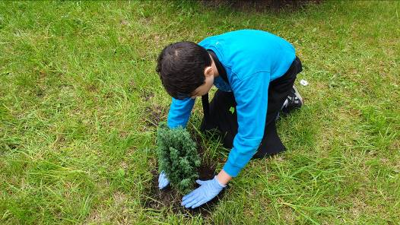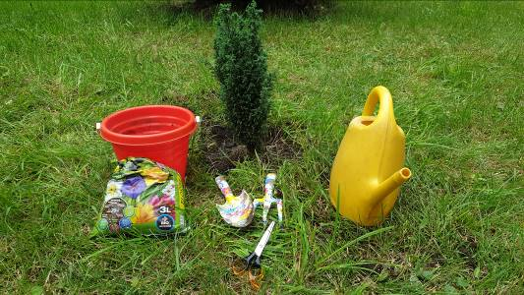

1. **Sign the following images:**

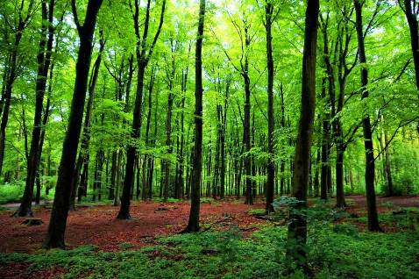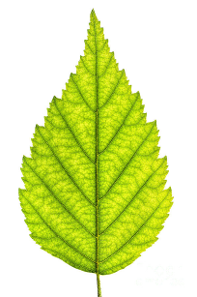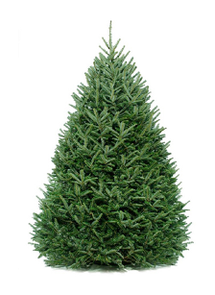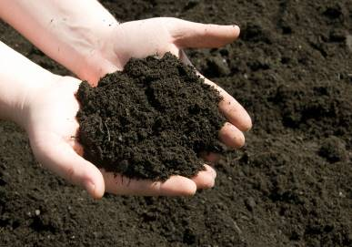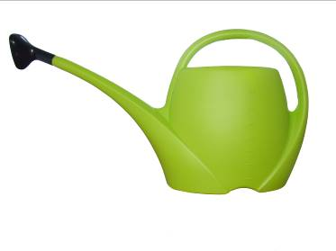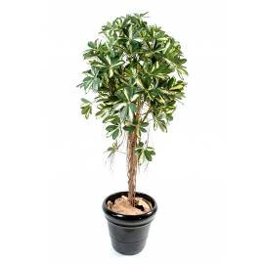

1. **Watch the video again and then explain to a colleague, using sign language, what you need in order to plant a tree.**
2. **Sign the main components of a tree. Use the following picture to show your components to the class.**

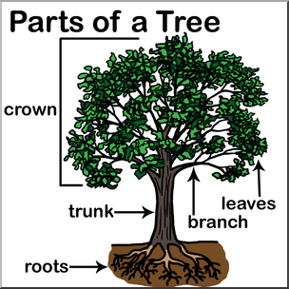

**Extend / Enrichment / Prolongations Web links with others digital tools:**

**1.** [**www.freepik.com**](http://www.freepik.com)

**2.** [**www.pixabay.com**](http://www.pixabay.com)

**3.** [**www.pdclipart.org**](http://www.pdclipart.org)