You can create your own resources, videos and games at:

http://www.opensign.eu

GAME : Eating Sugar

Age: 7 to 12 years
Creator : Média’Pi

Competences :
- Know the difference between natural and artificial sugar and their effects on the body

- To learn about preferring natural sugar without excess

- Take the time to listen to the 3 answers and choose your answer wisely

European Competences
https://eur-lex.europa.eu/legal-content/EN/TXT/?uri=uriserv%3AOJ.C_.2018.189.01.0001.01.ENG&toc=OJ%3AC%3A2018%3A189%3ATOC

Specific vocabulary / keywords :
Natural sugar, artificial sugar

Lesson outline
After viewing the video « Sugar » at http://opensign.eu/thematic_topics/56,
playing this game will allow an evaluation of comprehension of the video :
http://www.open-sign.eu/multiplechoice/62

Resources:
A computer and an internet connection.
Focus on sign language:
Do not hesitate to ask the player to replay the question and answers , reformulating them in the sign language of the country. You can ask the player about his or her choice.

Ce projet n ° 2017-1-FR01-KA201-037433 a été financé avec le soutien de la Commission européenne. Cette publication n'engage que son auteur et la Commission ne peut être tenue responsable de l'usage qui pourrait être fait des informations qui y figurent.

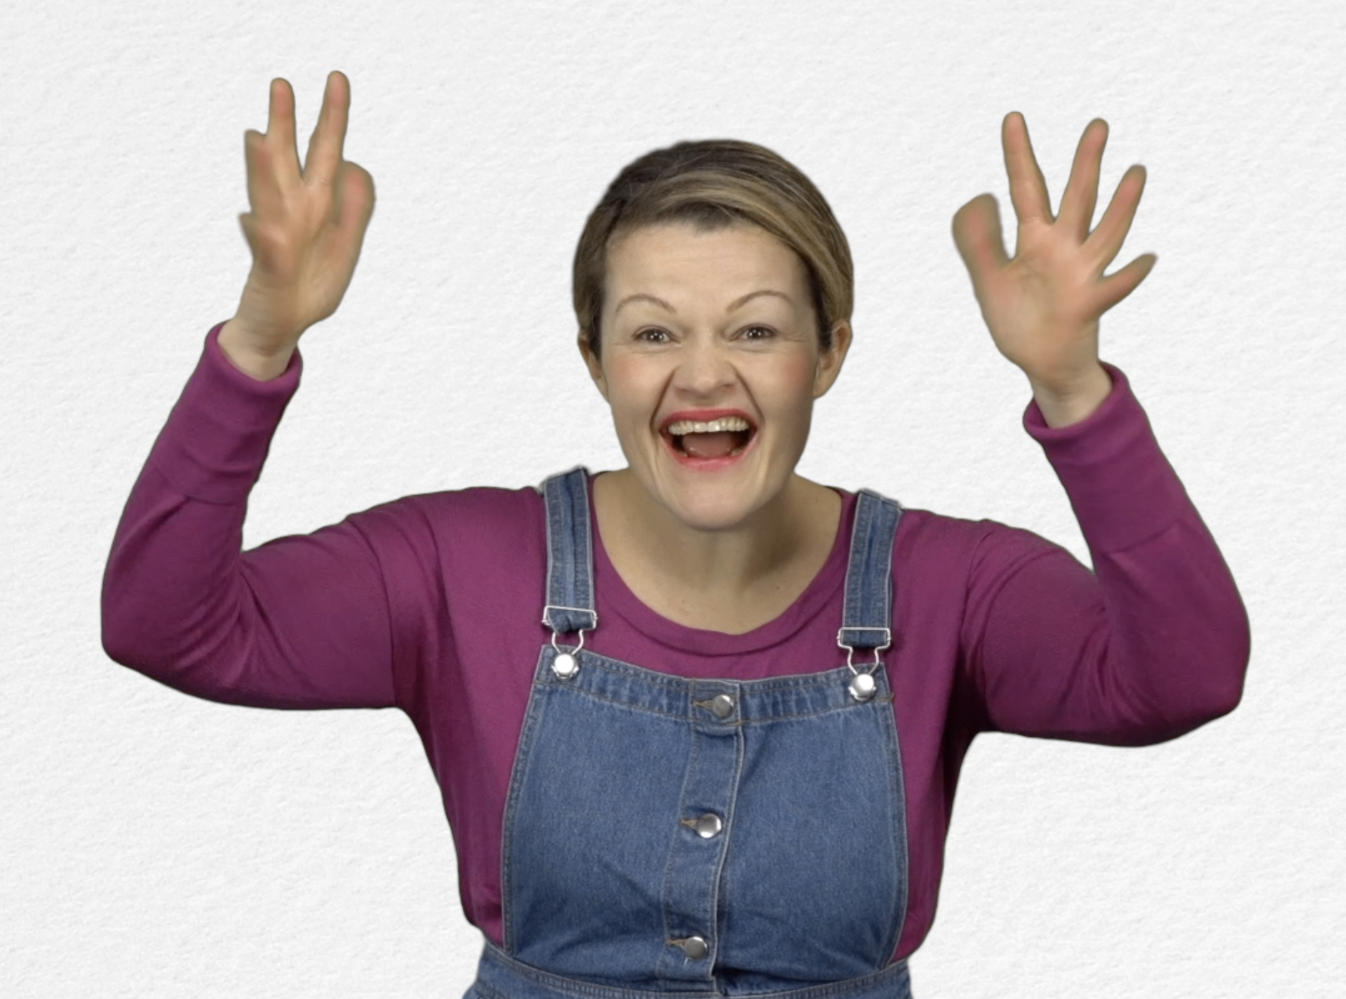
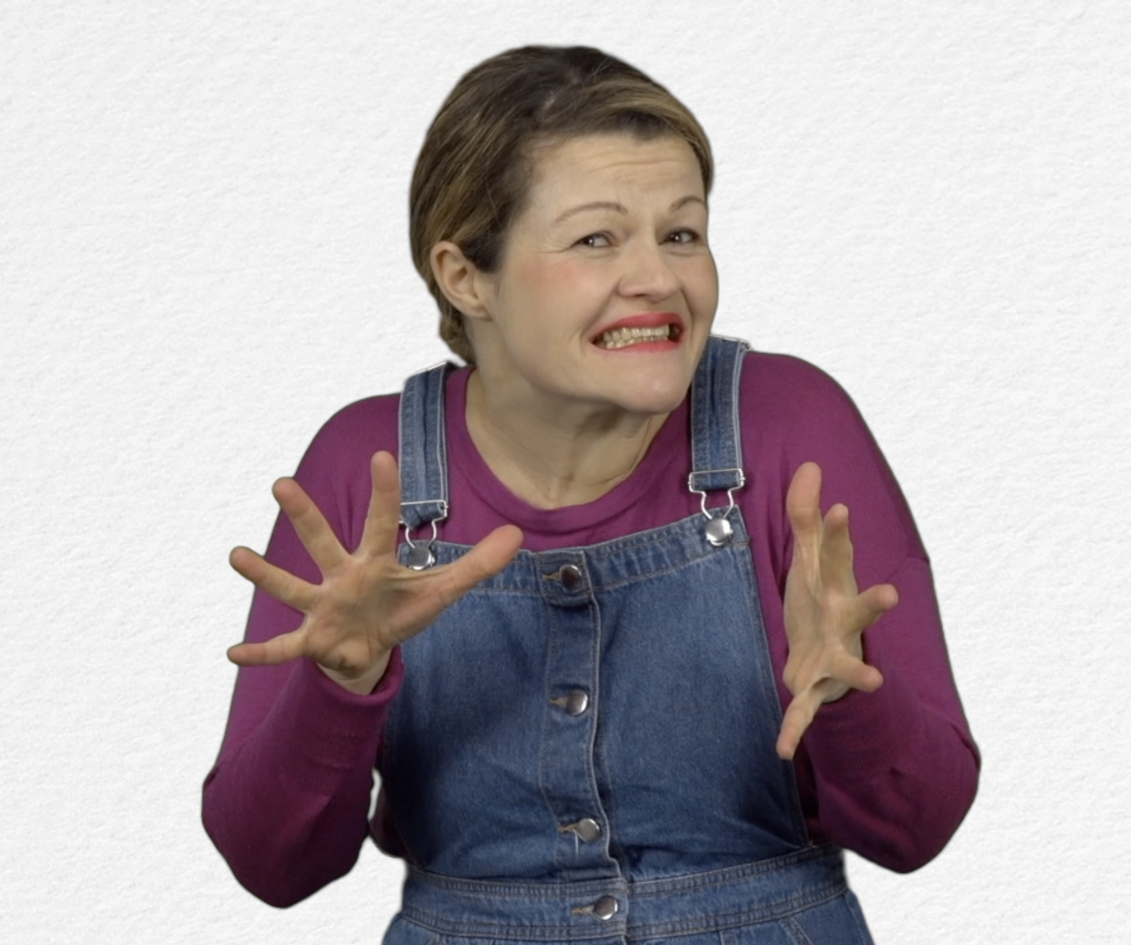
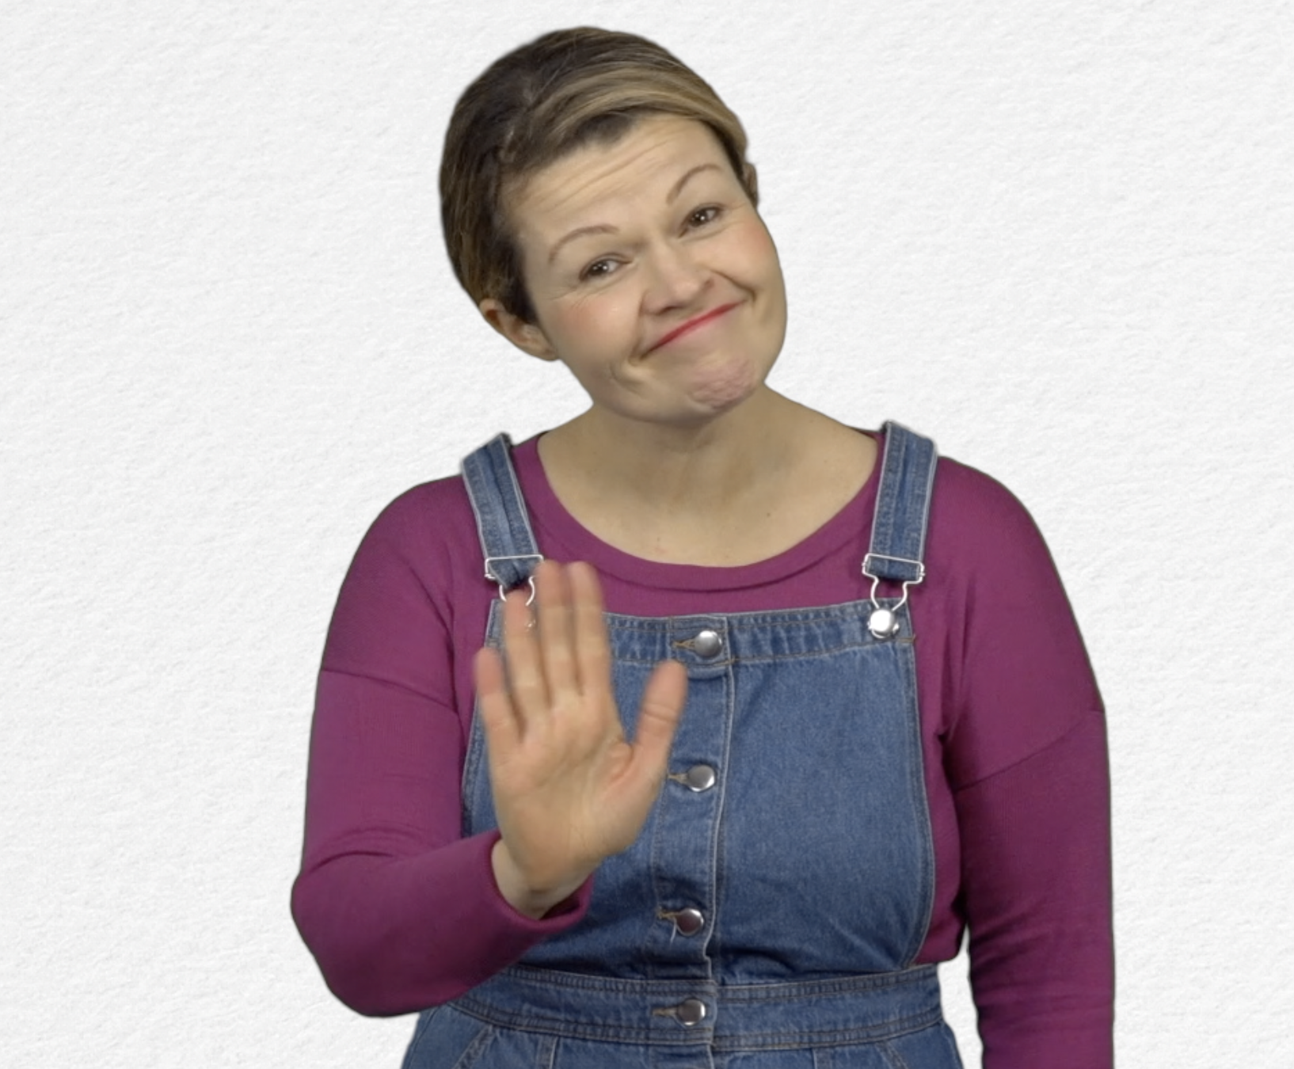
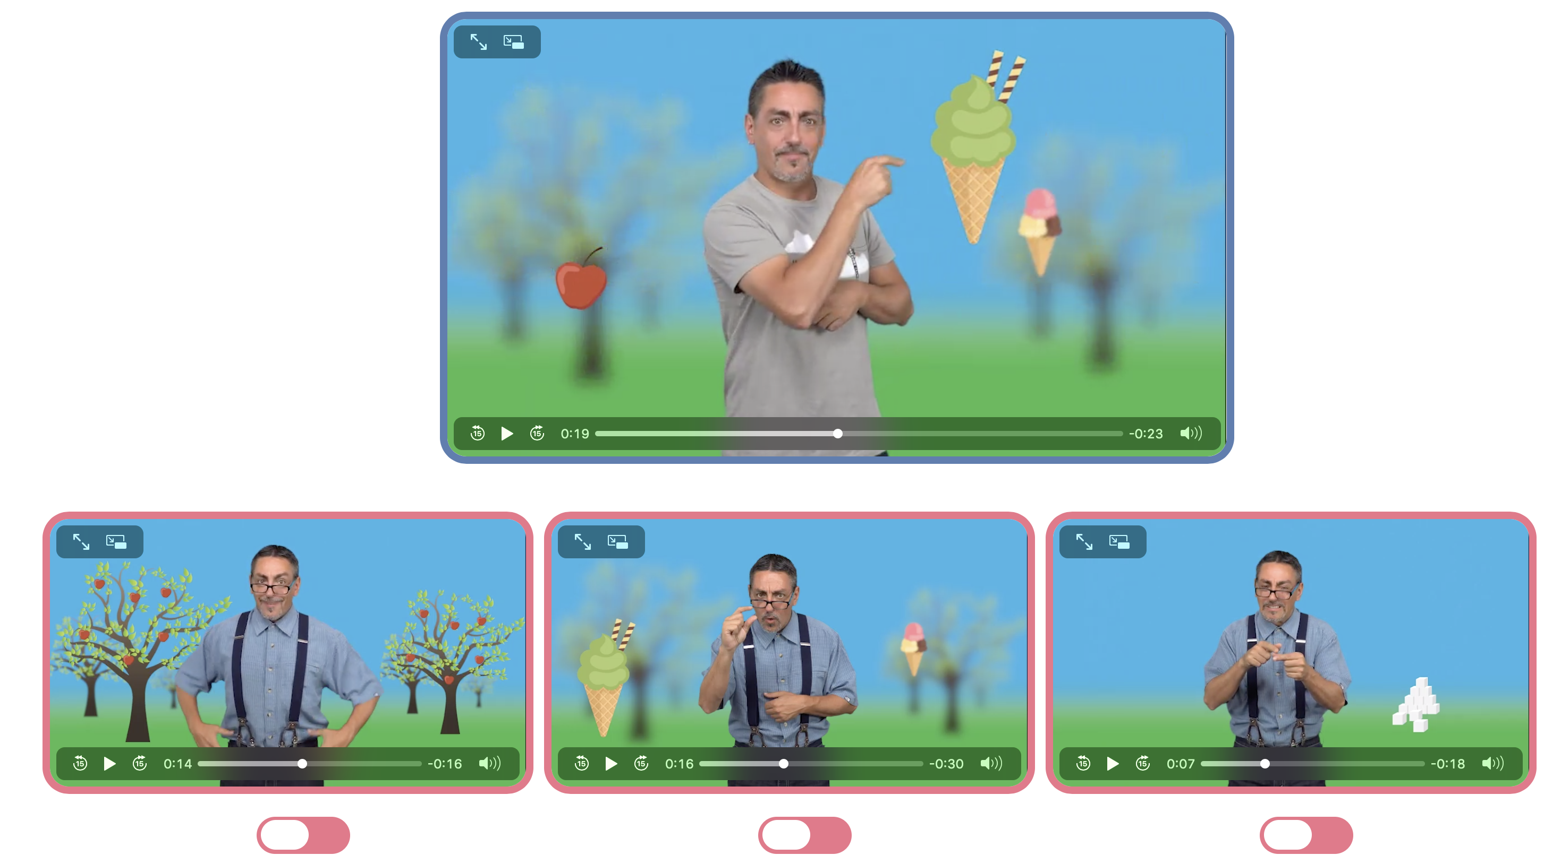
- Game : Eating Sugar: http://www.open-sign.eu/multiplechoice/62

What did you think of this game?

Note what you needed to do to complete the game.

- Extend / Enrichment / Prolongation Web links with other digital tools :

1. Thematic video : http://www.open-sign.eu/thematic_topics/56
2. Game: Energy Levels : http://www.open-sign.eu/multiplechoice/80
3. Memory Game : Hidden Sugar (Level 1) http://www.opensign.eu/memory_game/78

