GAME : Sugar levels (Level 1)

Age: 7 to 12 years
Creator : Média’Pi

Competences :
- Make a link between two elements: food and the amount of sugar contained within the food.

- Remember the place of the cards and develop a strategy to select the cards
effectively

- Be patient and persistent

European Competences
https://eur-lex.europa.eu/legal-content/EN/TXT/?uri=uriserv%3AOJ.C_.2018.189.01.0001.01.ENG&toc=OJ%3AC%3A2018%3A189%3ATOC

Specific vocabulary / keywords : cubes of sugar, orange juice, banana, daily limits, double

Lesson outline:
After viewing the video « Sugar » at http://opensign.eu/thematic_topics/56,
playing this game will allow an evaluation of comprehension of the video :
http://www.opensign.eu/memory_game/78

Resources:
A computer and an internet connection.
Focus on sign language:
Be able to question the relationship between the quantity of food and the quantity of hidden sugar in them.

Ce projet n ° 2017-1-FR01-KA201-037433 a été financé avec le soutien de la Commission européenne. Cette publication n'engage que son auteur et la Commission ne peut être tenue responsable de l'usage qui pourrait être fait des informations qui y figurent.

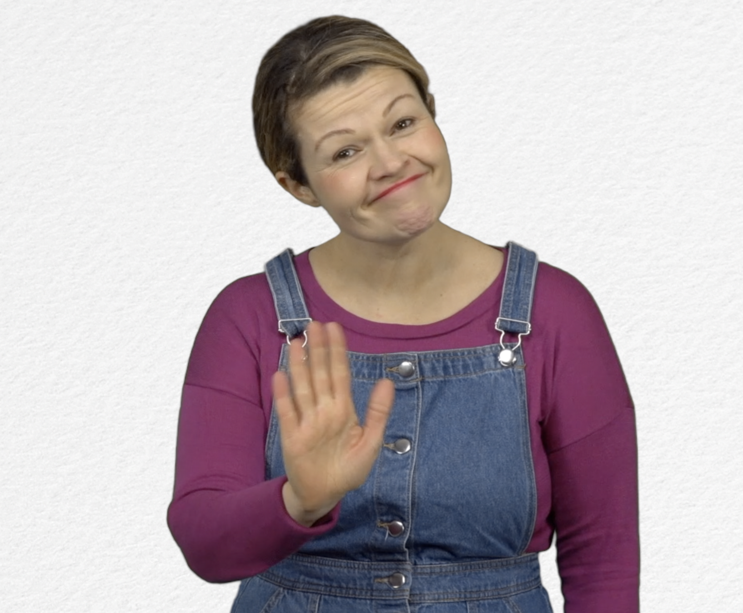
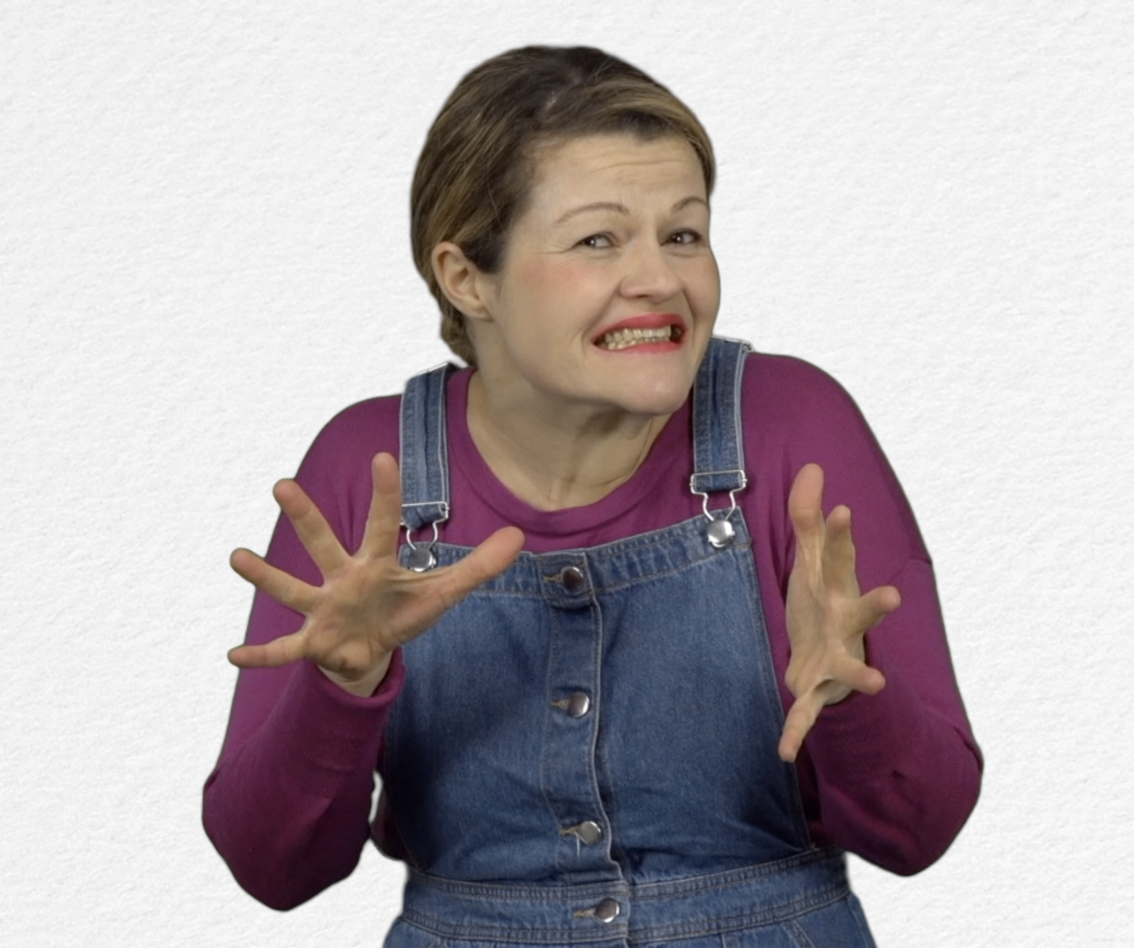
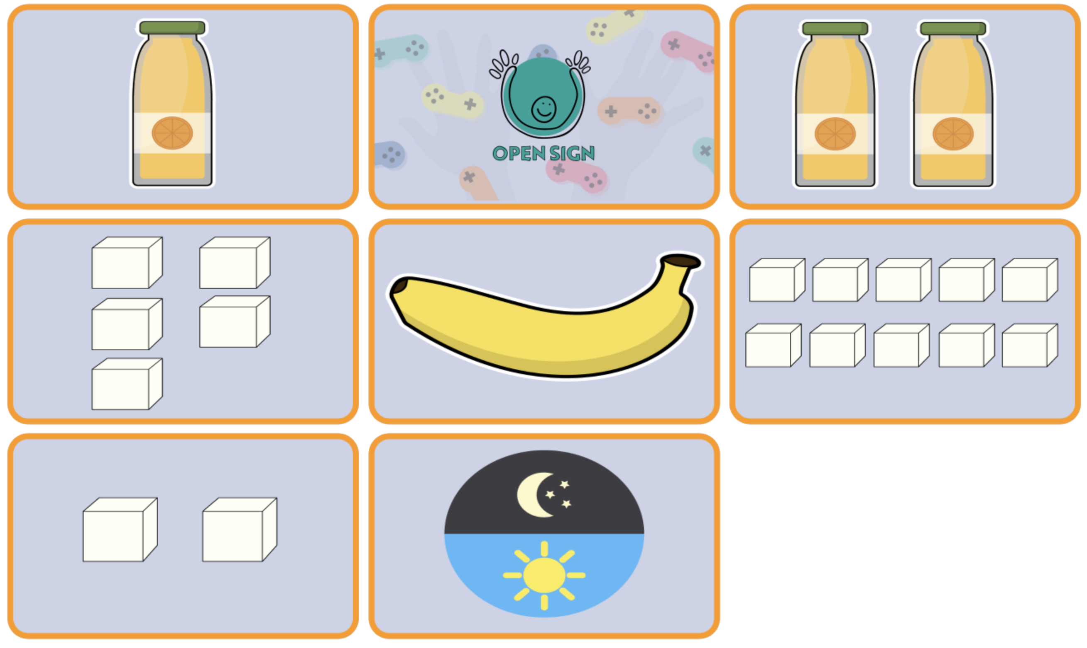
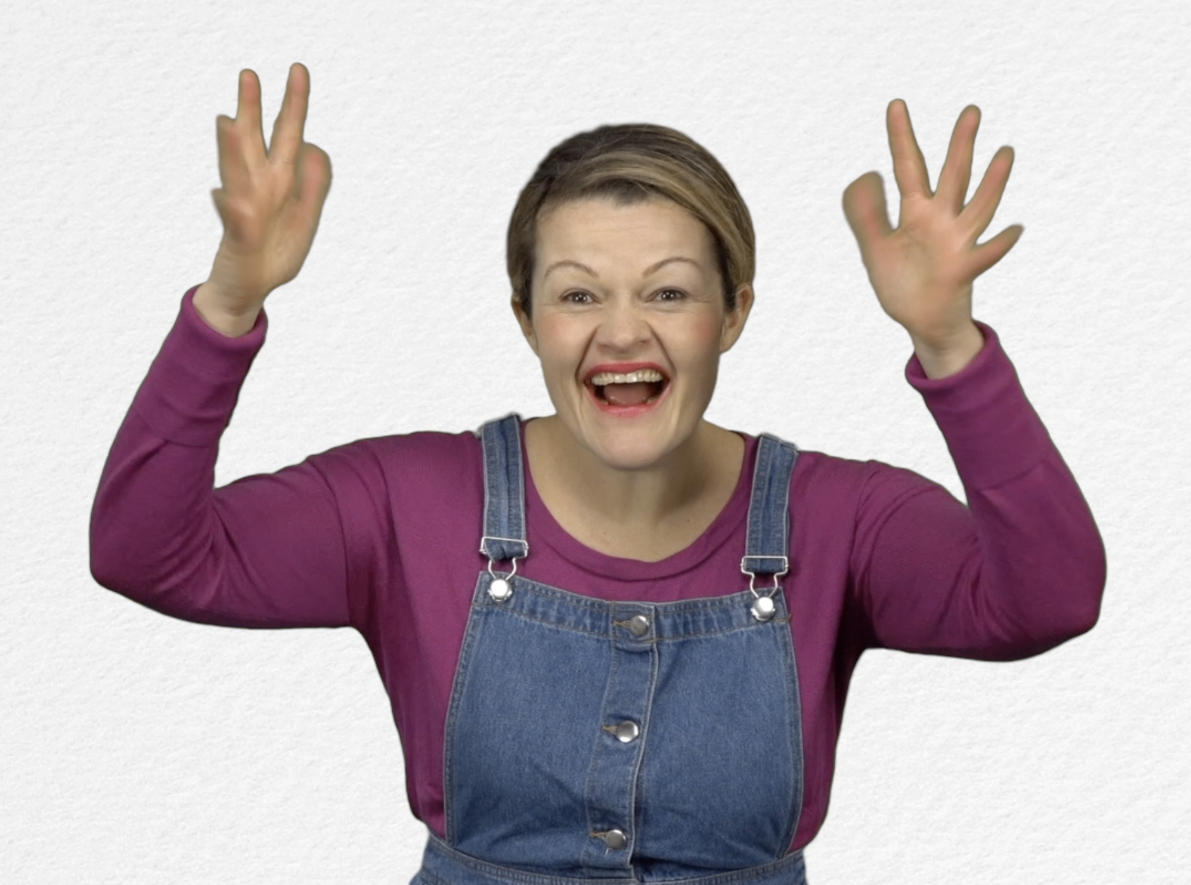
- GAME : Sugar levels: http://www.opensign.eu/memory_game/78
What did you think of this game?
Note what you needed to do to complete the game.

- Extend / Enrichment / Prolongation Web links with other digital tools :

1. Thematic video : http://www.open-sign.eu/thematic_topics/56
- Memory Game : Hidden Sugar (Level 2): http://www.open-sign.eu/memory_game/79
- Game : Energy Levels : http://www.open-sign.eu/multiplechoice/80
- Game: Eating Sugar: http://www.open-sign.eu/multiplechoice/62

