You can create your own resources, videos and games at:

http://www.opensign.eu

GAME: Sugar Levels (Level 2)

Age: 8 to 12 years
Creator : Média’Pi

Competences :
- Make a link between two elements: food and the amount of sugar contained within the food.

- Remember the place of the cards and develop a strategy to select the cards
effectively

- Be patient and persistent

European Competences
https://eur-lex.europa.eu/legal-content/EN/TXT/?uri=uriserv%3AOJ.C_.2018.189.01.0001.01.ENG&toc=OJ%3AC%3A2018%3A189%3ATOC

Specific vocabulary / keywords : cubes of sugar, water, soda, tomato sauce, icecream

Lesson outline
After viewing the video « Sugar » at http://opensign.eu/thematic_topics/56,
playing this game will allow an evaluation of comprehension of the video :
http://www.open-sign.eu/memory_game/79

Resources:
A computer and an internet connection.
Focus on sign language:
Be able to question the relationship between the quantity of food and the quantity of hidden sugar in them.

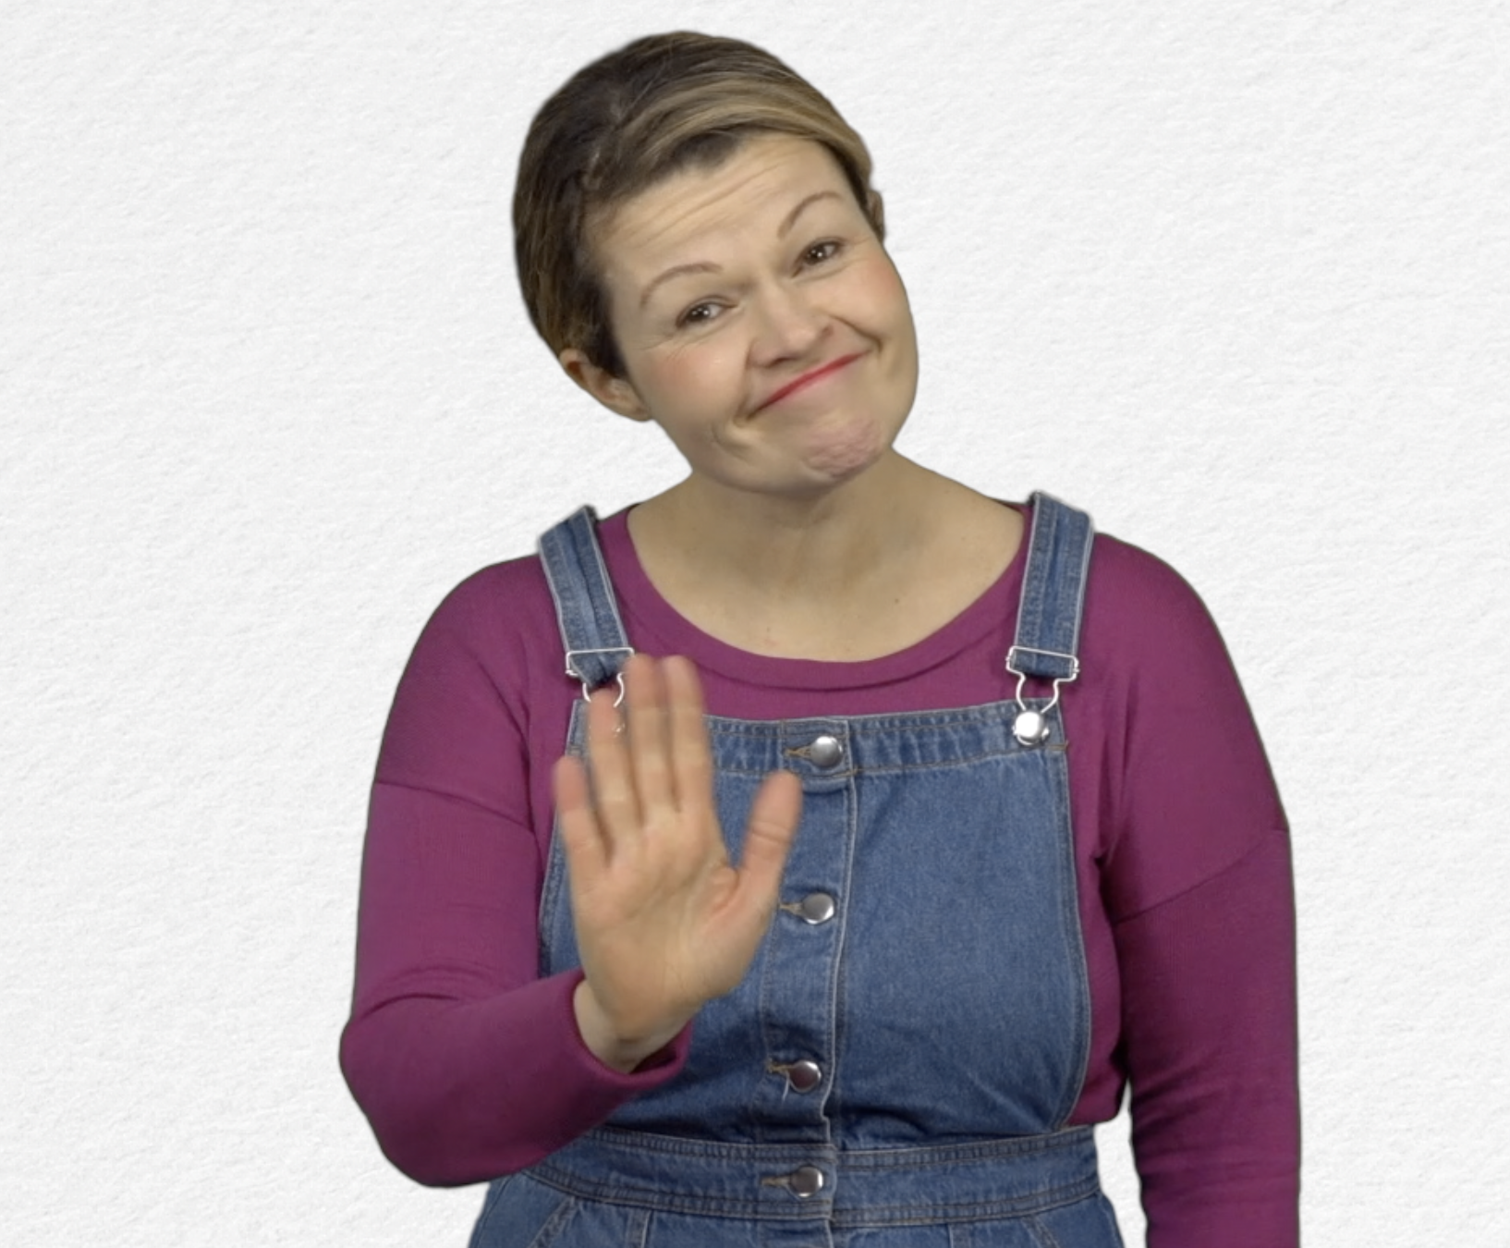
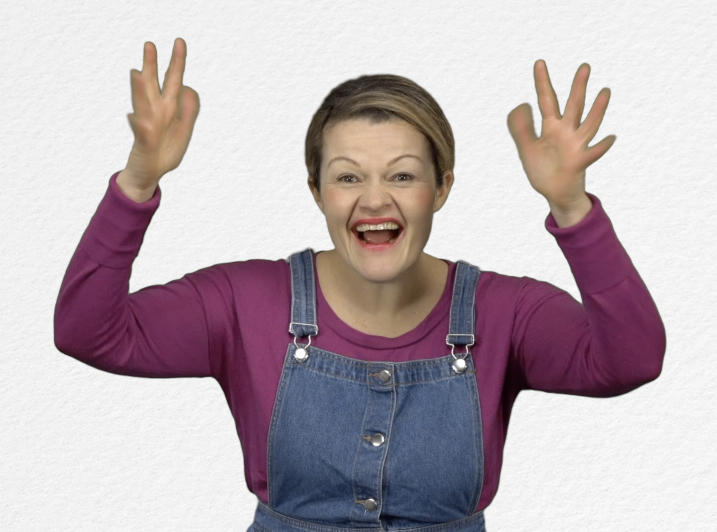
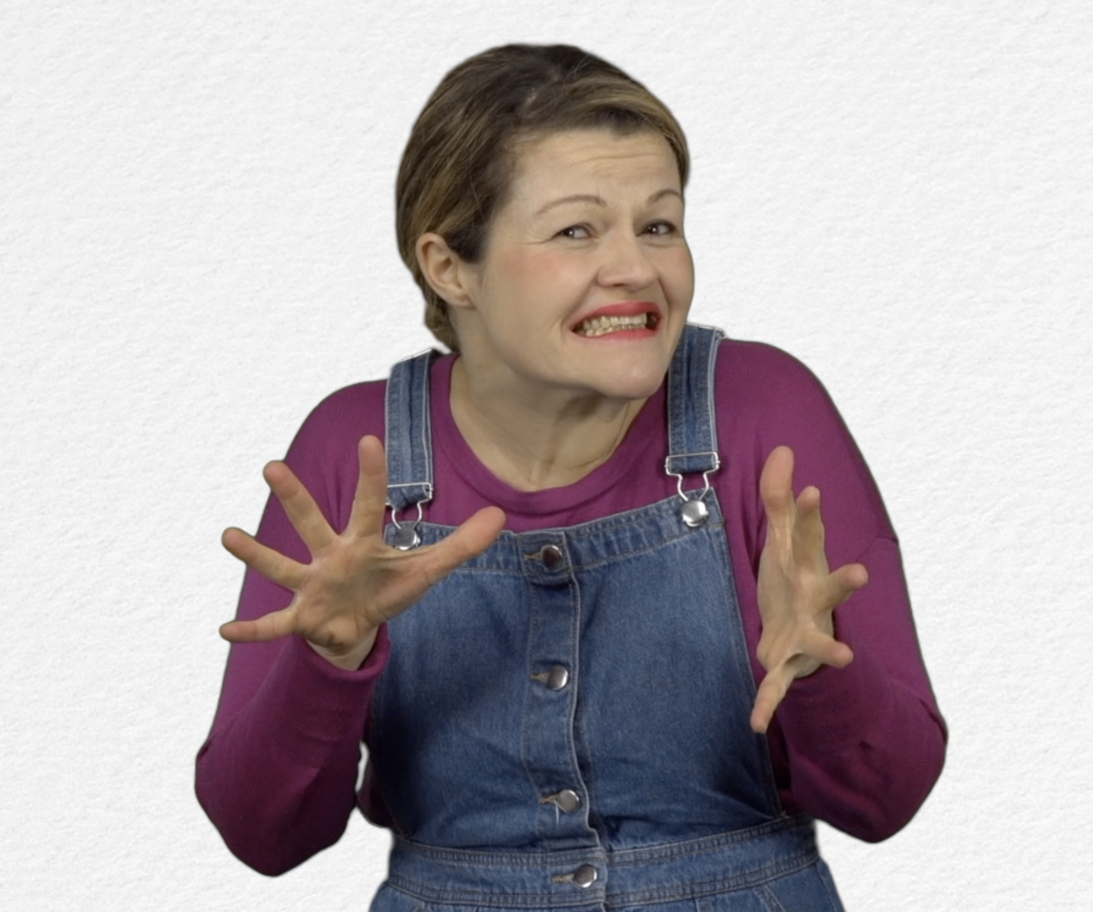
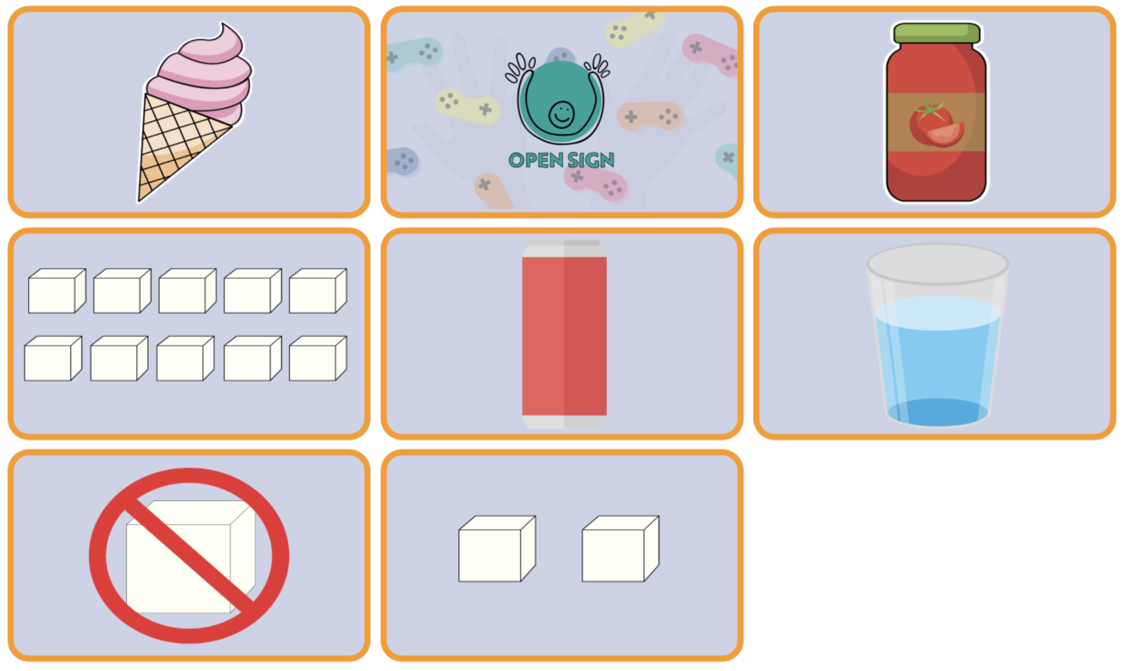
- GAME: Sugar Levels JEU : http://www.open-sign.eu/memory_game/79

- Extend / Enrichment / Prolongation Web links with other digital tools :

- Thematic video : http://www.open-sign.eu/thematic_topics/56
- Game: Eating Sugar: http://www.open-sign.eu/multiplechoice/62
2. Game : Energy Levels : http://www.open-sign.eu/multiplechoice/80
3.

