You can create your own resources, videos and games at:

http://www.opensign.eu

GAME: Stop the stress !

Age: 7 to 12 years
Creator : Média’Pi

Competences :
- To understand that you have the power not to suffer under the negative impact of your emotions

- Follow the logical, chronological order of the situation

- Identifying logical cues to the discourse

European Competences
https://eur-lex.europa.eu/legal-content/EN/TXT/?uri=uriserv%3AOJ.C_.2018.189.01.0001.01.ENG&toc=OJ%3AC%3A2018%3A189%3ATOC

Specific vocabulary / keywords :
Stress, fear, sadness, emotions, managing stress. suffering, refusal and control.

Lesson outline:
After viewing and sharing the « How to manage your emotions » video at:
http://opensign.eu/thematic_topics/59
This game will allow us to question our emotions. Can we manage our emotions? Play the game at: http://opensign.eu/sequence/82

Resources:
A computer and an internet connection.
Focus on sign language:
Identify the different emotions that overwhelm the person in the video. focus around the entire body postures for each emotion can help to apprehend the discovery of emotions.

Ce projet n ° 2017-1-FR01-KA201-037433 a été financé avec le soutien de la Commission européenne. Cette publication n'engage que son auteur et la Commission ne peut être tenue responsable de l'usage qui pourrait être fait des informations qui y figurent.

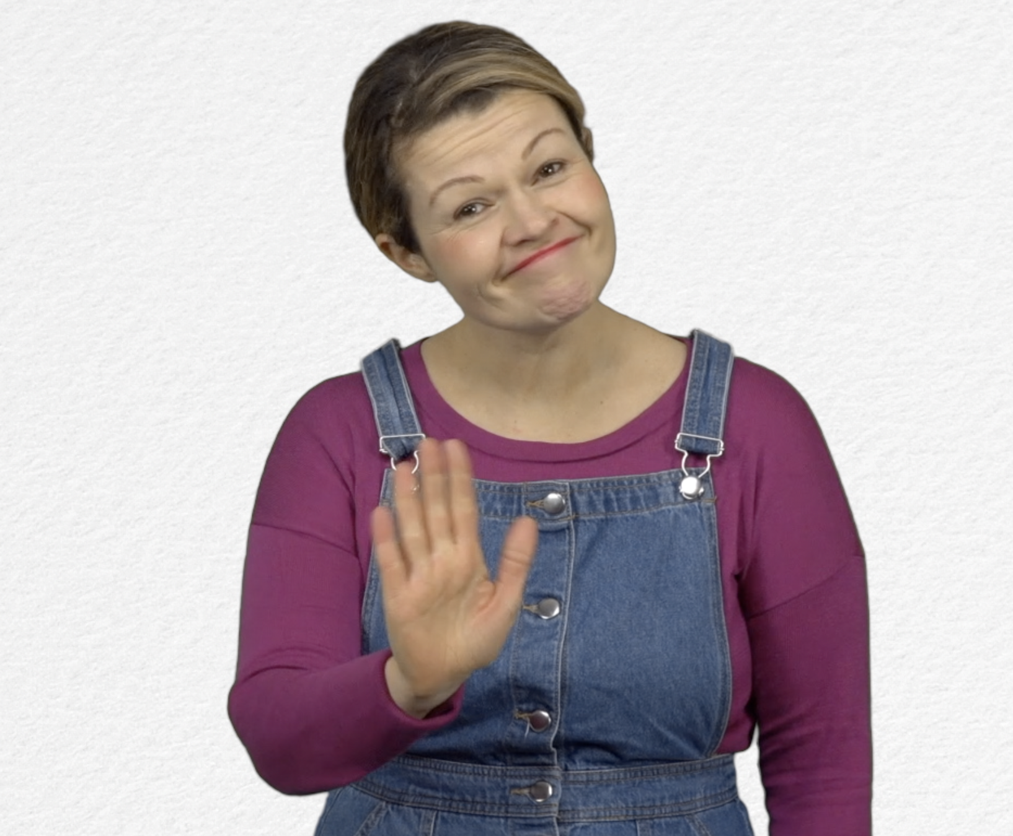
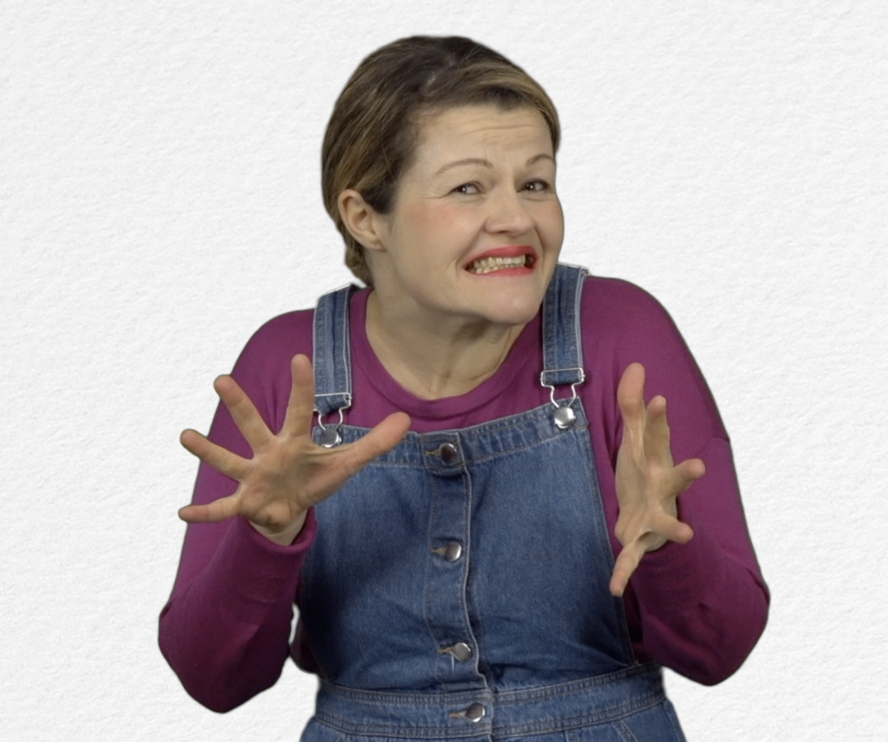
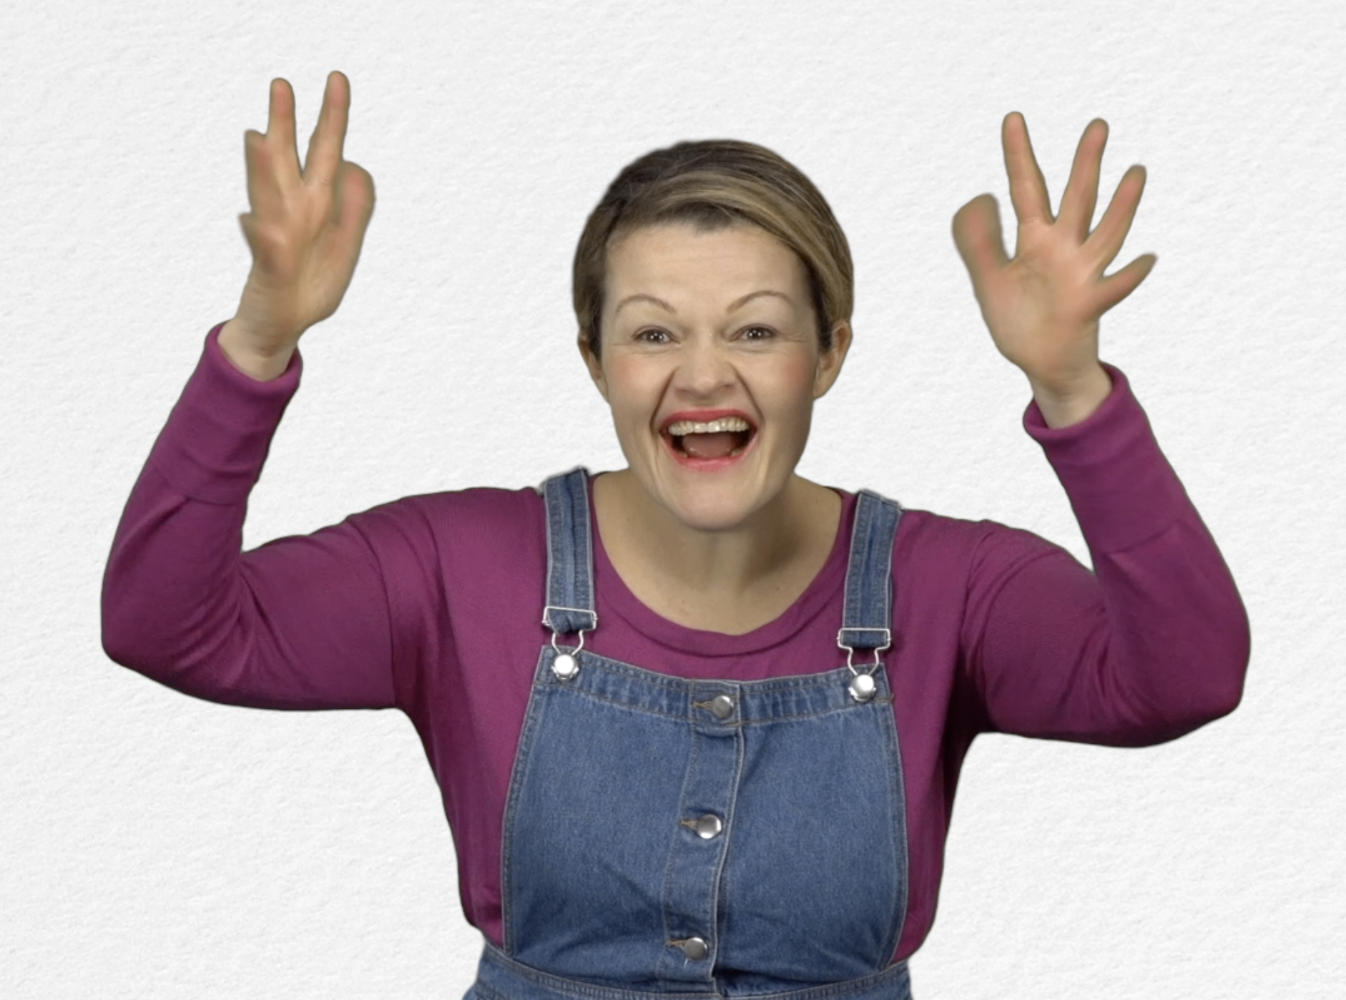
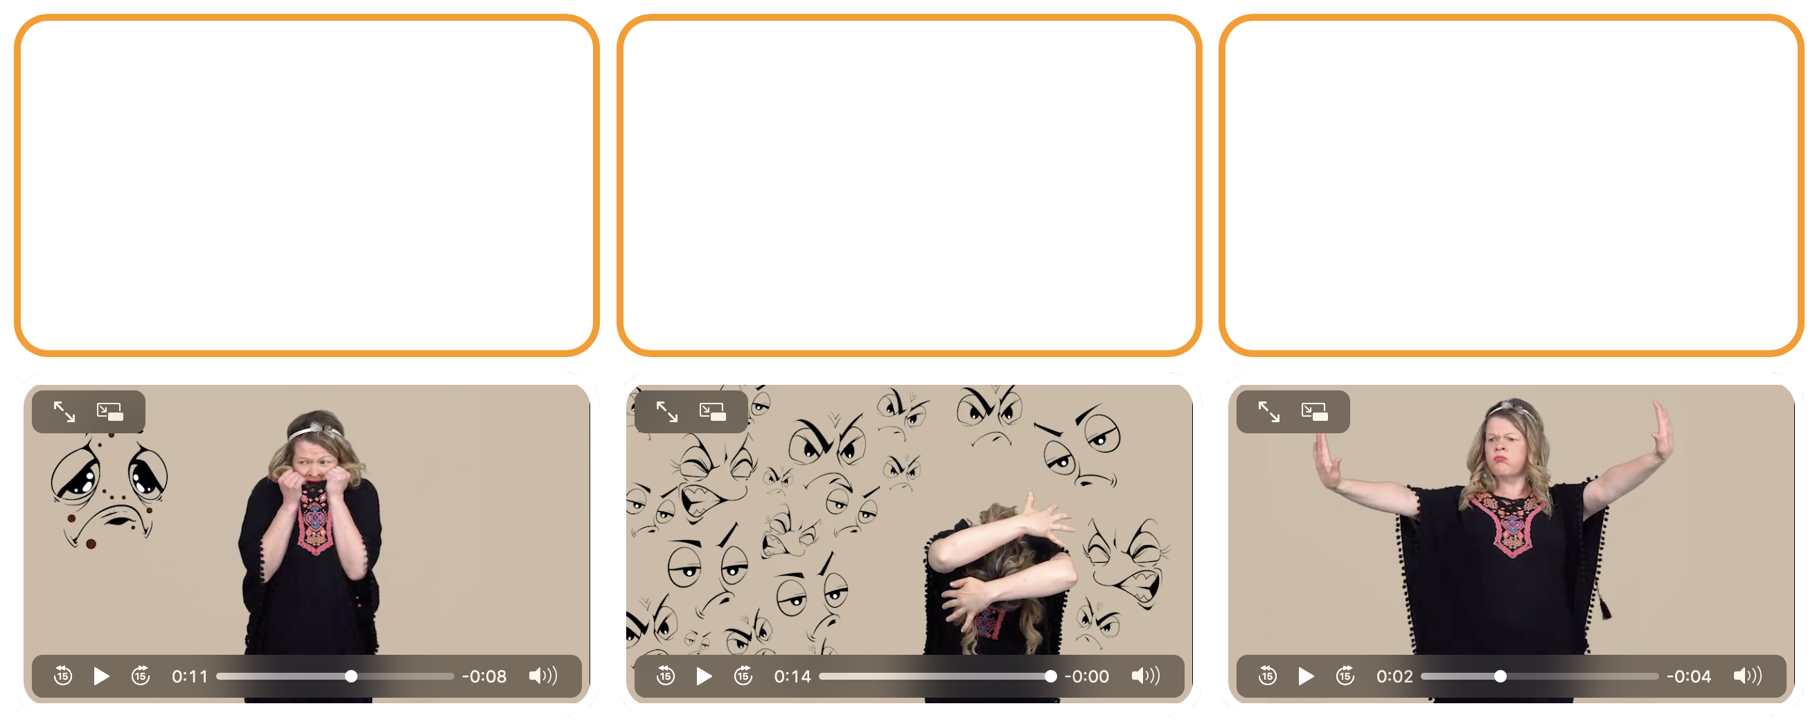
- GAME : Stop the stress ! http://opensign.eu/sequence/82
Tick the box if you have succeeded on the first try or note the number of tries.

- Extend / Enrichment / Prolongation Web links with other digital tools :

- Vidéo: « How to manage our Emotions » : http://opensign.eu/thematic_topics/59
- Game : Stop the stress ! : http://opensign.eu/sequence/82
- Game : Stress : http://opensign.eu/multiplechoice/81
- DIY Open sign: http://www.opensign.eu/manual_activities_videos
- Film Vice et versa : https://fr.wikipedia.org/wiki/Vice-versa_(film,_2015)

