You can create your own resources, videos and games at:

http://www.opensign.eu

Thematic Topic : Emotions
Age: 7 to 12 years
Creator: Média’Pi

Competences :
- Know different breathing techniques to regain calm.
- Identify emotions and practice breathing
- Listen to your body and practice standing still.

European Competences
https://eur-lex.europa.eu/legal-content/EN/TXT/?uri=uriserv%3AOJ.C_.2018.189.01.0001.01.ENG&toc=OJ%3AC%3A2018%3A189%3ATOC

Formative Evaluation :
- Mimic the different sensations felt after a moment of anger.
- Propose real life situations that can create emotions such as jealousy, sadness or joy
- Theatricalise these scenes.

Summative Evaluation:
- Present these techniques in tutoring to a younger child and guide him in his discovery.

Specific vocabulary / keywords:
Emotions: sadness, fear, anger, joy, stress. State: calm, calm, serene.
Breathing: inhale, exhale. Thoughts. Meditation
Lesson outline:
Dans un moment d’échange en cercle, échanger autour des différentes émotions travaillées préalablement: identifier des émotions et les opposer au calme: Exprimer le mal-être ou le déplaisir a vivre certains moments d’émotions.

Get in a circle and have an exchange about the different emotions stated above. Identify those emotions and their opposites calmly. Express the uncomfortableness or the displeasure of experiencing certain moments of emotion.

Watch the thematic video: How to deal with your emotions:
http://opensign.eu/thematic_topics/59
During the first broadcast: pause the video to have a discussion about the content and give the essential vocabulary.

For the physical poses in exercise 5: get the children face to face in pairs, a child can practise the exercise and the other child can watch their partner closely and count the number of
breaths. Then the children can change roles. Then the children can practise the poses by themselves.

Return into a circle to discuss well-being or the difficulties in practicing these exercises.

Resources required: A computer, an internet connection, a video projector, a mat, small cushions and blankets.

A focus on sign language: Practising mime and using the body permits us to visualise and revive certain emotions. Naming the emotions while being careful to give the notions of intensity in the signs is important.

- Vocabulary, exercises :

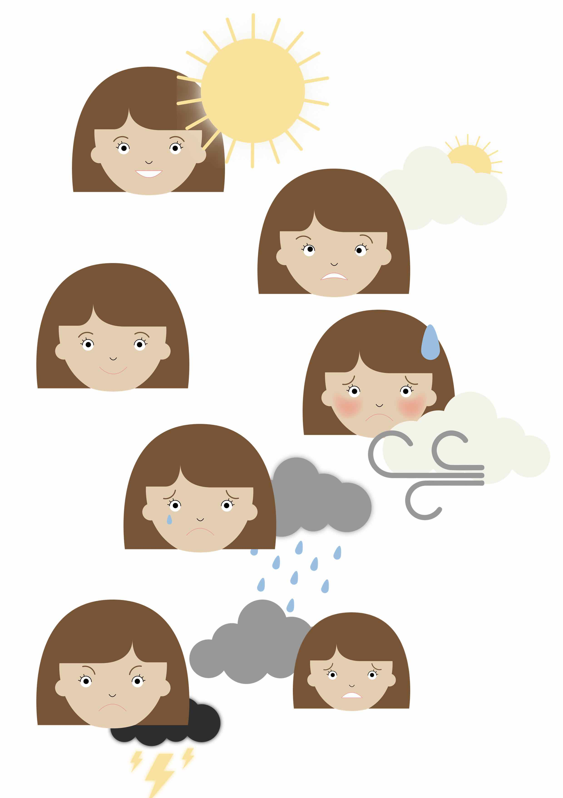
- My emotions :

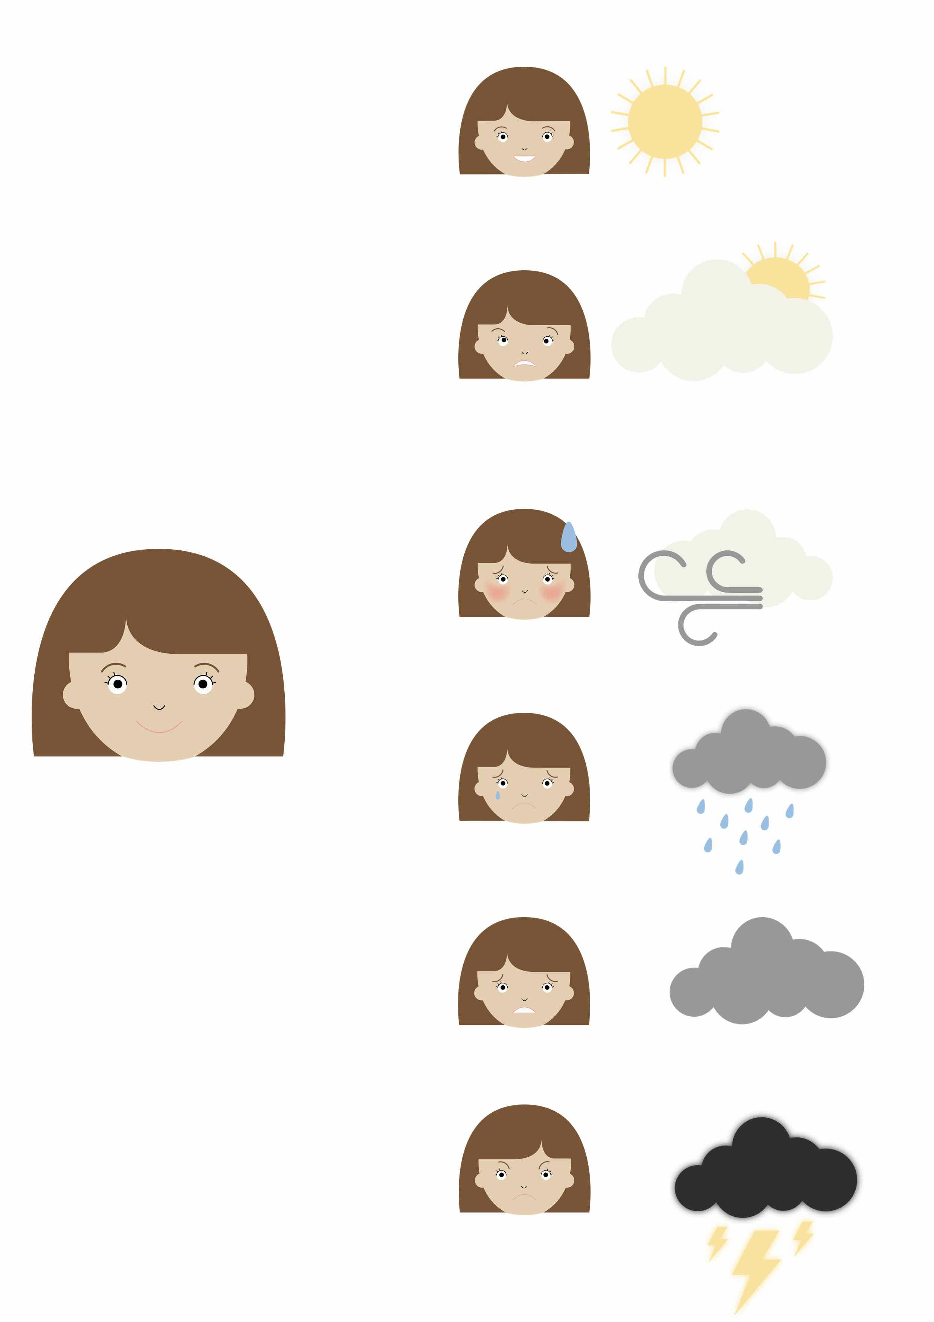
- My emotions 2:

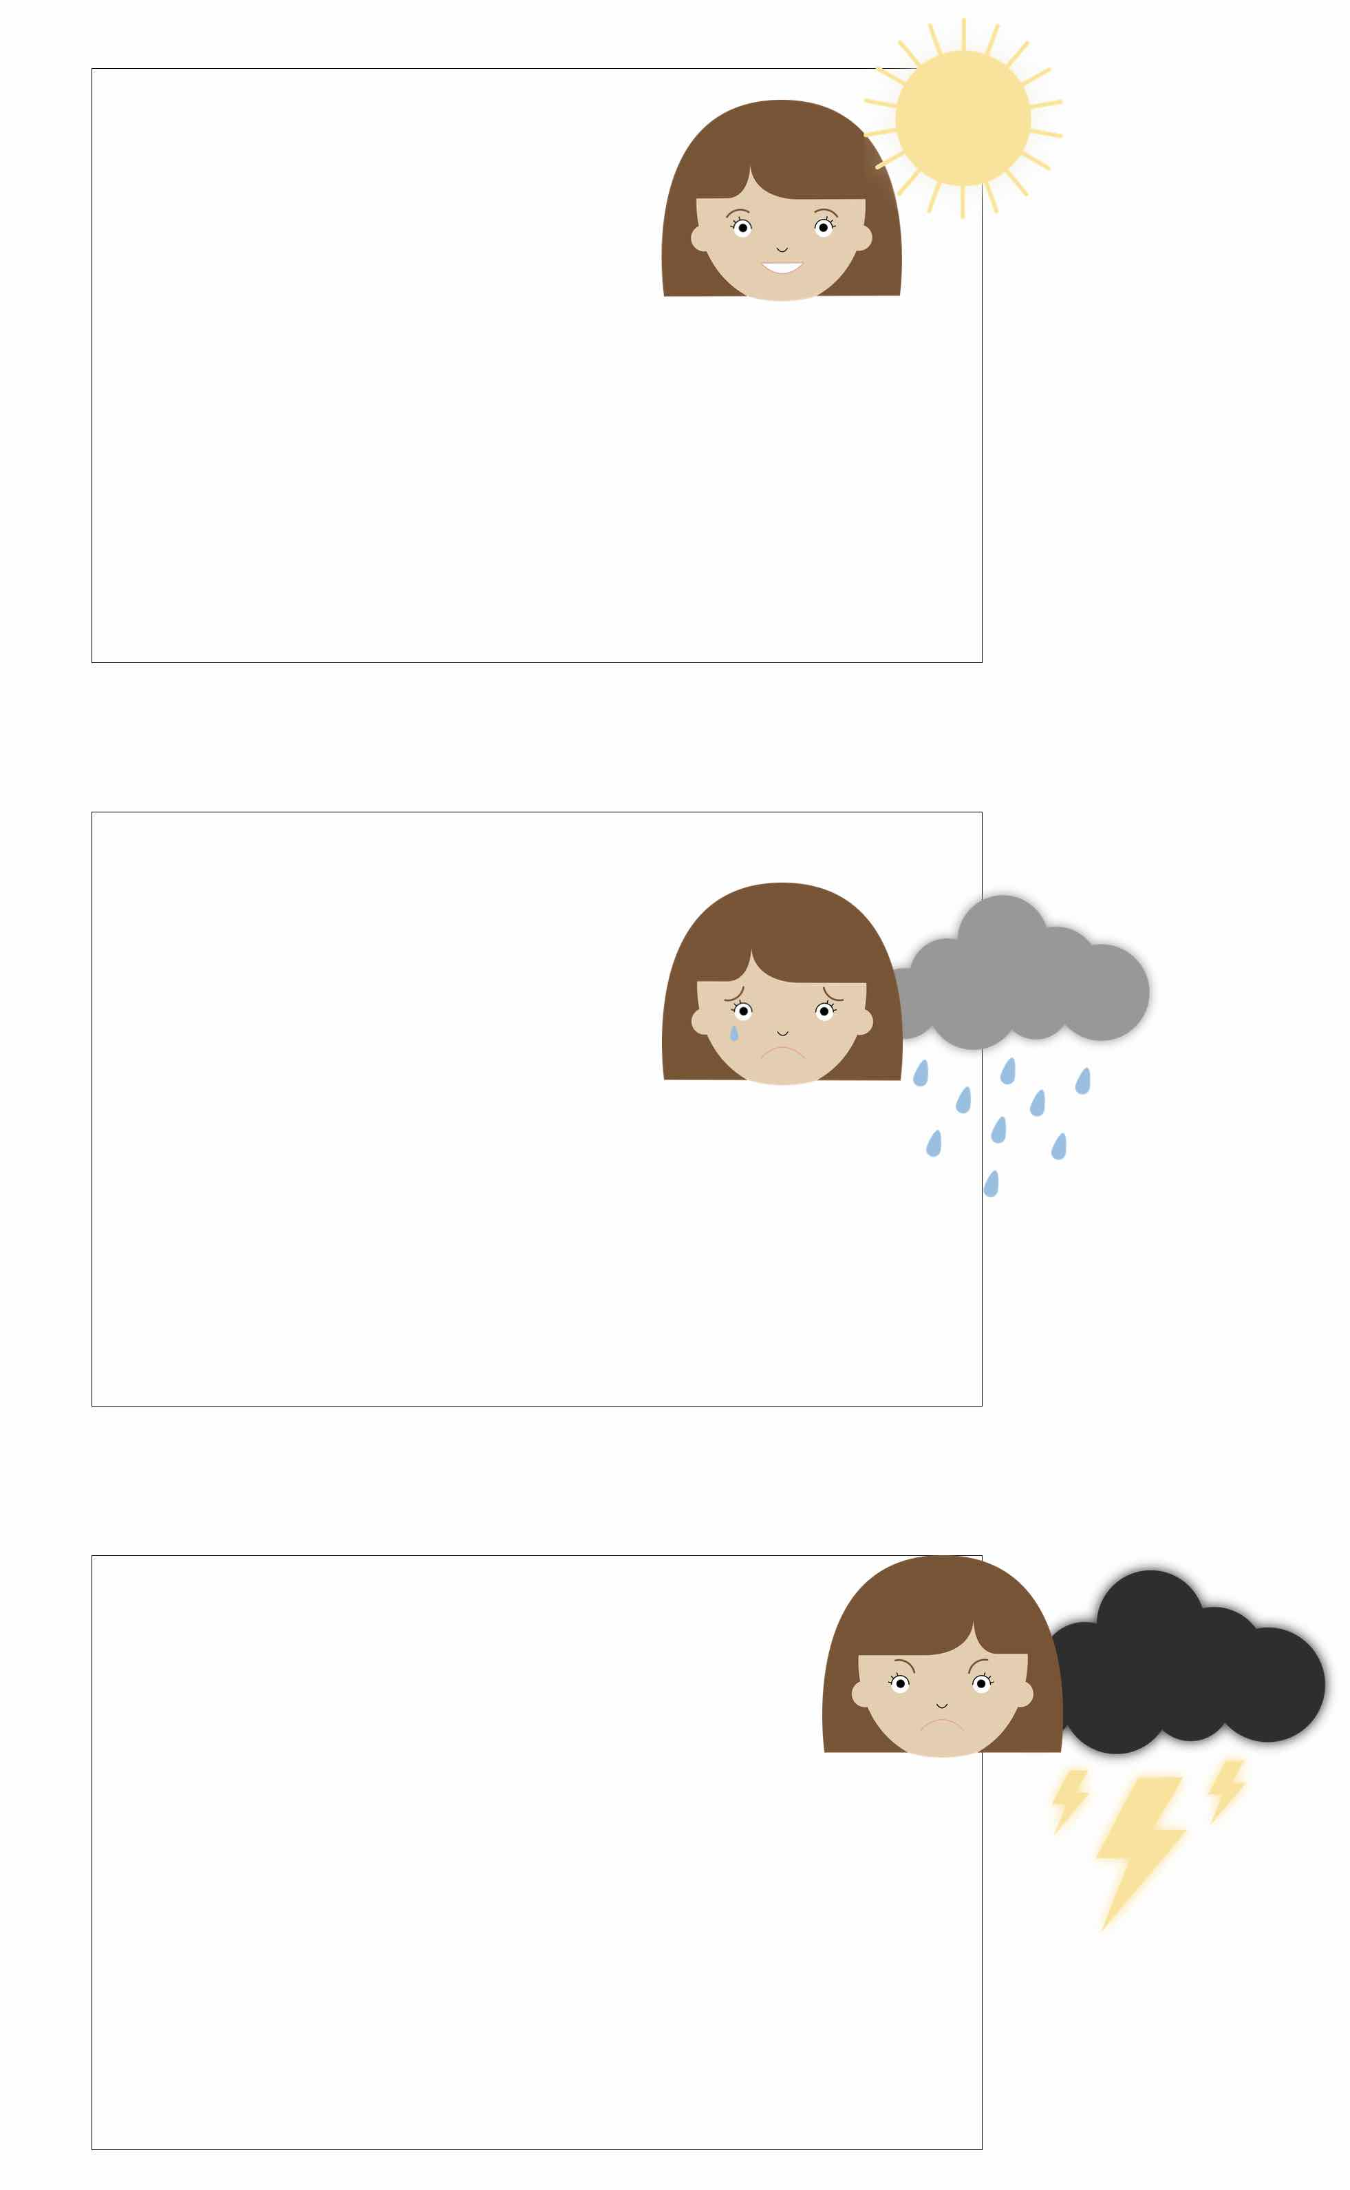
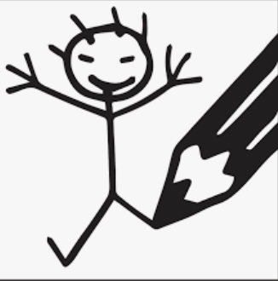
- Draw a situation in your life that links with the emotions experienced below

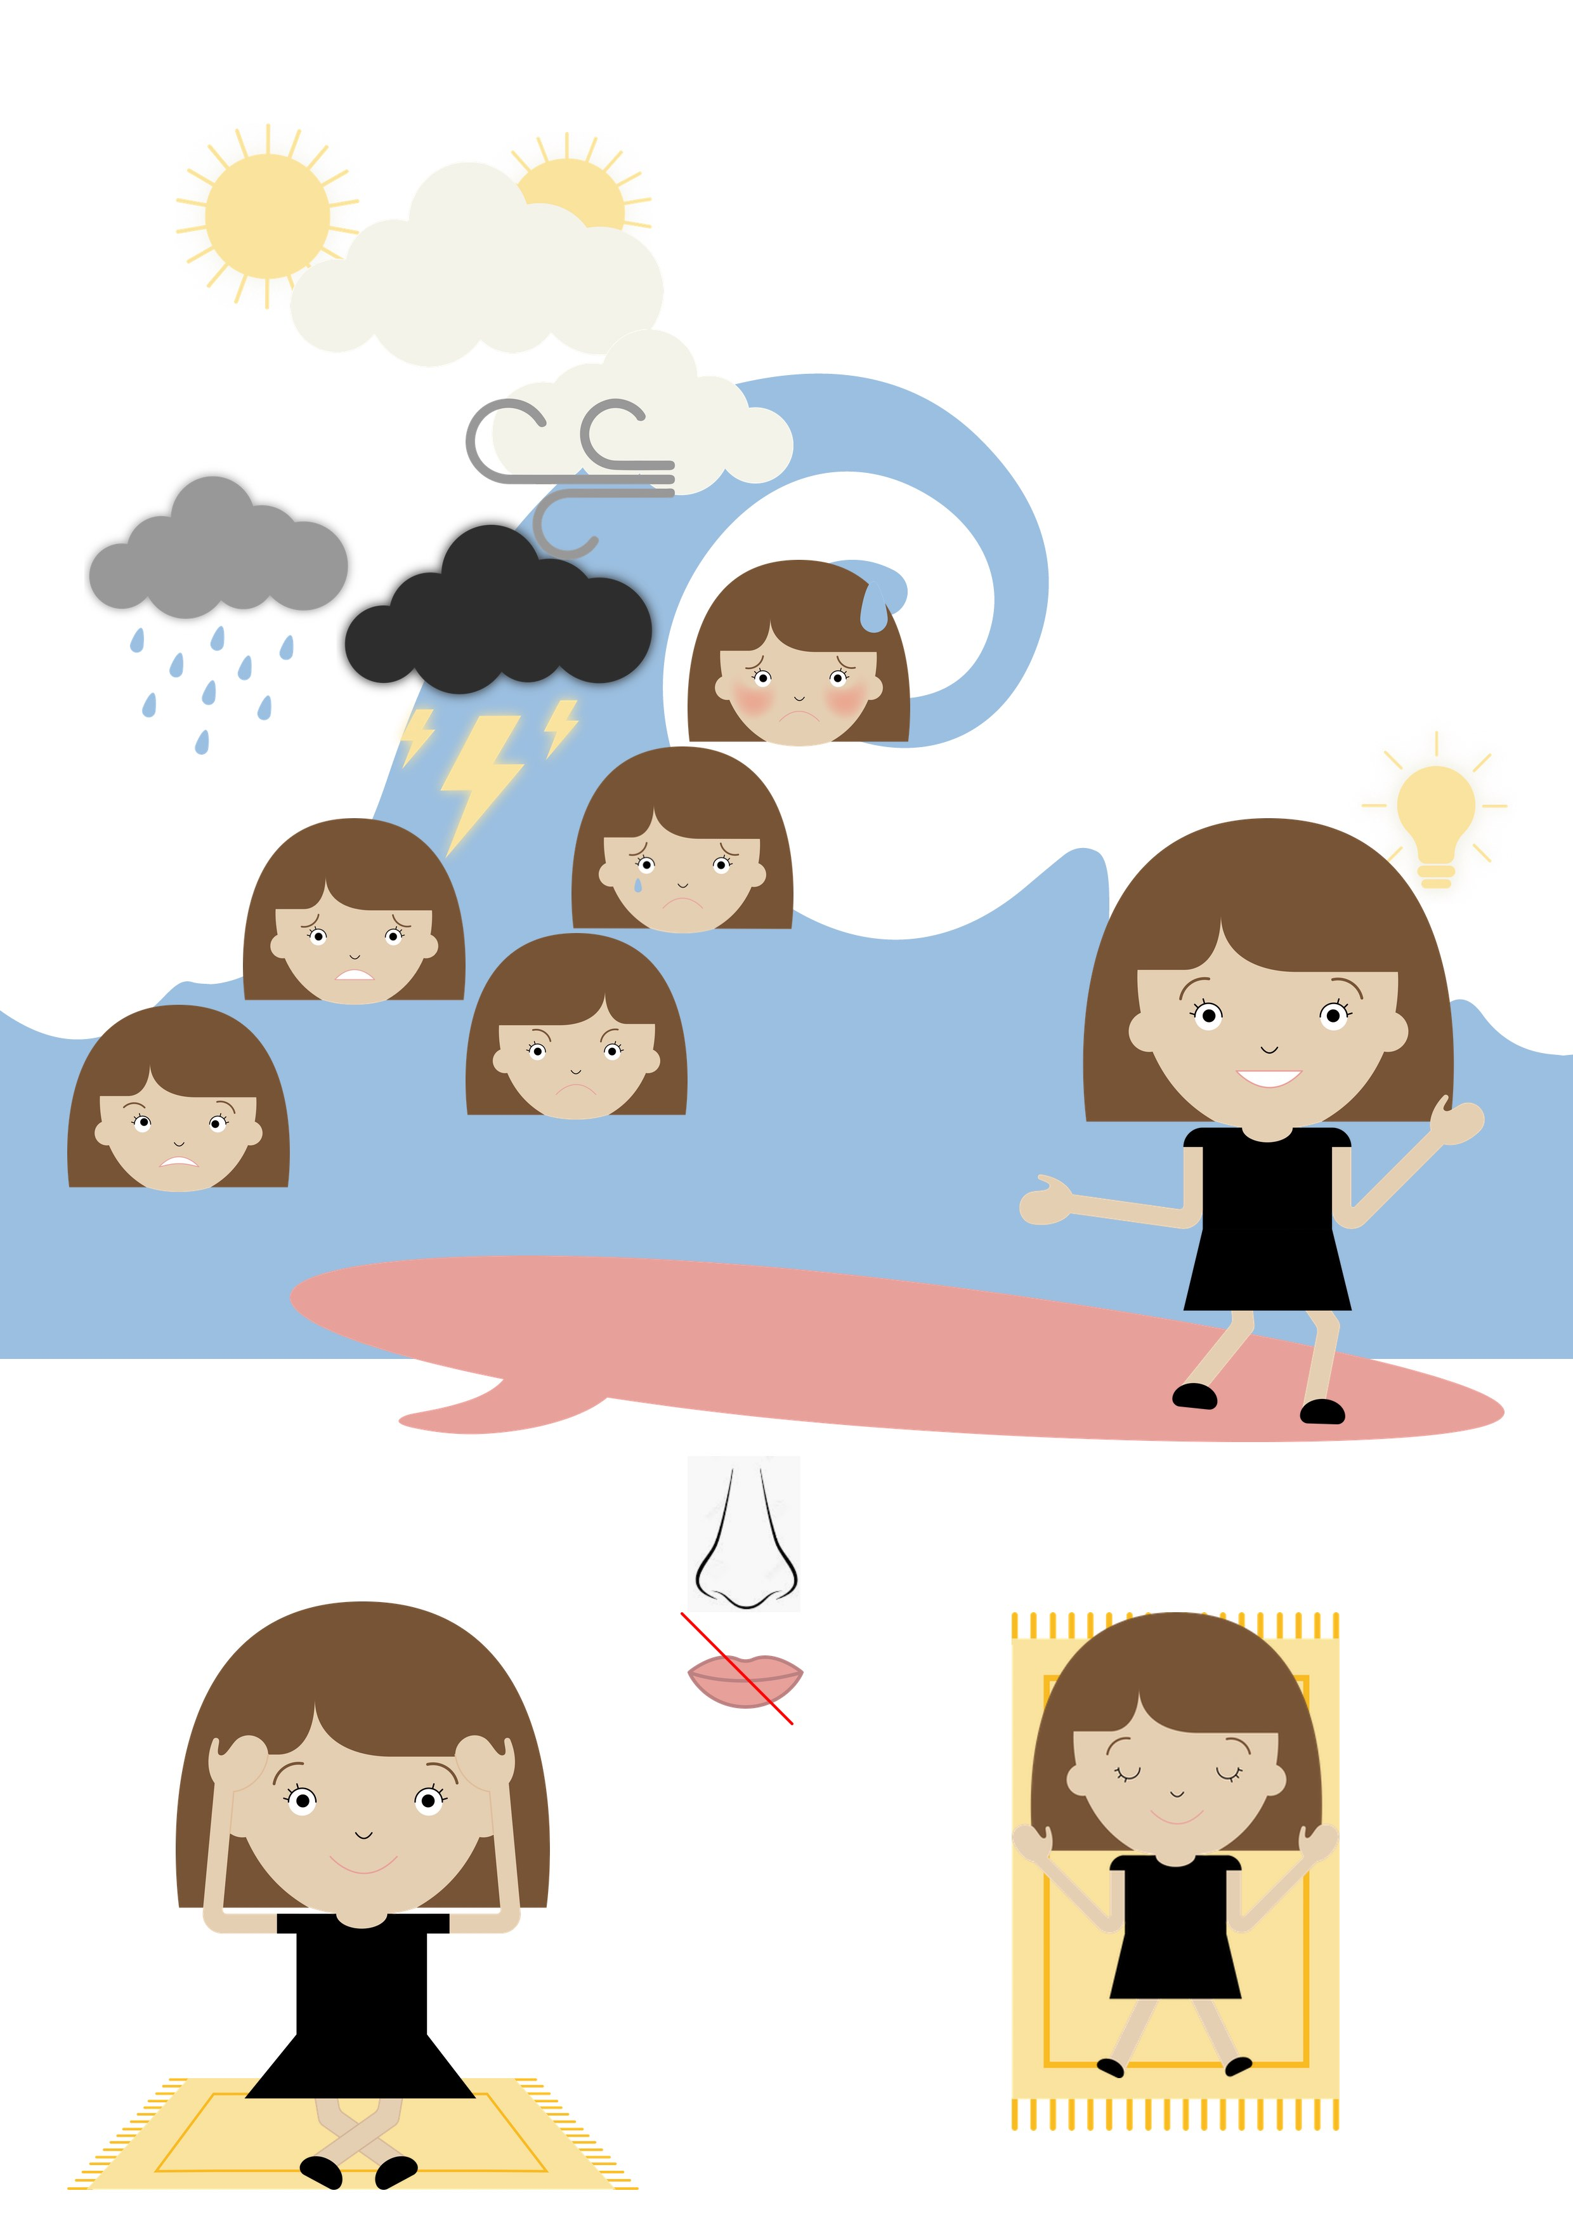
- Surf the wave of emotions

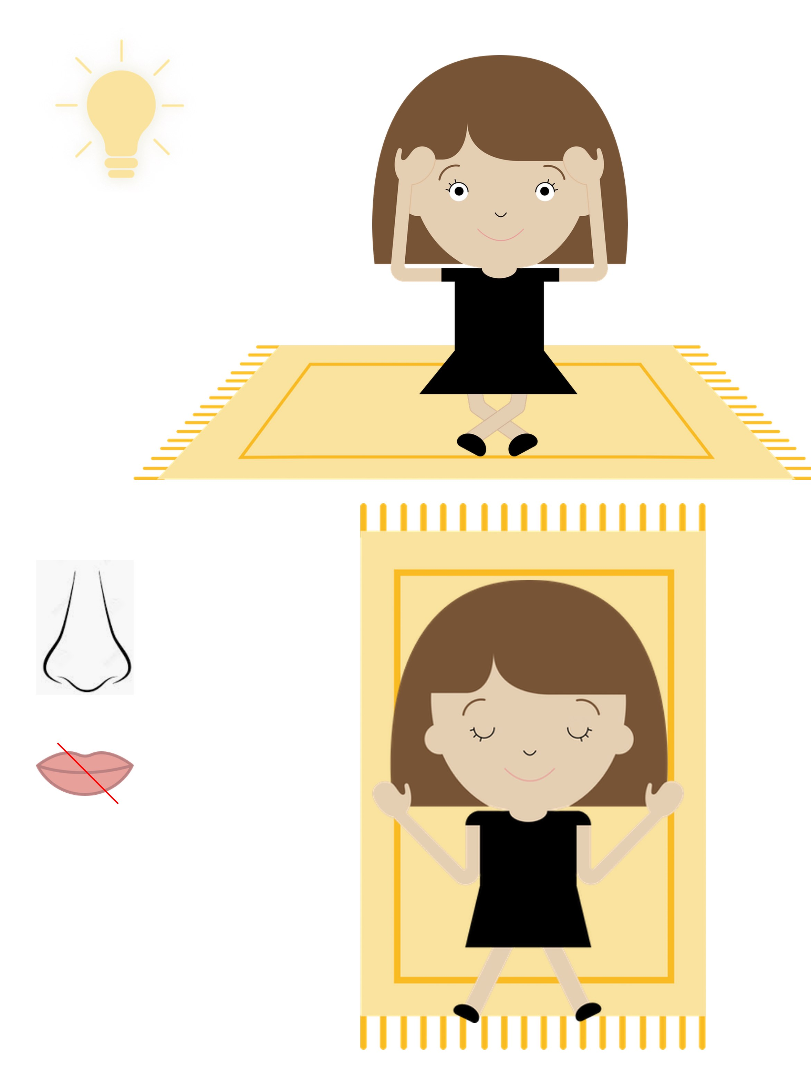
- Solutions:

- Extend / Enrichment / Prolongation Web links with others digital tools :

- Game : Stop le stress ! : http://opensign.eu/multiplechoice/82
- Game : Stress : http://opensign.eu/multiplechoice/81
- DIY Open sign: http://www.opensign.eu/manual_activities_videos
- Film Vice et versa : https://fr.wikipedia.org/wiki/Vice-versa_(film,_2015)

Ce projet n ° 2017-1-FR01-KA201-037433 a été financé avec le soutien de la Commission européenne. Cette publication n'engage que son auteur et la Commission ne peut être tenue responsable de l'usage qui pourrait être fait des informations qui y figurent.

