You can create your own resources, videos and games at:

http://www.opensign.eu

GAME : Recycling 2

Age: 8 to 12 years
Creator : Média’Pi

Competences :
- Link an iconic/visual video description with objects used in Ancient Egypt

- Remember hidden memory cards and strategically choose your cards
- Be patient and perseverant

European Competences
https://eur-lex.europa.eu/legal-content/EN/TXT/?uri=uriserv%3AOJ.C_.2018.189.01.0001.01.ENG&toc=OJ%3AC%3A2018%3A189%3ATOC

Specific vocabulary / keywords :
Household waste, glass, a metal pot, newspaper.

Lesson outline: This game can be played before or after viewing of the video: « Why Recycle? » at: http://opensign.eu/thematic_topics/88

Resources:
A computer and an internet connection.
Focus on sign language:
Encourage the player to watch the video and to pay attention to the clues in the video. Repeat the different elements of the discourse to confirm the knowledge of the game lexicon.

Ce projet n ° 2017-1-FR01-KA201-037433 a été financé avec le soutien de la Commission européenne. Cette publication n'engage que son auteur et la Commission ne peut être tenue responsable de l'usage qui pourrait être fait des informations qui y figurent.

- Game : Recycling 2: http://opensign.eu/memory_game/75
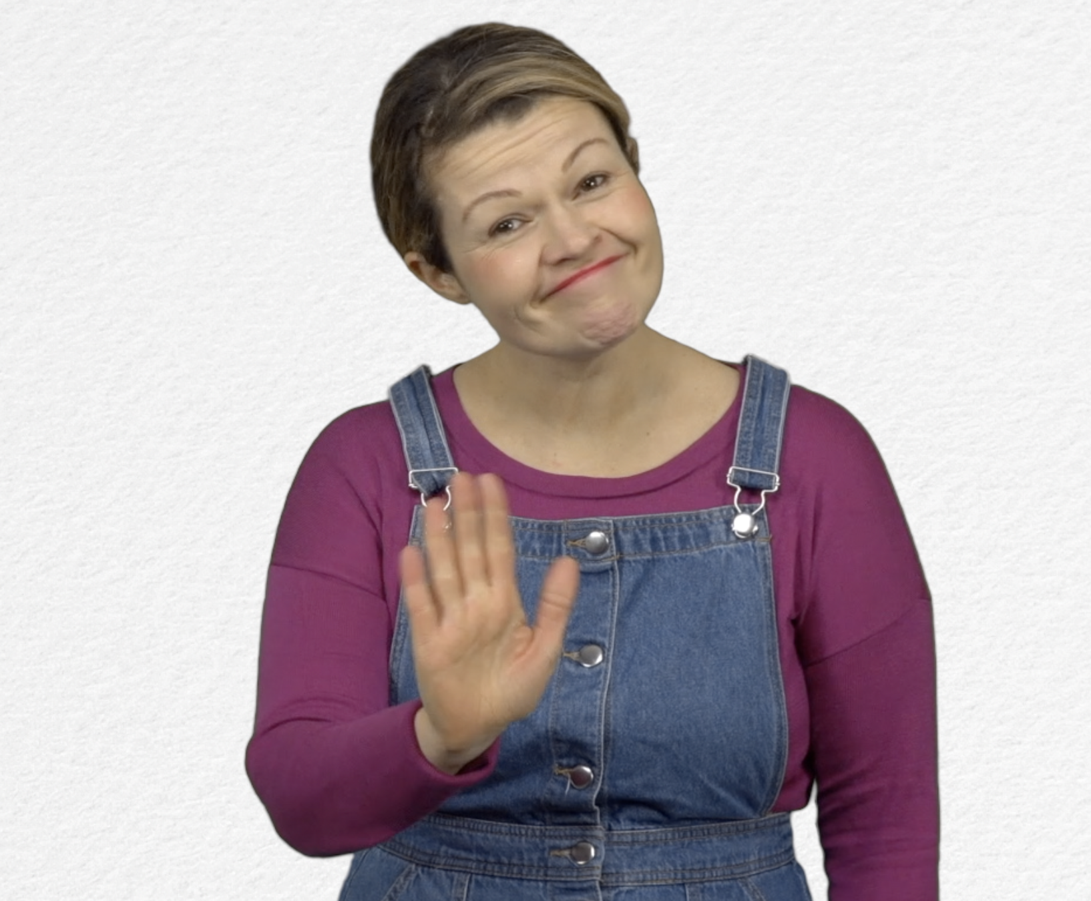
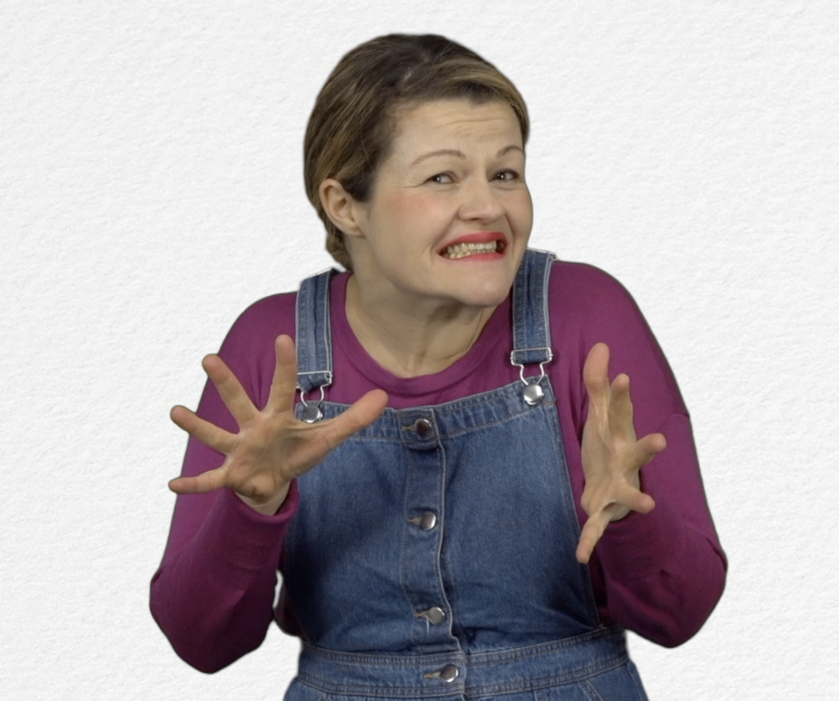
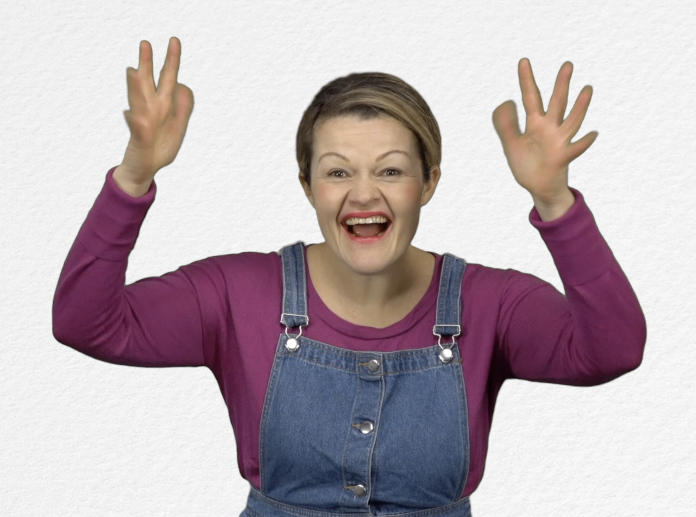
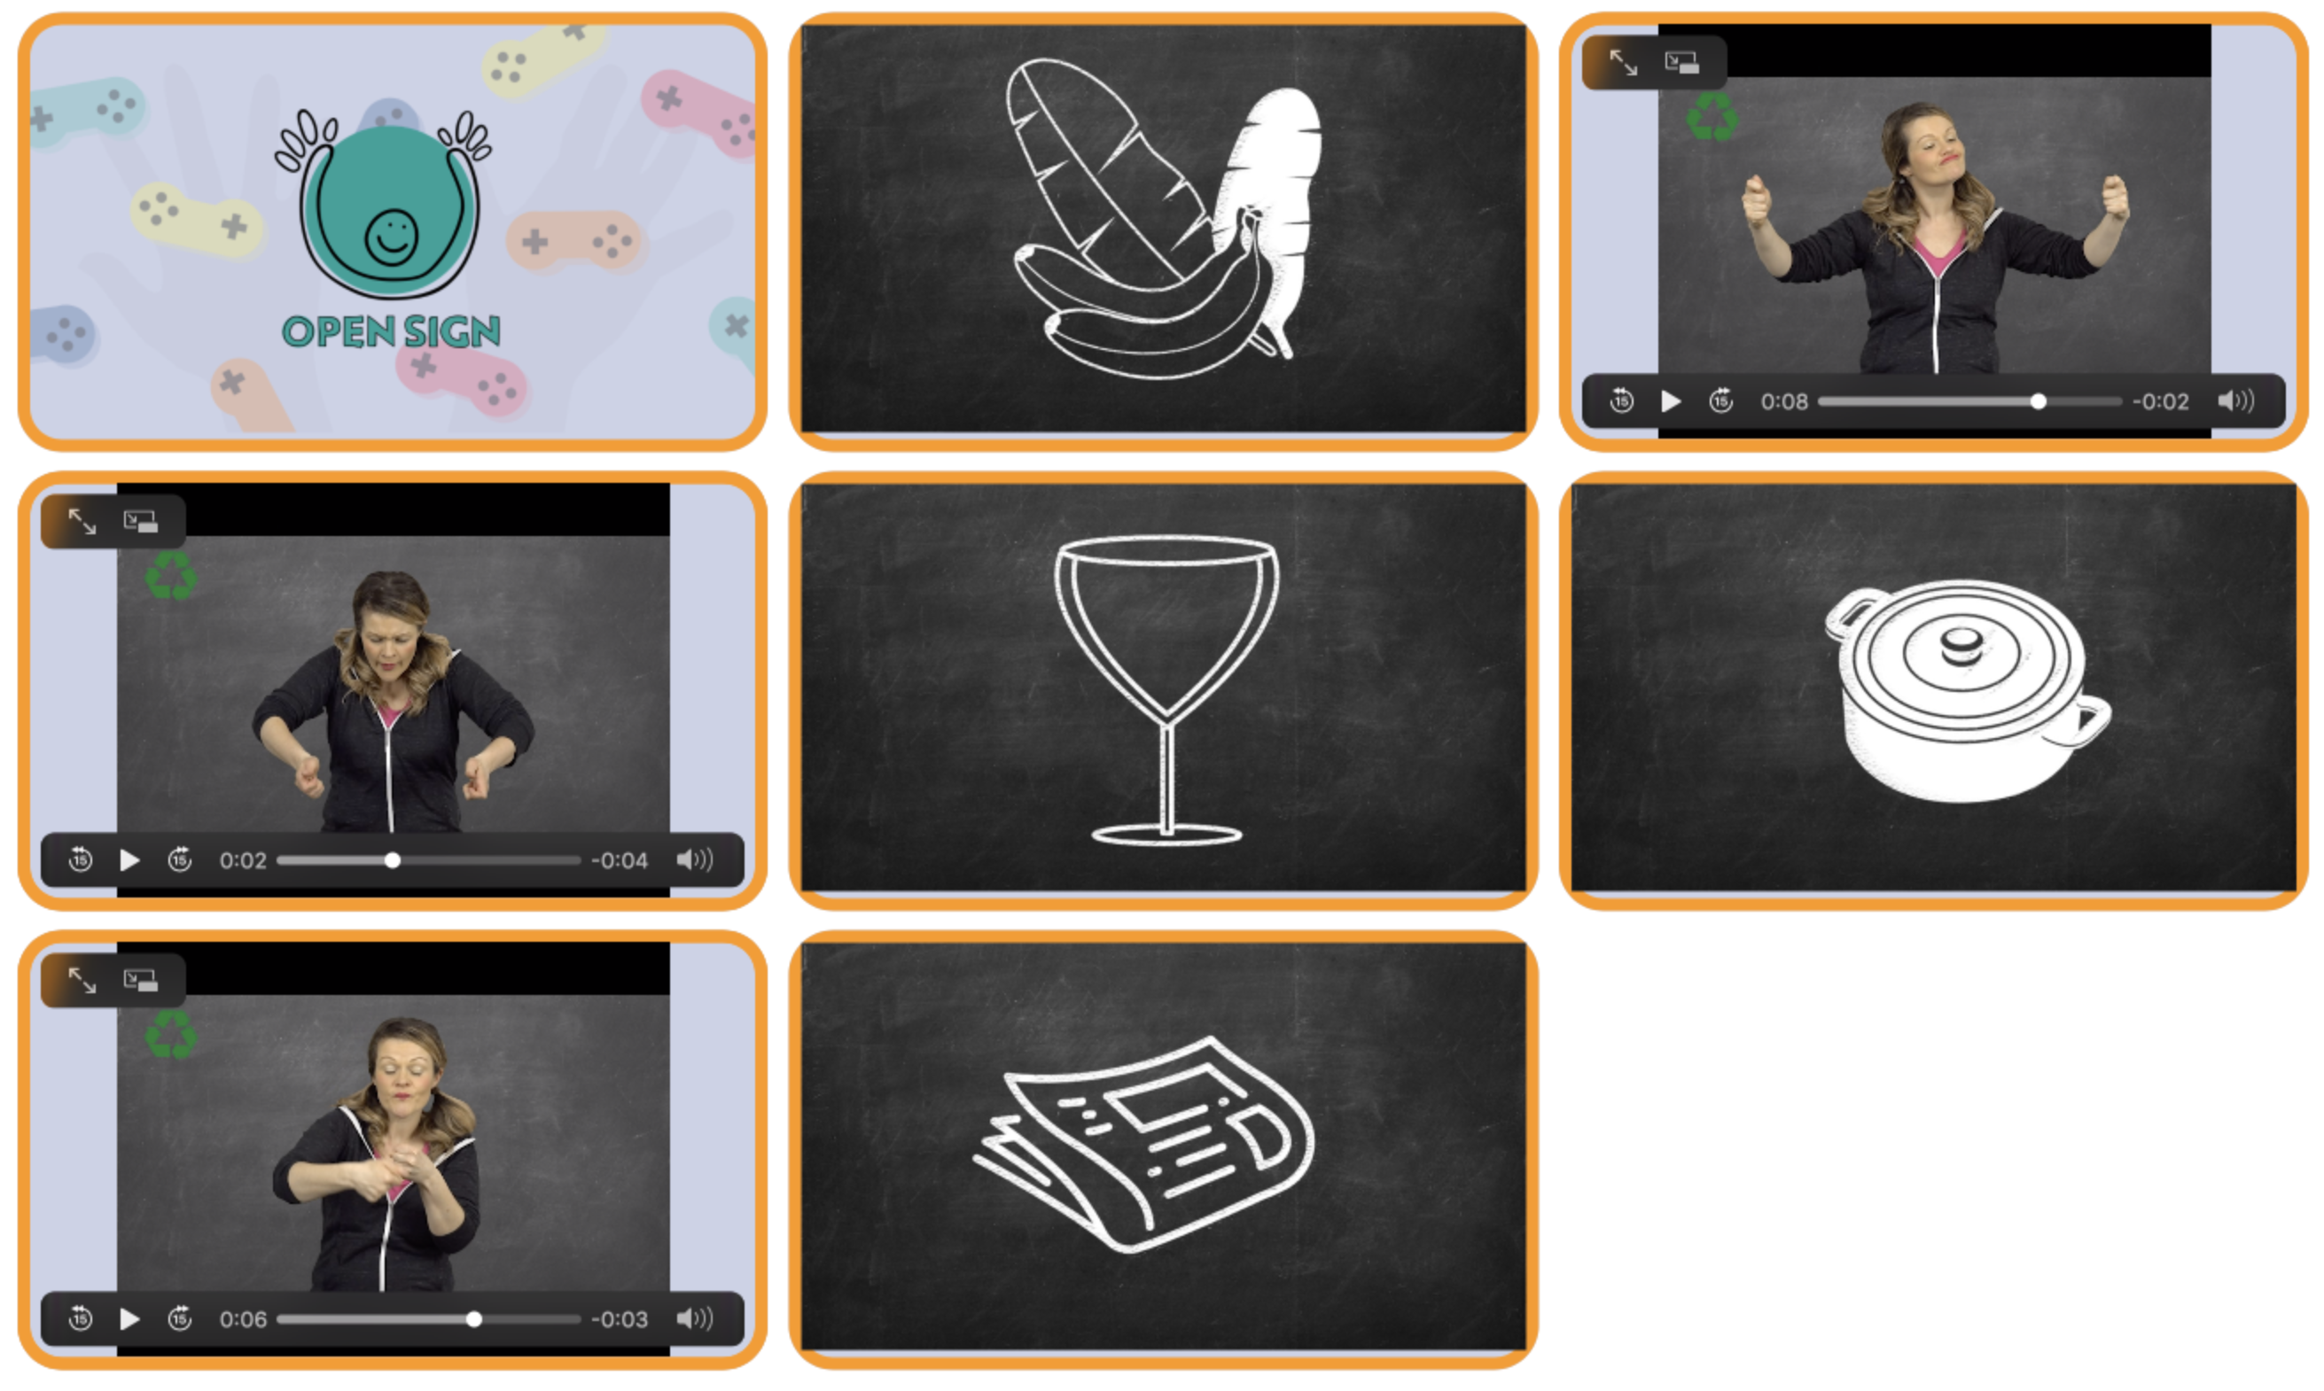
Tick the box if you have succeeded on the first try or note the number of tries.

- Extend / Enrichment / Prolongation Web links with other digital tools :

- Thematic video: Why recycle? http://opensign.eu/thematic_topics/88
- Thematic video: Recycling- how? http://opensign.eu/thematic_topics/88
- Memory Game: Recycling 1 : http://opensign.eu/memory_game/51
- Quiz Landfill :http://opensign.eu/sequence/76
- Quiz: Recyclable ? : http://opensign.eu/multiplechoice/77

