Toi aussi, tu peux créer tes propres supports : vidéos, jeux, fiches…

http://www.opensign.eu/gamescreator

GAME : recyclable ?

Age: 8 to 12 years
Creator : Média’Pi

Competences :
- Identify if certain materials are recyclable or not

- Select the correct answer(s)

- Be attentive to the question and take the time to answer E

European Competences
https://eur-lex.europa.eu/legal-content/EN/TXT/?uri=uriserv%3AOJ.C_.2018.189.01.0001.01.ENG&toc=OJ%3AC%3A2018%3A189%3ATOC

Specific vocabulary / keywords :
Recyclable / glass pane / metal can / paper handkerchief

Lesson outline
After viewing the “Recycling-How?” video at: http://opensign.eu/thematic_topics/89

Guide the students while watching the video a second time and restate the information given in the video in a clear and explicit manner.

Resources:
A computer and an internet connection.
Focus on sign language:
Reformulate your instructions and the possibility of multiple responses

Ce projet n ° 2017-1-FR01-KA201-037433 a été financé avec le soutien de la Commission européenne. Cette publication n'engage que son auteur et la Commission ne peut être tenue responsable de l'usage qui pourrait être fait des informations qui y figurent.

- GAME: Recyclable ?: http://opensign.eu/multiplechoice/77

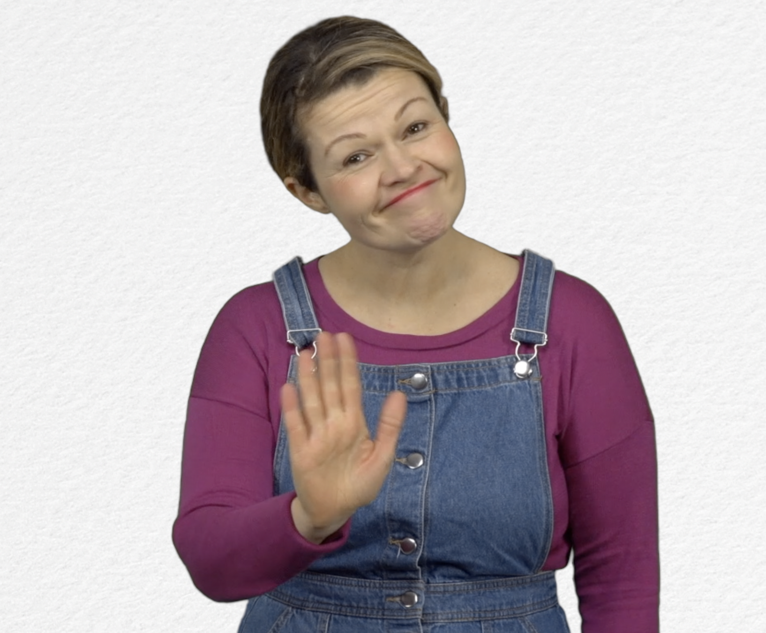
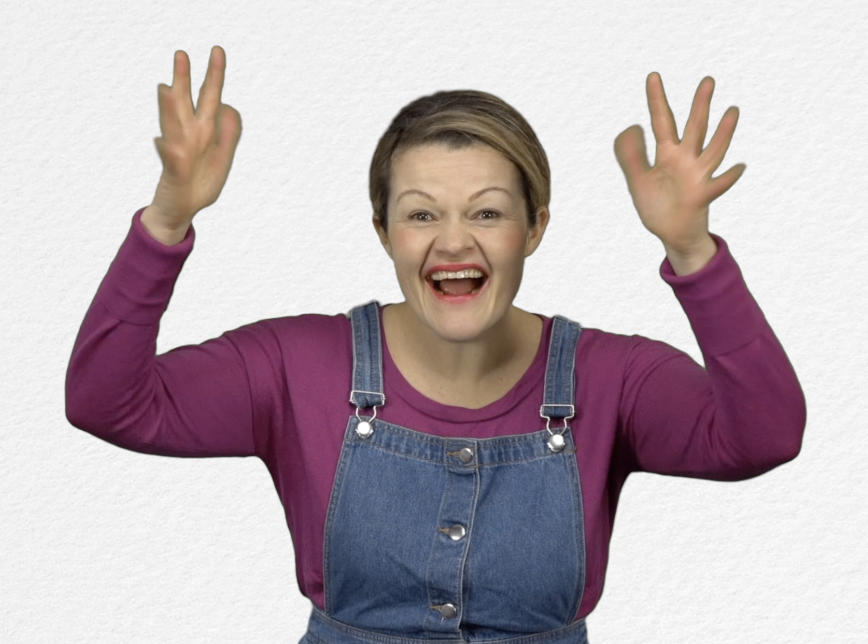
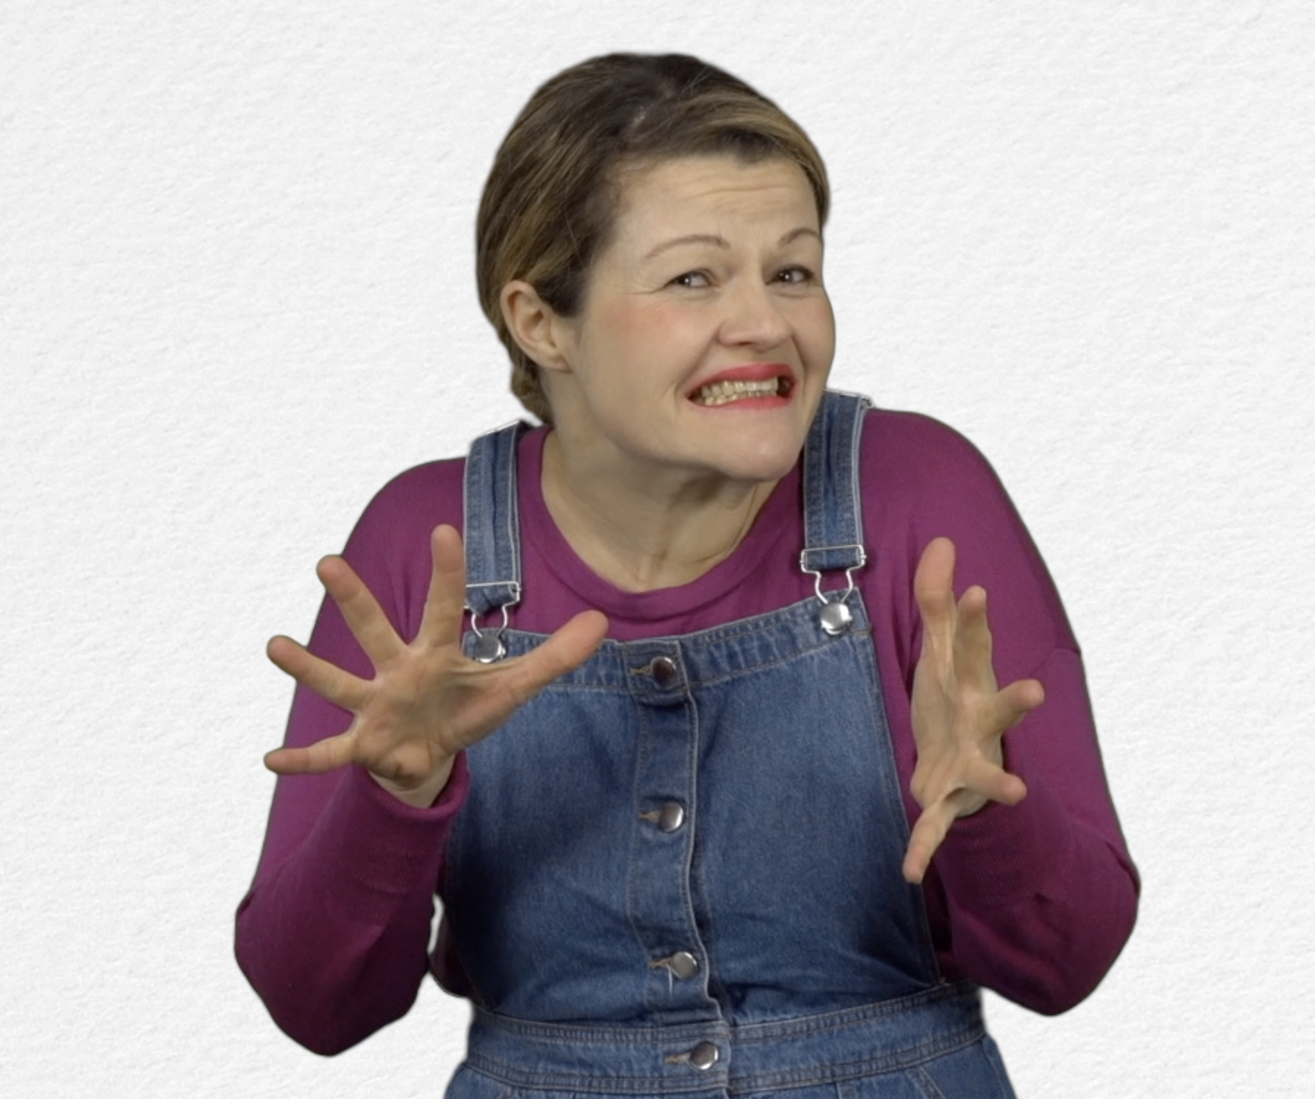
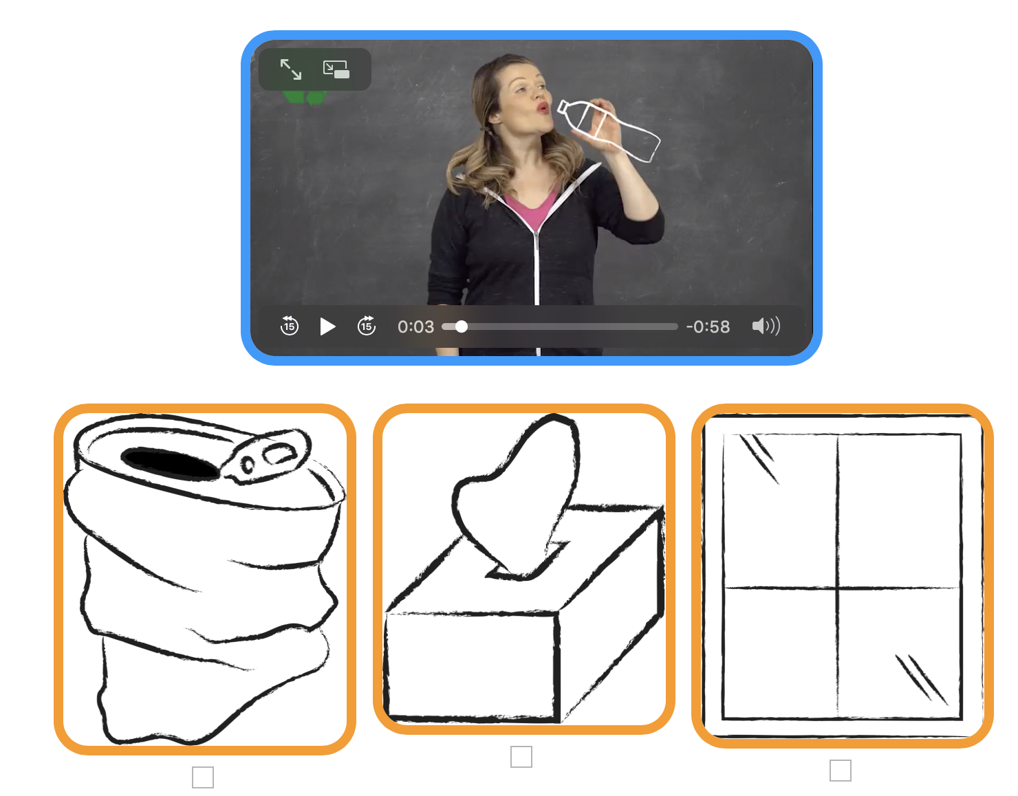
Tick the box if you have succeeded on the first try or note the number of tries.

- Extend / Enrichment / Prolongation Web links with other digital tools :

- Thematic video: Why recycle? http://opensign.eu/thematic_topics/88
- Thematic video: Recycling- how? http://opensign.eu/thematic_topics/89
- Memory Game : Recyclable objects 1: http://opensign.eu/memory_game/51
- Memory Game : Recyclable objects 2: http://opensign.eu/memory_game/75
- Quiz: Landfills: http://opensign.eu/sequence/76

