Title: PERSONALIZING A NOTEBOOK

Age category: 6 -12 years old

Authors: Istituto dei Sordi di Torino www.istitutosorditorino.org

Competences :
- The students will learn to personalize their own object between the others.
- The students will use their creativity in order to create something new and personal.
- The students will be aware of their identity.

Competences according to European curriculum:
http://eur-lex.europa.eu/legal-content/EN/TXT/?uri=LEGISSUM%3Ac11090

Formative assessment:
- Identify the main materials (notebook, scissors…).
- Ask what they mean as identity.
- Ask what they what to create and need as additional material.

Summative Assessment:
- Communicate personal thoughts, impressions, creativity while making a new object and have fun.

Specific vocabulary list/Keywords:
- Imagination, identity, creativity, art.

Short description of the educational context/scenario:
The teacher and the children will prepare and collect the materials they need: scissors, a notebook, some colored papers, pencils and markers, glue, all other things that can attract the pupils (ribbons, fabric ...).
The teacher will explain that we can personalize some individual materials, whereas there are some objects that have to have the same characteristics in a community in order to communicate something. For example, traffic lights have the red light to communicate to all to stop.
The teacher will stimulate creativity and personal tastes by asking the children what they like and what they don’t like.
The teacher will assist the students during the decoration of a personal notebook and will combine the playtime with the teaching.

Materials needed/Technical requirements:
- Scissors, a notebook, some colored papers, pencils and markers, glue.

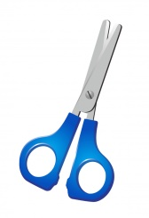
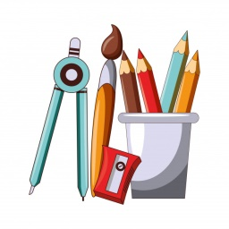

Focus on sign language:
- Sign the new vocabulary, sign the main materials needed to personalize a notebook, sign the steps to take in order to create this new object.

- Draw yourself and fill the information about you.

NAME______________________________

SURNAME__________________________

AGE________________________________

SCHOOL____________________________

FAVOURITE COLOR______________________

FAVOURITE SPORT_________________________________________________

FAVOURITE SUBJECT________________________________________________

THREE QUALITIES ___________________________________________________________________________________________________________________________________________________________________________________________________________________________

THREE DEFECTS
___________________________________________________________________________________________________________________________________________________________________________________________________________________________

- Circle the things that you like.

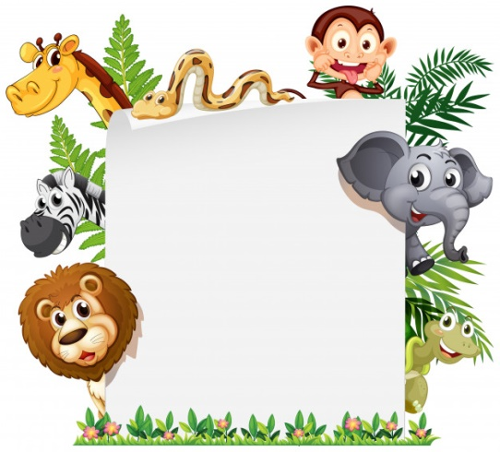
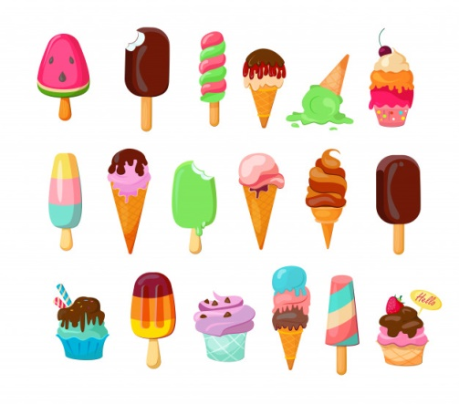
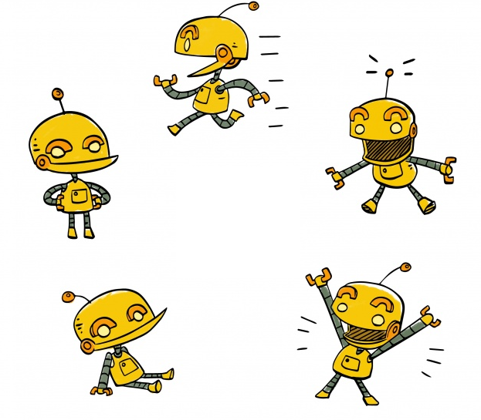
ROBOTS
ANIMALS
- Draw and describe your best friend.

NAME_________________________________________________

SURNAME__________________________________________________

AGE_______________ PHYSICAL CHARACTERISTICS__________________________
____________________________________________________________________________

HIS / HER FAVOURITE GAME IS____________________________________________

HIS / HER FAVOURITE FOOD IS_________________________________________________________________________________________

HE / SHE IS MY BEST FRIEND BECAUSE___________________________________________________________________________________________________________________________________________________________________________________________________________________________________________________________________________________________________
- Where do I come from?
Draw you and the your family members (one person in each circle). Cut and paste them on the tree in order to create your own family tree!

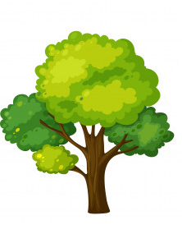
Extend / Enrichment / Prolongations Web links with others digital tools:

- https://www.youtube.com/watch?v=om3INBWfoxY
- https://www.youtube.com/watch?v=A5e1CtoJDvY

