You can create your own resources, videos and games at:

http://www.opensign.eu

Thematic Topic : Recycling 2: What to do with waste?

Age: 9-12 years
Creators: Media’Pi

Competences:
- linking scientific and technological knowledge to health, safety and environmental issues

- Sorting waste correctly

- implement responsible actions individually and collectively within and outside the school

European Key Competences:
https://eur-lex.europa.eu/legal-content/EN/TXT/?uri=uriserv%3AOJ.C_.2018.189.01.0001.01.ENG&toc=OJ%3AC%3A2018%3A189%3ATOC

Formative Evaluation:
- Name the different types of material
- Identify broad categories of recyclable material
- Give examples of the reuse of waste through processing
- Explain the concept of recycling and locate logos on packaging
- Explain the concept of waste reduction and repair

Summative evaluation:
- Explain the impact of humans on the environment and how to change this individually ad collectively.
Specific vocabulary and keywords: household waste, vegetables, glass, paper, cardboard, plastic, sort, recycle, process.

Educational progress:
First, watch the video with pauses, ask questions about the sign language that is being used and pause to ask questions about vocabulary and concepts. Go back to the beginning of the video. Then, watch the video a second time without stopping.

Resources required : computer, video projector, examples of waste and packaging

Focus on sign language: Distinction between the object and the matter

I. Vocabulary:

Objects and their raw material - write the name of the object |  |  |  | What’s the sign?
 | …metal
 | A can | 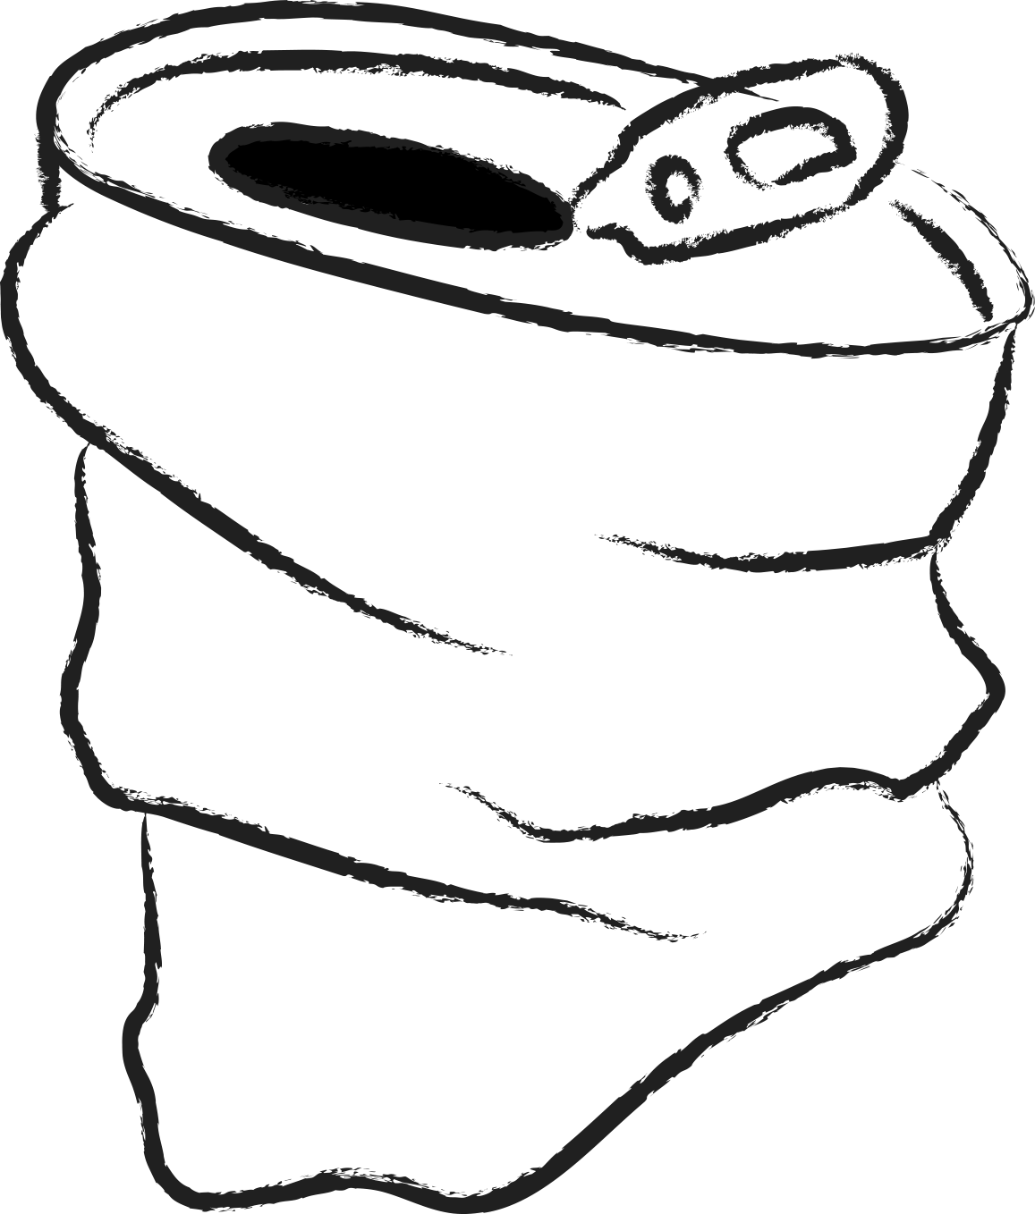
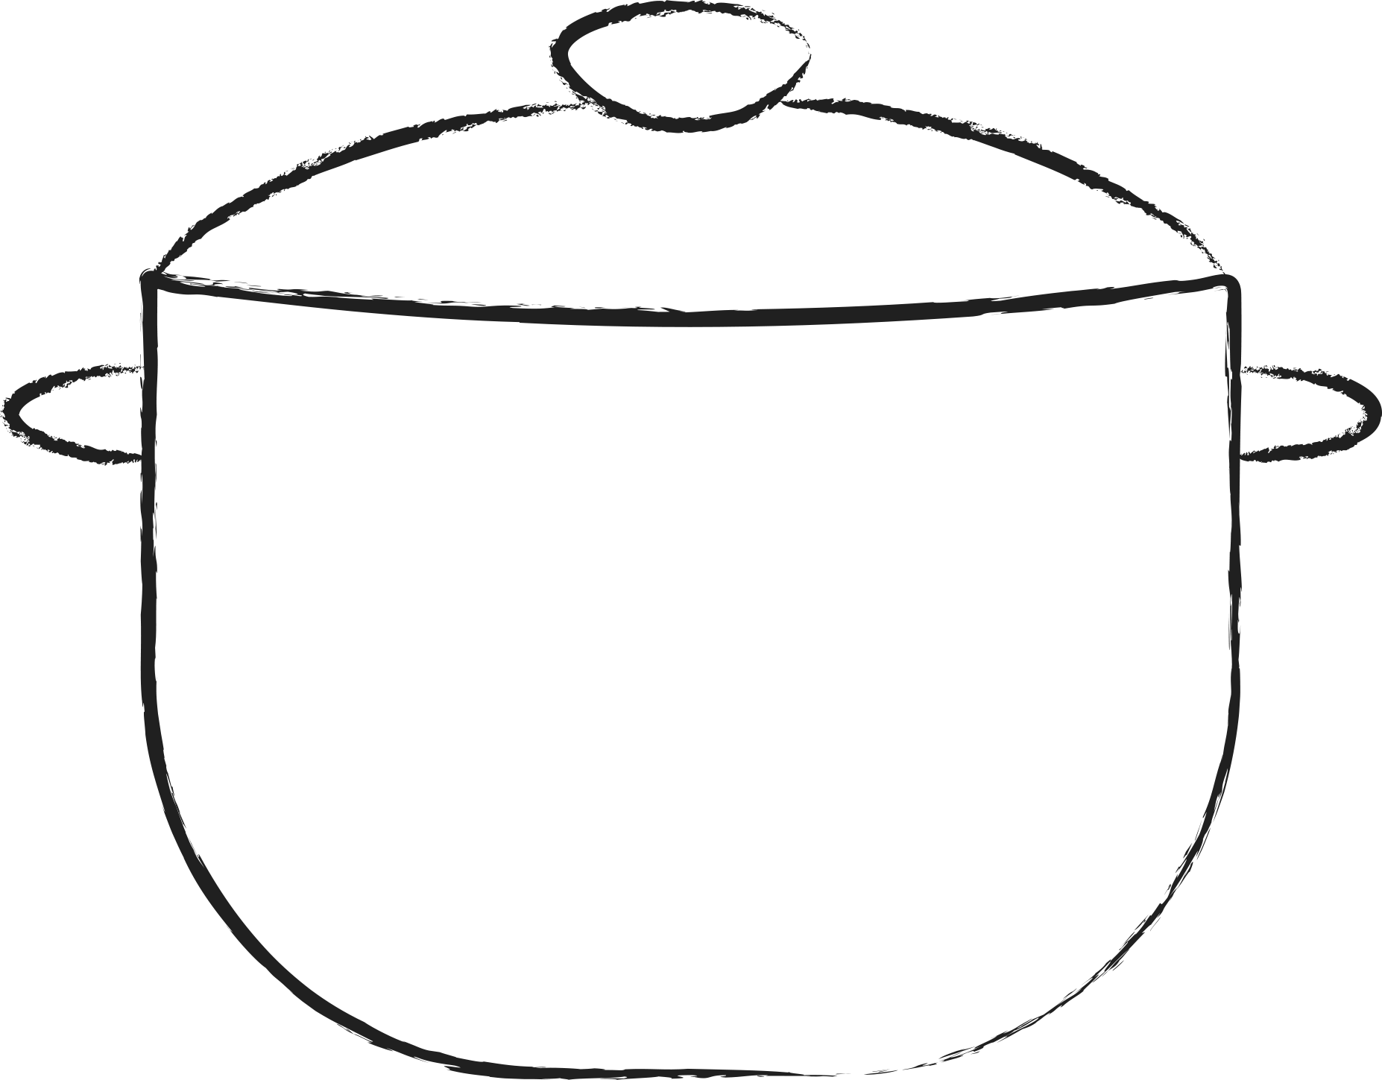
 | … organic matter / which comes from nature without transformation
 |  | 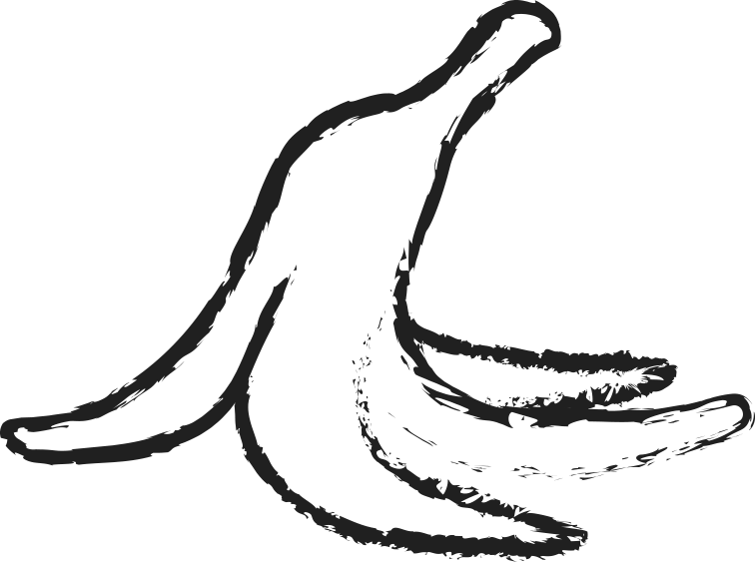
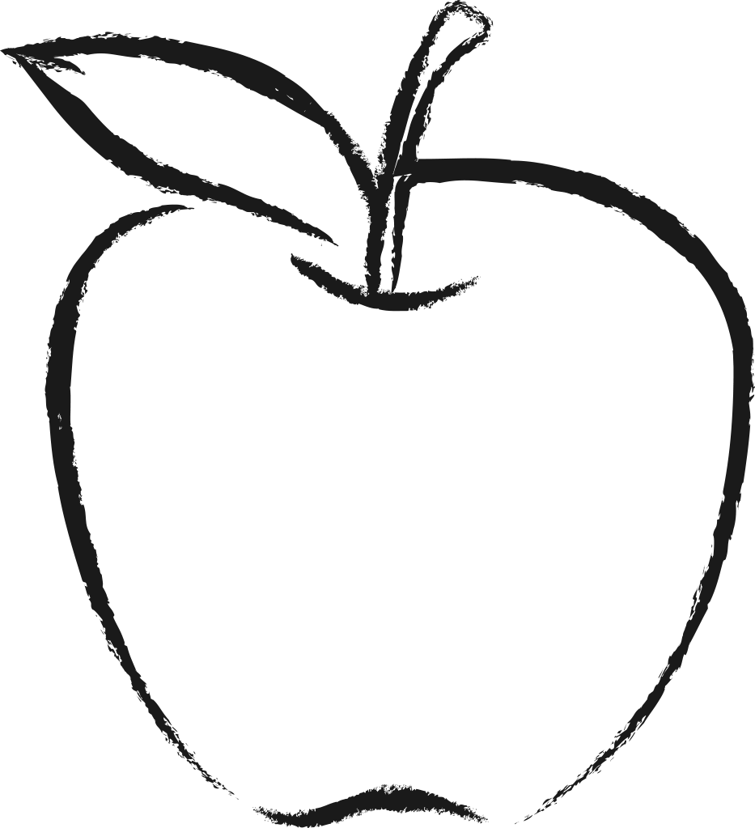
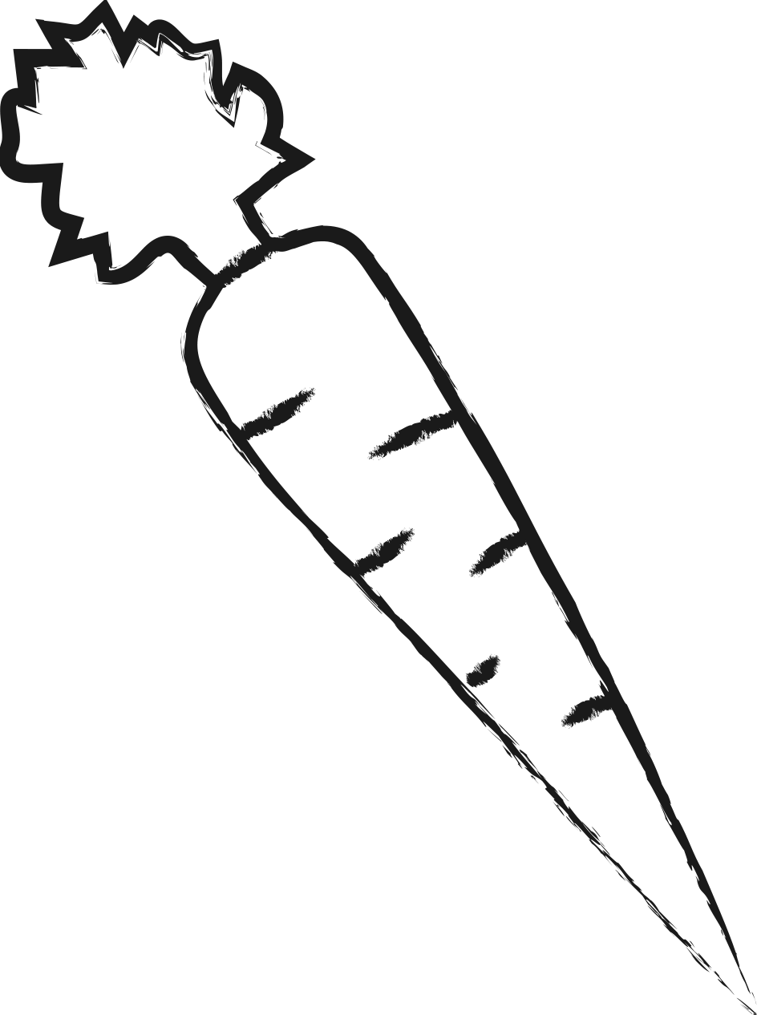
 | … paper
 |  | 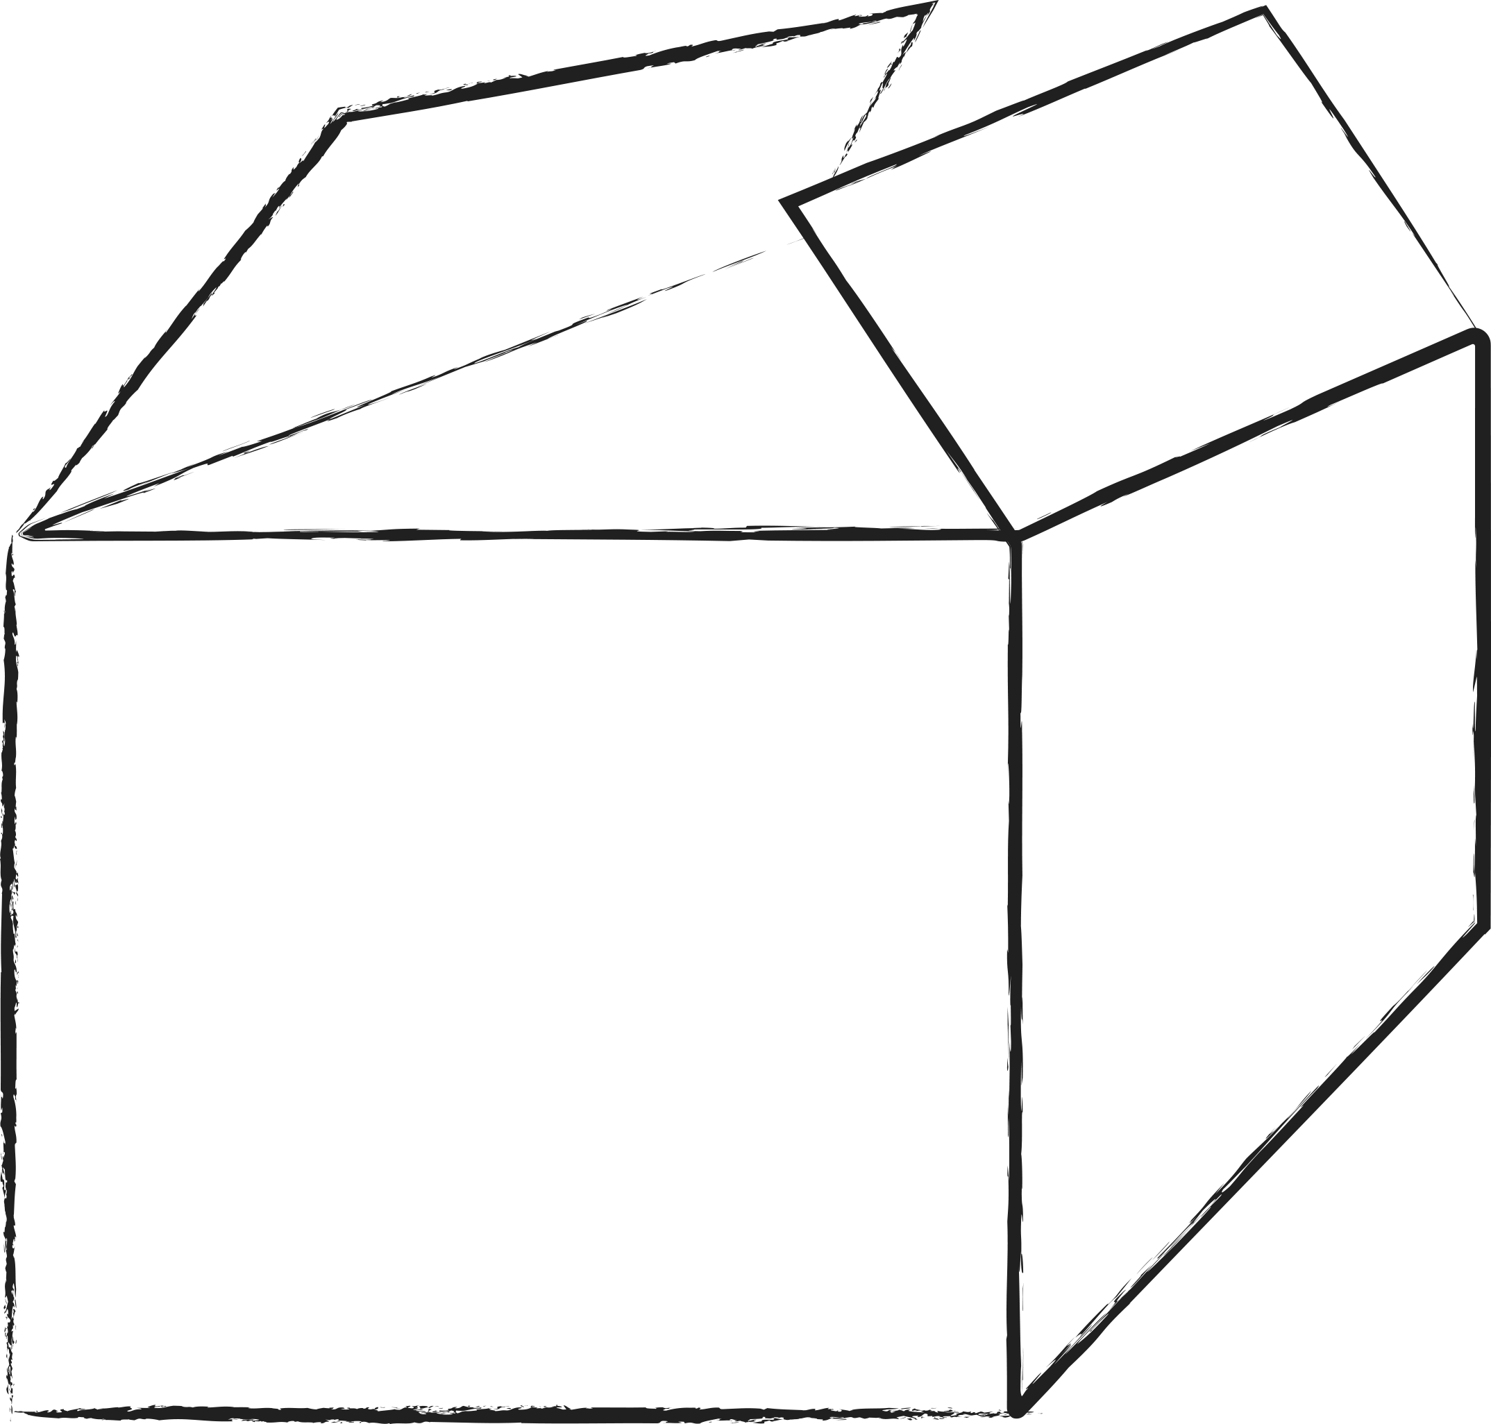
 |  | 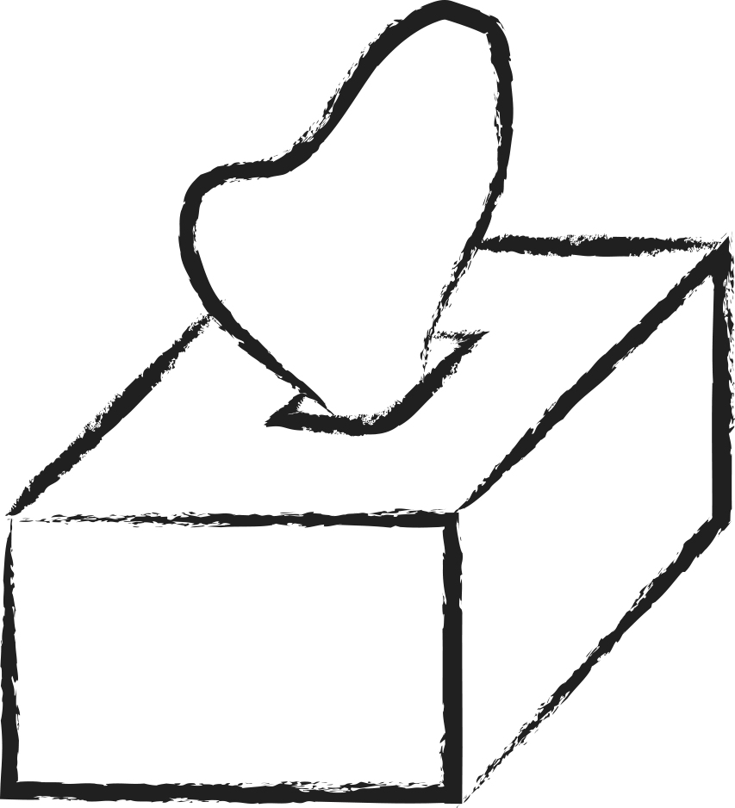
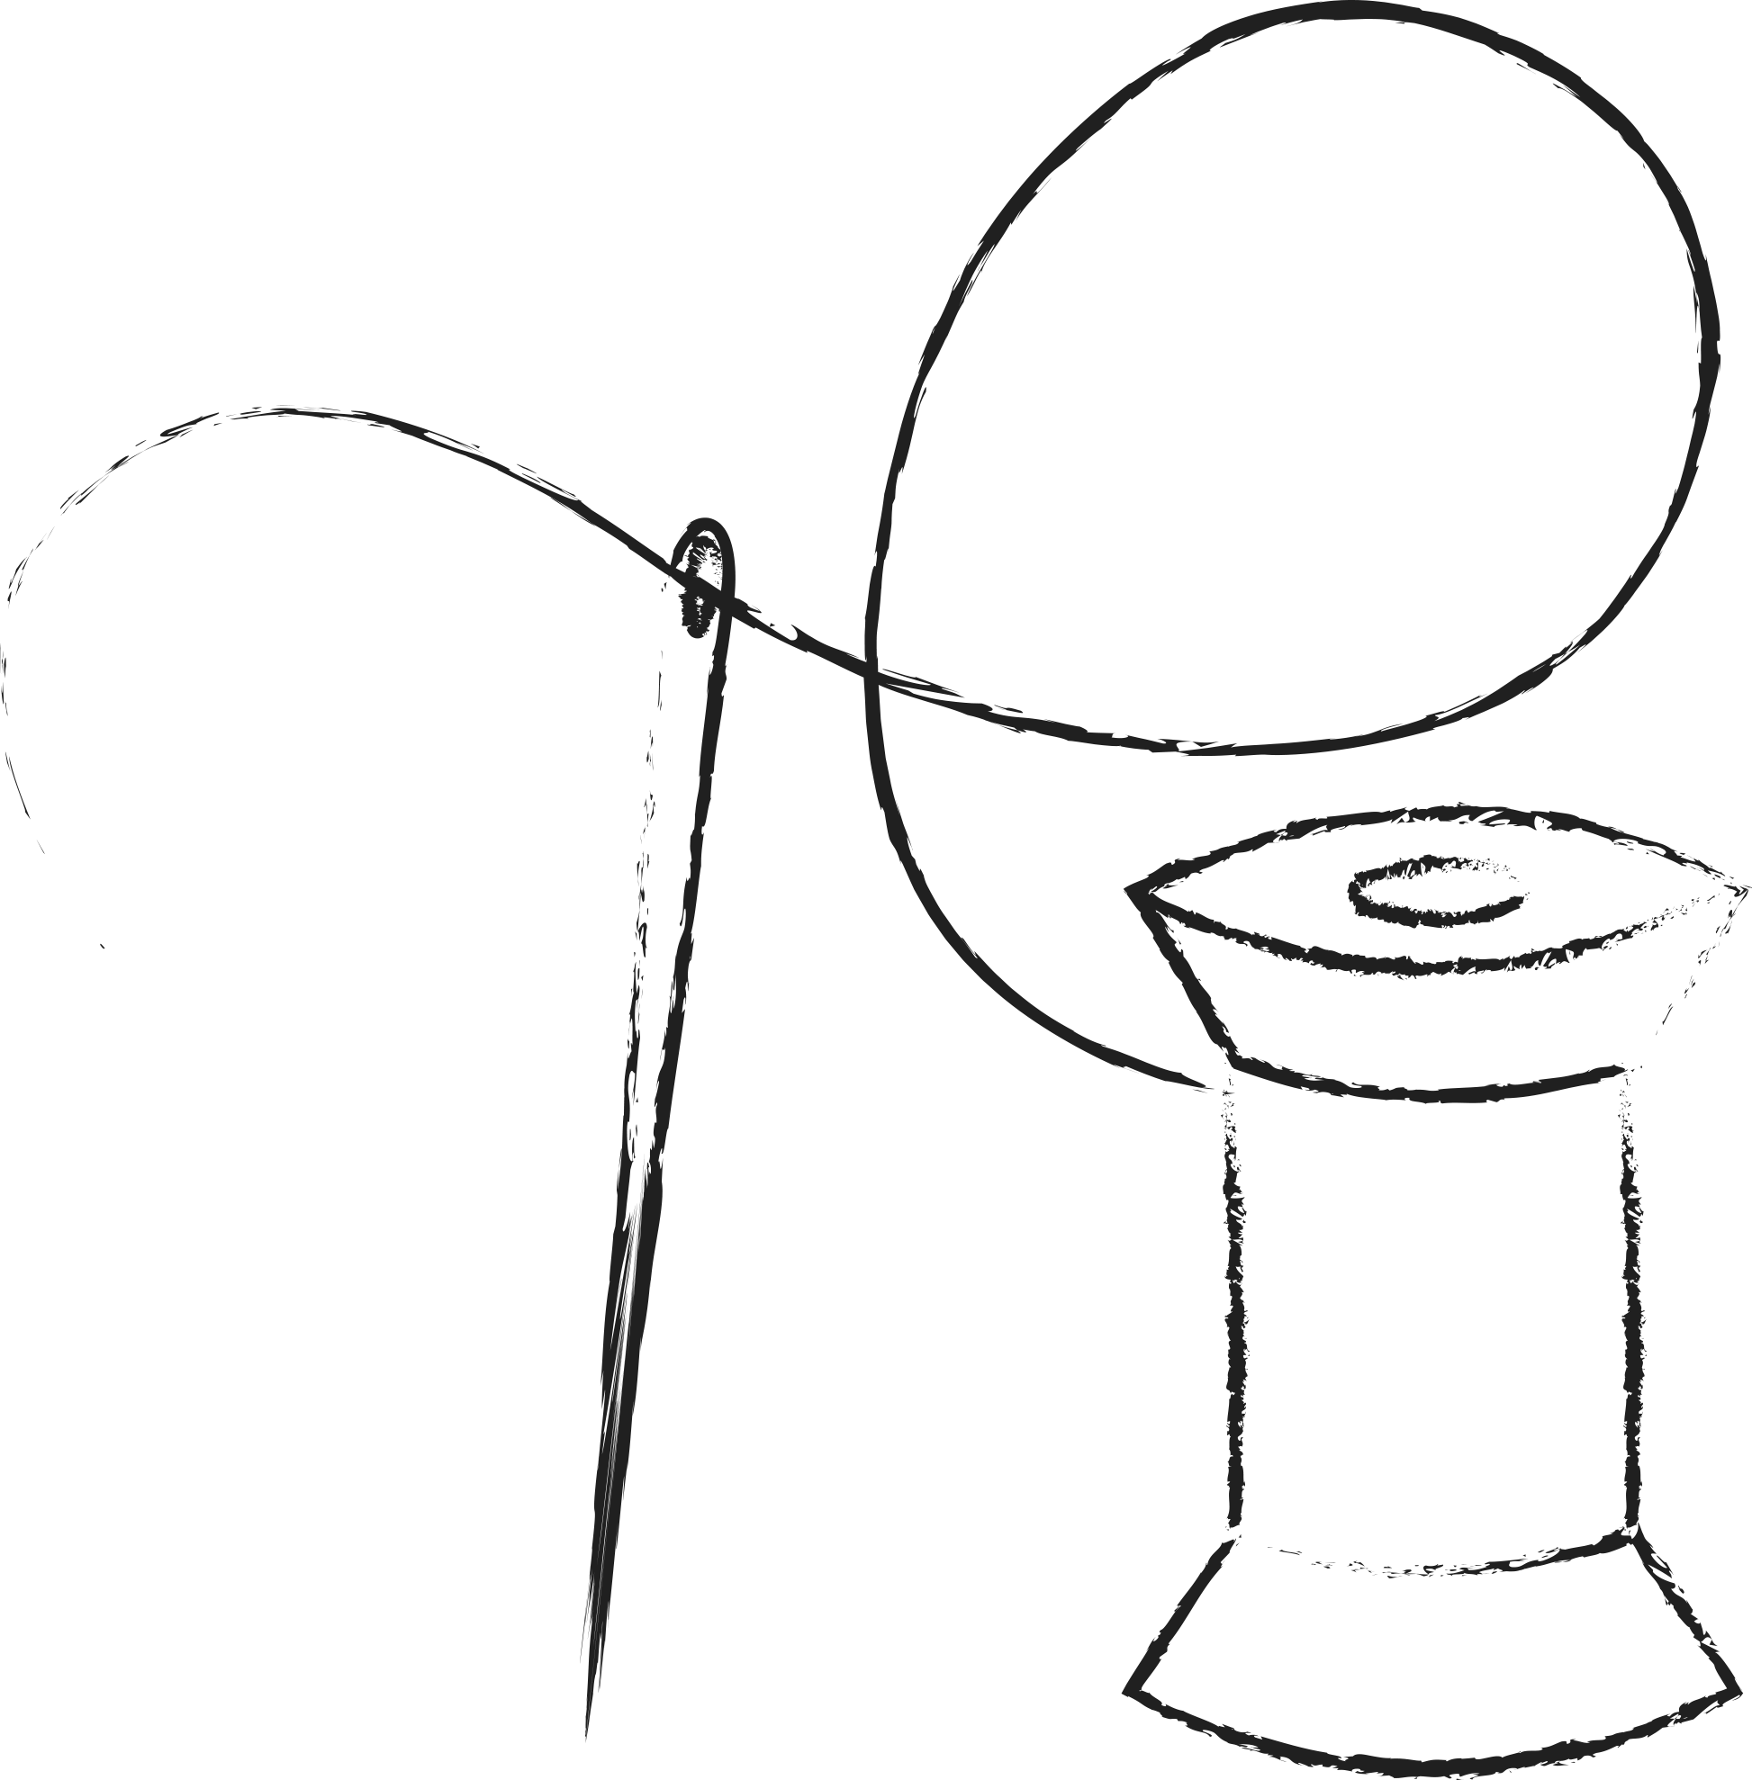 | … cotton
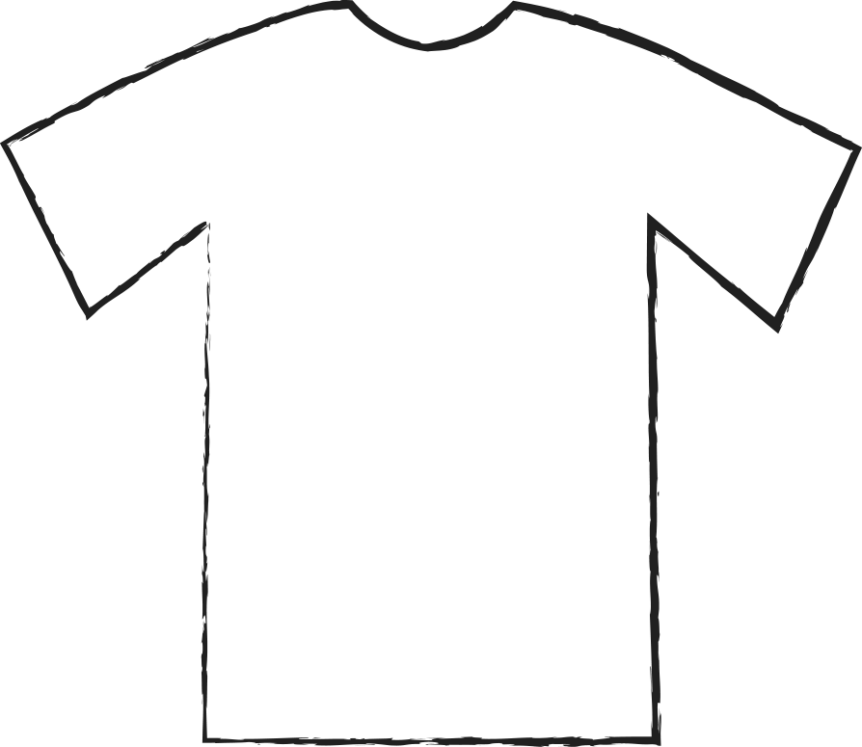
 | … glass
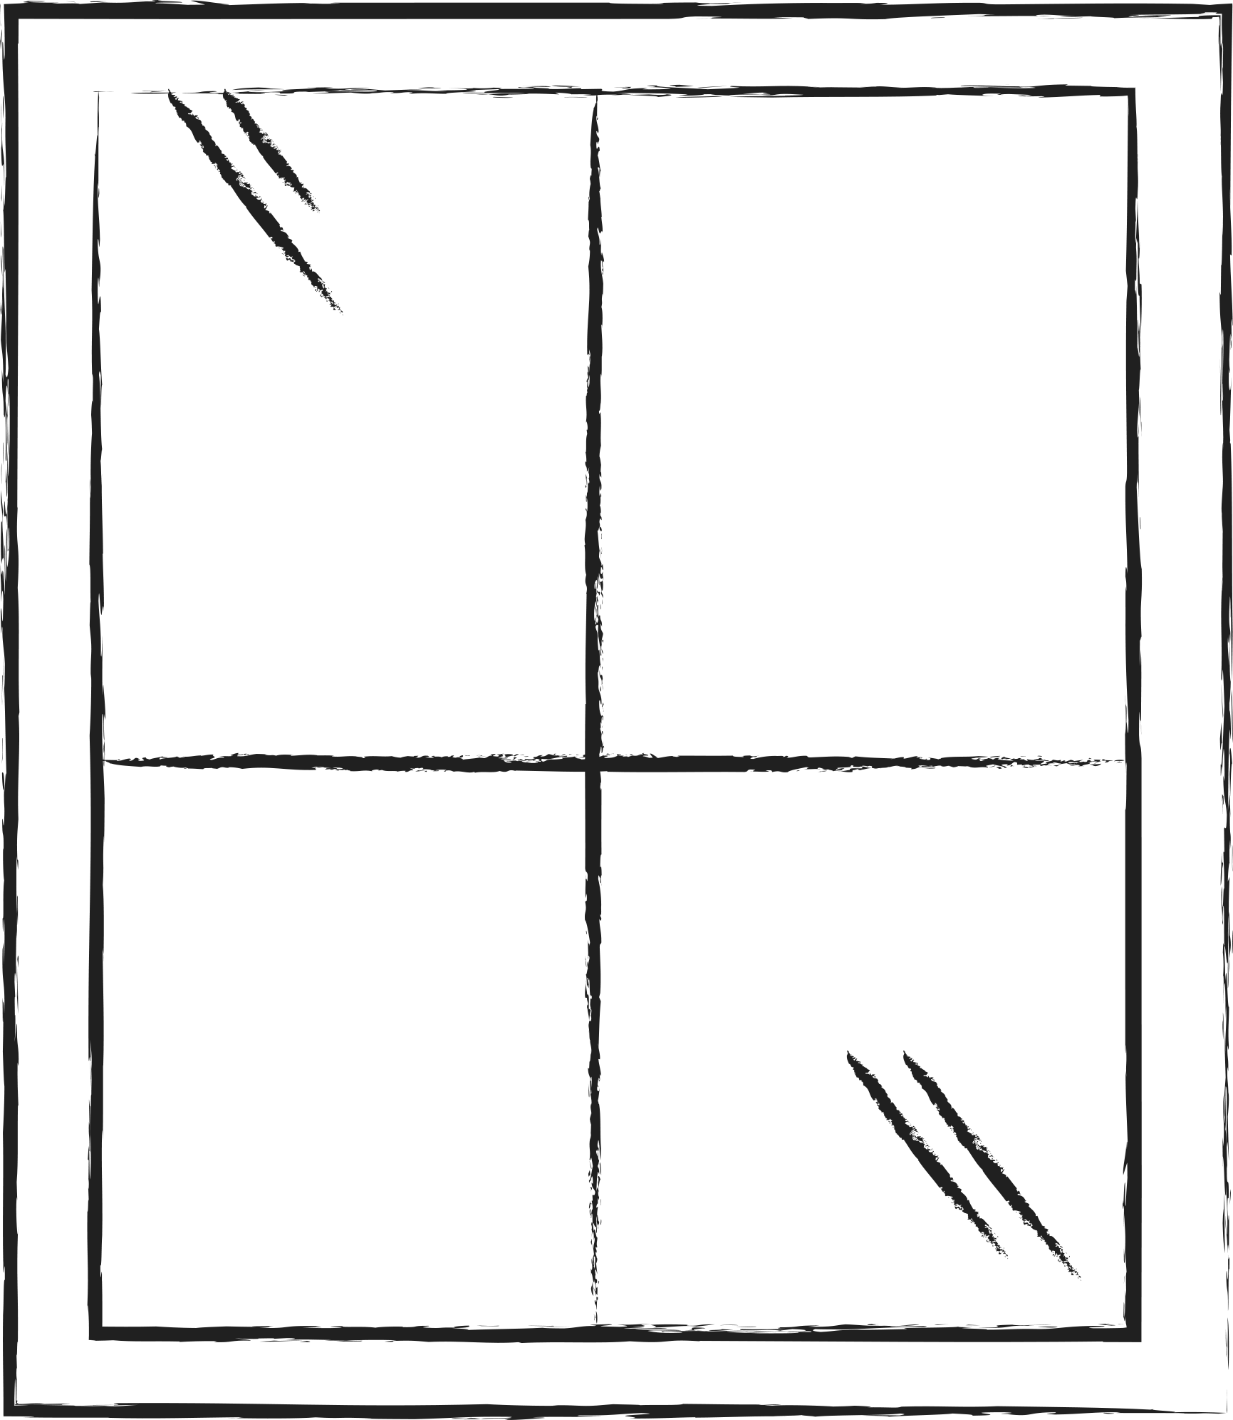
 | … plastic
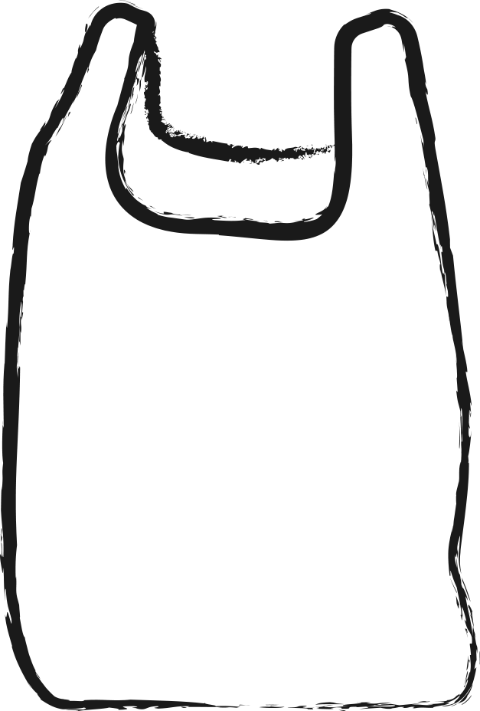 |  | 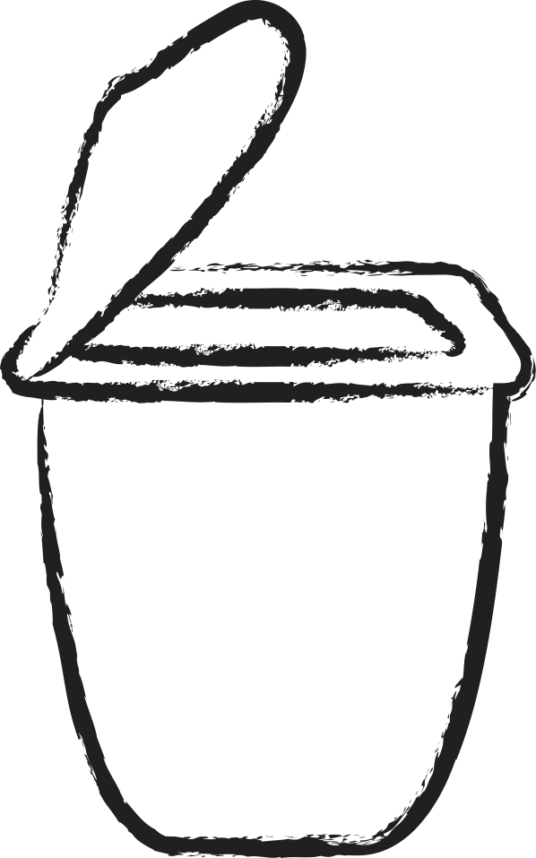

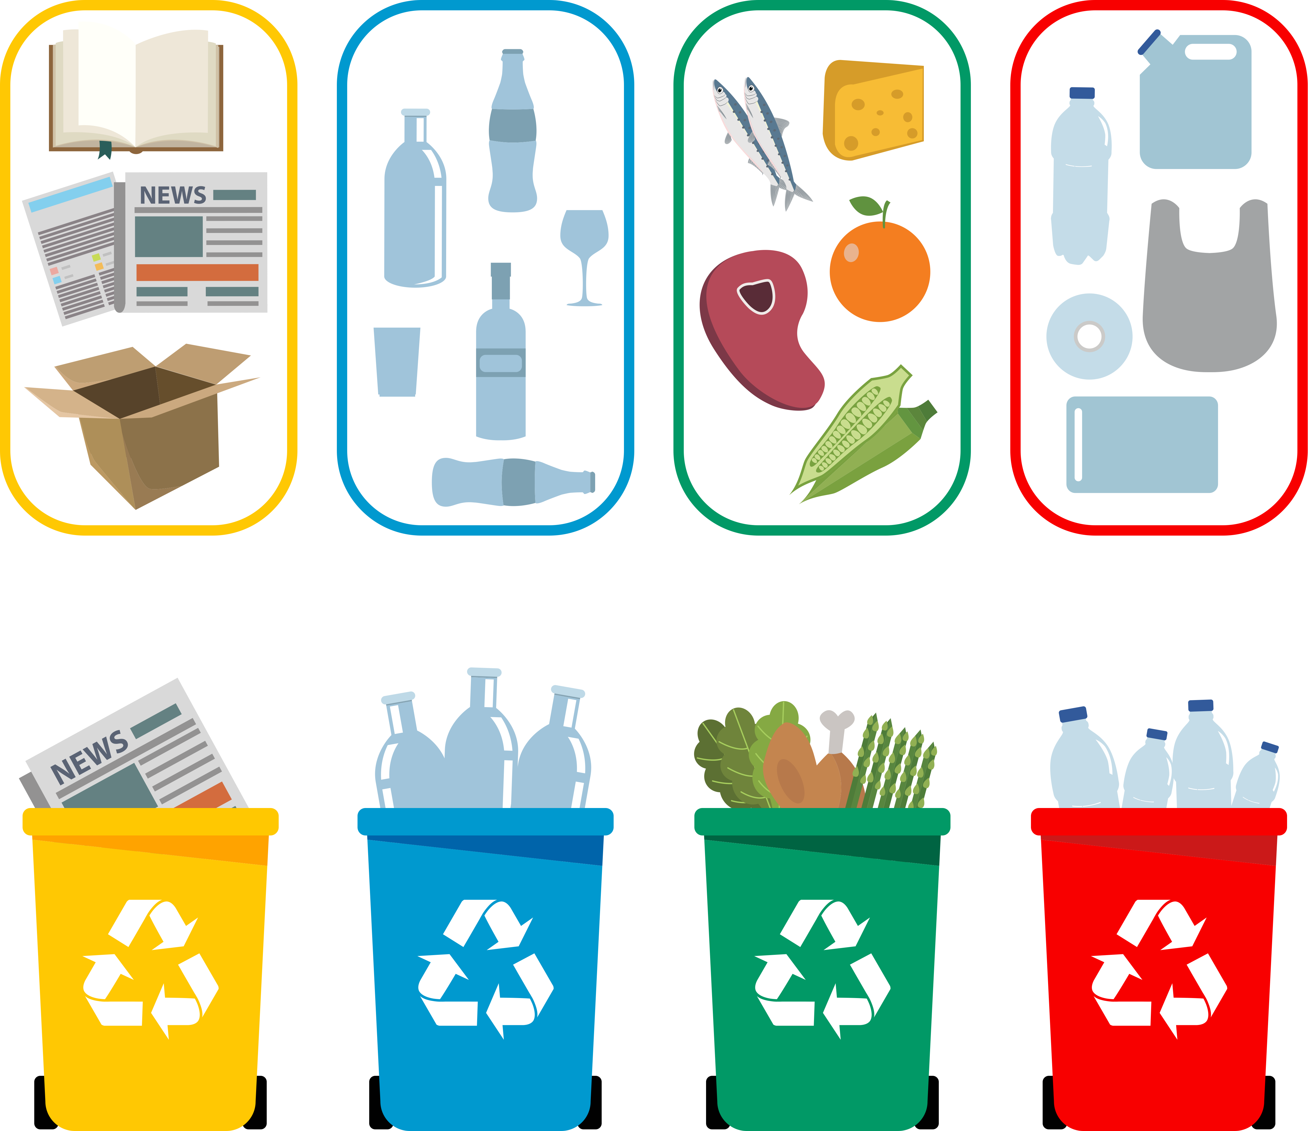

Are the rubbish bin colours the same in your country?

What is your grey bin for?

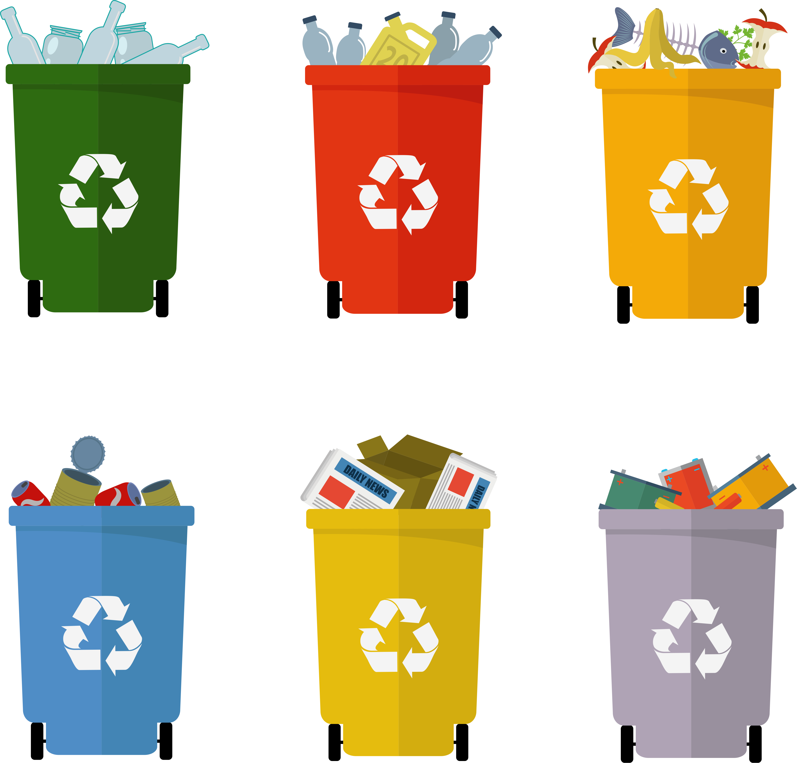

- Extend / Enrichment / Prolongation Web links with other digital tools:

1. Waste management and recycling
https://www.youtube.com/watch?v=4JDGFNoY-rQ
2. What really happens to the plastic that is thrown away:
https://www.youtube.com/watch?v=_6xlNyWPpB8
3. How to keep plastics out of our ocean? / National Geographic
https://www.youtube.com/watch?v=HQTUWK7CM-Y
4. Do not waste your waste!
https://www.youtube.com/watch?v=Kr_DGf77OhM

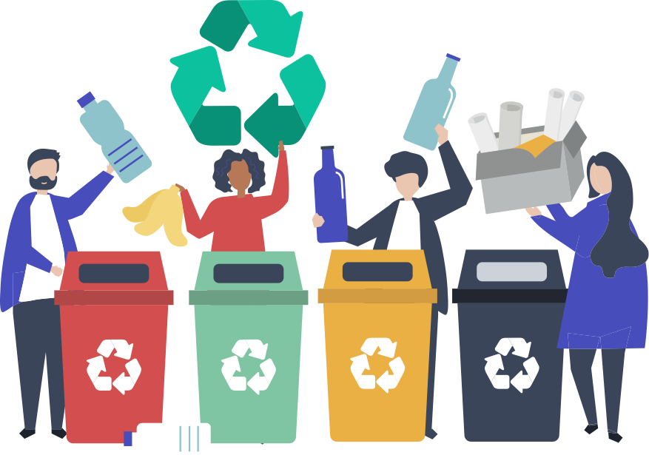
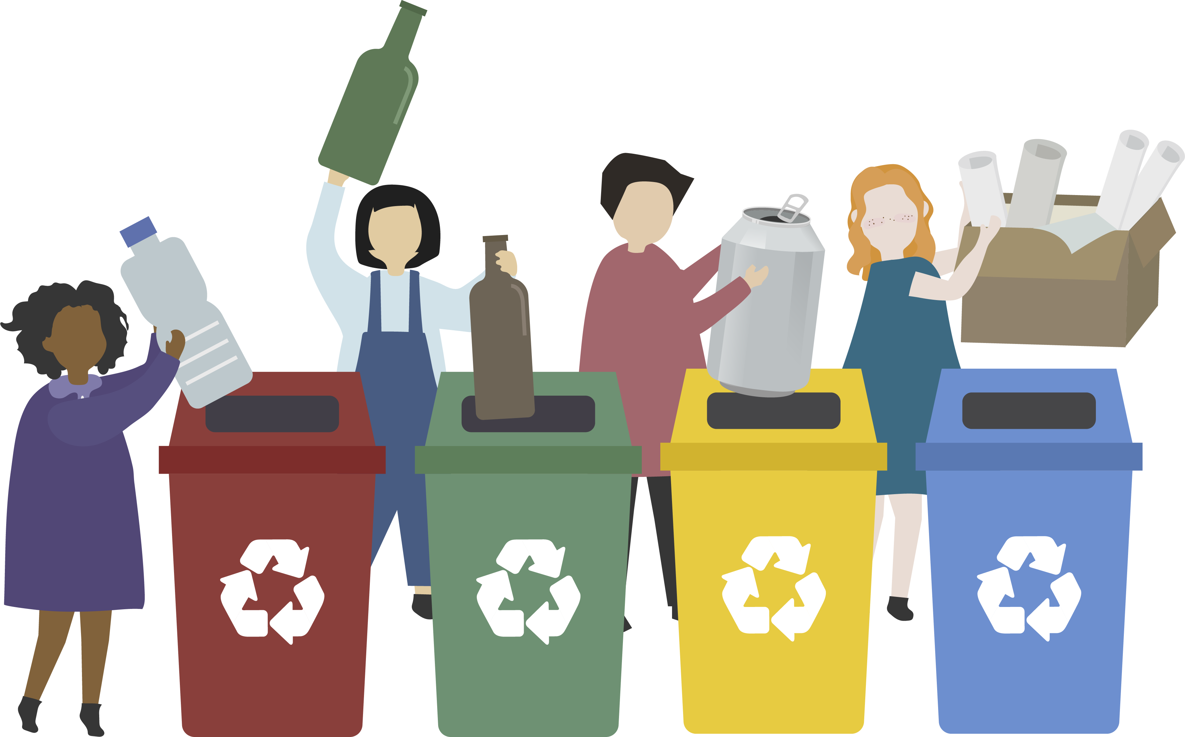
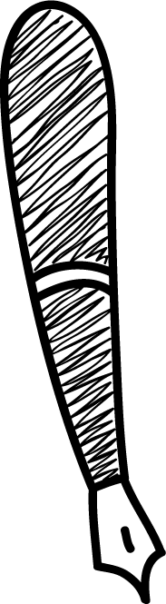
5- And if we reduce our waste! (CC: Rikac/ pixabay license

Write the name of the raw material of these objects

Write the name of the raw material of these objects

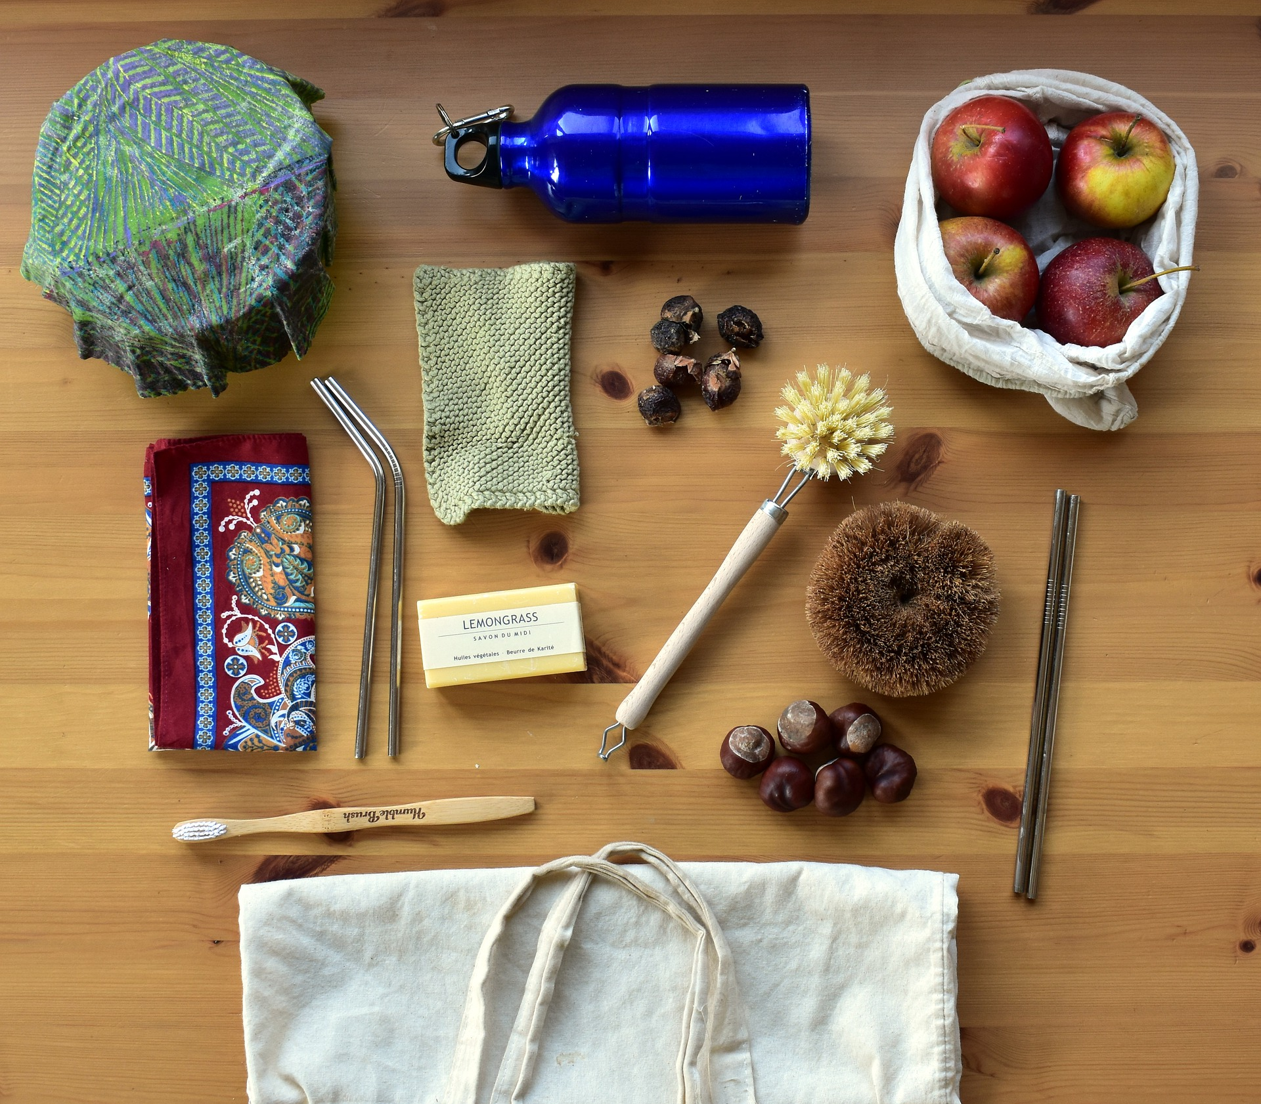

Ce projet n ° 2017-1-FR01-KA201-037433 a été financé avec le soutien de la Commission européenne. Cette publication n'engage que son auteur et la Commission ne peut être tenue responsable de l'usage qui pourrait être fait des informations qui y figurent.

